North Carolina 4-H
Project Record Report Form
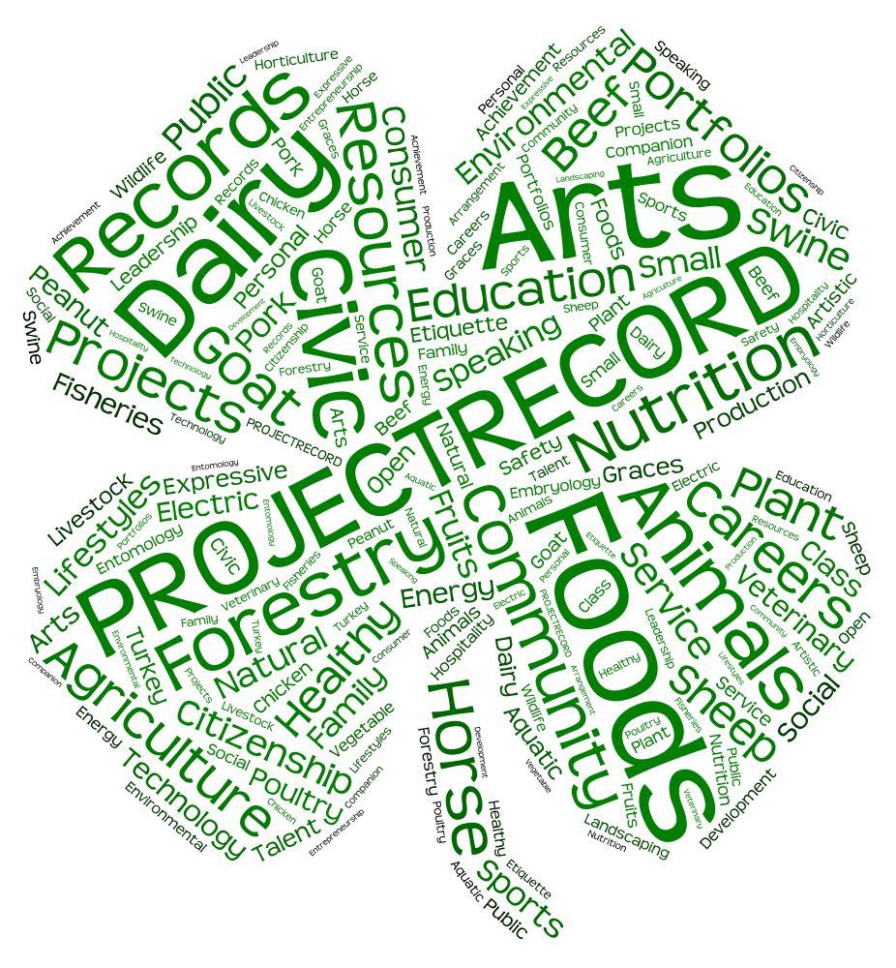
Age Categories:
13–15 & 16-18

SECTION 1: Personal Data
County You Participate In 4-H: ______________ Program Year: _______

4-H Project Record Category in which you are entering: _________________________________

Competition Category: 13 thru 15 years old 16 thru 18 years old
(age as of Jan. 1 for the project reporting year)

Number of years in the above program area: _____ Years in 4-H: _____

Name: __________ __________ __________ Male Female
(first) (middle) (last)

Name you want used in publicity: ______________________________________
(please print)

Home Mailing Address: ______________________________________

City: ______________________ State: ________ Zip Code: __________

Primary Telephone Number (include area code): ______________________________________

Date and Year of Birth: __________ Age as of January 1: __________
(age as of Jan. 1 for the project reporting year)
Names of parents or guardians: _______________________________________________

Name of your 4-H club or group: _____________________ 4-H’ers Primary email address: _________________

Name of School: __________________ Grade in School: __________________

Prior 4-H Project Record Gold awards won in this category Gold Year:
for this age group:

STATEMENT BY 4-H MEMBER
I give North Carolina 4-H permission to use my record as a sample, after identifying information has been removed, and allow North Carolina 4-H to use my Digital Media if any is provided to use for 4-H Marketing opportunities. I also understand that North Carolina 4-H will contact me before any of my information is shared.

I have personally prepared this report and certify that it accurately reflects my work:

Date: ____________, 20 ___________ Signature of 4-H Member: _____________________________________

APPROVAL OF THIS REPORT

We have reviewed this report and believe it to be correct:

Date: _______________, 20________ Signed: ____________________________________________________
(Parent or guardian)
Date: _______________, 20________ Signed: ____________________________________________________
(Local 4-H Leader)
Date: _______________, 20________ Signed: ____________________________________________________
(County Extension Agent)

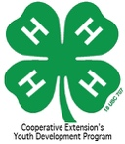

4-H & YOU!

Looking back over the past year in 4-H:

1. Discuss your favorite thing about 4-H. It does not have to relate to the project reported in Section 3.

2. Who is your role model in 4-H? Why?

3. Discuss the most important thing you have learned during the past year in 4-H.

Looking to the future:

4. If you were in charge of 4-H, how would you make it better? In your:

County:

District:

State:

SECTION 2
My 4-H Story

Program Year:_____

SECTION 3
4-H Project Focus

Activity Knowledge Skills Gained

Savings, Profits, Losses

*Level = L - Local, C - County, D - District, S - State, R - Regional, N - National

Program Year:_____
SECTION 4
Leadership

Responsibility Accomplishment Level

*Level = L - Local, C - County, D - District, S - State, R - Regional, N - National
Program Year:_____
SECTION 5
Citizenship

Description of Activity Level

*Level = L - Local, C - County, D - District, S - State, R - Regional, N - National

Program Year:_____

SECTION 6
Community Service

Description of Activity Level Hours

*Level = L - Local, C - County, D - District, S - State, R - Regional, N - National

Program Year:_____

SECTION 7
4-H Awards and Recognition

Project Record Award

Award/Recognition For What Received

Other 4-H Awards
Award/Recognition For What Received

*Level = L - Local, C - County, D - District, S - State, R - Regional, N - National

Program Year:_____

SECTION 8
Non 4-H Experiences

Responsibility /Accomplishments

Non 4-H Awards & Recognition

Type of Award For What Received

*Level = L - Local, C - County, D - District, S - State, R - Regional, N - National

Program Year:_____
SECTION 9
4-H Photos and Supporting Materials

Program Year:_____

SECTION 10
4-H Goal Setting

ACTION RESULTS TIMETABLE

For More Information

Visit our website: www.nc4h.org

Shannon B. McCollum, Ed.D
Extension 4-H Associate
shannon_mccollum@ncsu.edu
(919)515-8486

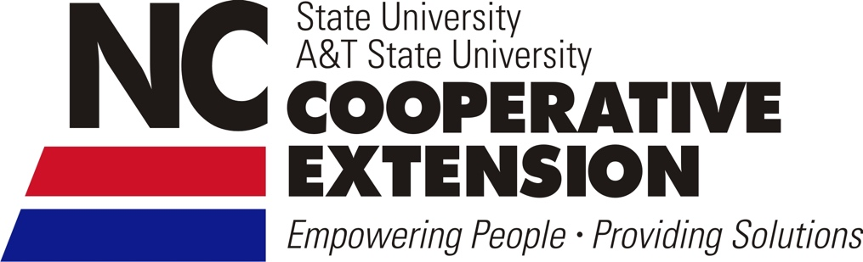

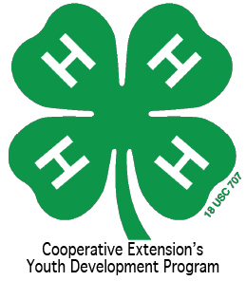

North Carolina State University and North Carolina A&T State University commit themselves to positive action to secure equal opportunity regardless of race, color, creed, national origin, religion, sex, age, veteran status or disability. In addition, the two Universities welcome all persons without regard to sexual orientation. North Carolina State University, North Carolina A&T State University, U.S. Department of Agriculture, and local governments cooperating.

