
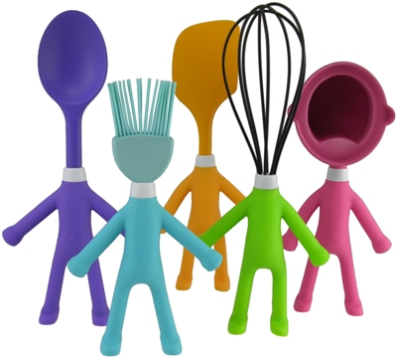
Area 4-H Food Show
March 11, 2017
Yadkin County Cooperative Extension

REGISTRATION FORM

NAME: AGE: (As of January 1, 2017)

ADDRESS: CITY: STATE: Zip code:

4-H CLUB: PHONE:

AGE GROUP:
Pre-Cloverbud (< 5) Cloverbud (5-8) Junior (9-13) Senior (14-18)

CHECK CATEGORY (enter only one):

Main Dish Vegetable/Salad/Soup Dessert Snack/Appetizer

NAME OF RECIPE: NUMBER OF SERVINGS:

Please fill out below or attach a copy of the recipe:

LIST OF INGREDIENTS:

INSTRUCTIONS:

ALL RECIPES SHOULD BE MADE FROM SCRATCH. Make healthy choices for ingredients used (i.e., low-fat milk, less sugar, less sodium).
RETURN FORM TO:
Your Local extension office by: Friday – March 3, 2017

Please answer the following questions:

- Can you determine if a recipe is a healthy choice? Yes No
- Do you know how to revise a recipe to make it a healthy choice? Yes No
- Do you know how many calories you need a day based on the recommended food guideline? Yes No
- Do you think you meet your daily requirement for physical activity? Yes No
- Are you interested in preparing and eating more healthy meals/snacks at home? Yes No

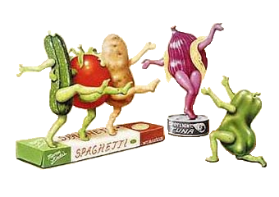
Area 4-H Food Show
Information and Regulation Sheet

What?
The food show will give participants a chance to learn about nutrition and exhibiting food.

Learning Objectives
A. Youth will increase knowledge and skills in nutrition and healthy lifestyle education.
B. Youth will increase communication/presentation skills

To Be Eligible:
- Youth must be between the ages of five and eighteen (age as of January 1, 2016).

- Youth must be accompanied by a parent/guardian and/or adult volunteer.

Divisions:
A. Pre-Cloverbuds (less than age 5)
B. Cloverbuds (ages 5-8)
C. Junior (ages 9-13)
D. Senior (ages 14-18)

Groups in Each Division:
A. Dessert
B. Main Dishes
C. Vegetable/Salad/Soup
D. Snack/Appetizer

When and Where:
The Food Show will be held at Yadkin County Cooperative Extension on March 11th, 2017, from 9:30 a.m. to
12:00 noon. Participants may set up between 9:30 a.m. to 10:00 a.m. Judging will begin at 10:00 a.m. and conclude when all entries have been judged.

General Rules:
- Participants may enter only one of the four categories.
- The food dish should be completely prepared at home and ready for show upon arrival.
- Participants must include a serving dish containing all of the food made from the recipe submitted. The exception of this would be a quantity recipe, such as a cookie recipe of which an attractive arrangement should be made. Individual portions will be served to the judges in containers (paper plates, cups, etc.) and furnished by the participants.
- Appropriate table appointments: serving dish, napkin, tablecloth, table decoration, and utensils. This is to be furnished by the participant. Keep it simple.
- 4” x 6” card with recipe, name, category, and food group to be displayed with the food.
- Questions about nutrition, preparation, ingredients, ideas for serving, etc. will be asked by the judges. Sample questions are listed on the back of this sheet.

For more information or to submit recipes, contact your local Extension Office.
DEADLINE TO REGISTER AND SUBMIT COPY OF RECIPES IS:
Friday – March 3, 2017


Sample Food Show Questions

- What is the first thing that you did before you started cooking?
- Why did you choose this recipe?
- What did you like best about making this recipe?
- What was the hardest part of making this dish?
- Have you made this dish before? Would you make it again?
- Would you do anything different if you decide to make this again?
- Did you have any help making your dish?
- How long did it take you to make it?
- What is something new that you learned while you were making this dish?
- Did it turn out the way that you thought it would?
- Did you help with the shopping to get the ingredients for your recipe?
- What food group does this fit into?
- What other food or beverage would you serve with this?
- Do you know how many servings of your main ingredient that you would need?
- Is your dish a healthy choice? Why?

AREA 4-H FOOD SHOW
Score Sheet

NAME:

NAME OF RECIPE:

CLOVERBUD: (no score/just comments)
5 = Excellent
4 = Very Good
3 = Good
2 = Needs Improvement
1 = Needs Much Improvement
JR

SR

CATEGORIES | SCORE (1-5) | COMMENTS & SUGGESTIONS
The Exhibitor Understands. . .
-Setting of Table
-Preparation of Food
-Appropriate Grooming
Includes A Recipe
-Ingredients
-Directions
-Neatness
The Food Is. . .
-Pleasing In Flavor
-Attractive In Appearance
-Suitably Prepared
The Table Setting
-Is Attractive
-Is Suitably Arranged
-Is Appropriate For Occasion
Nutrition
-What food groups are included in your recipe?
-Could you make this dish more nutritious?

Judge's Signature

