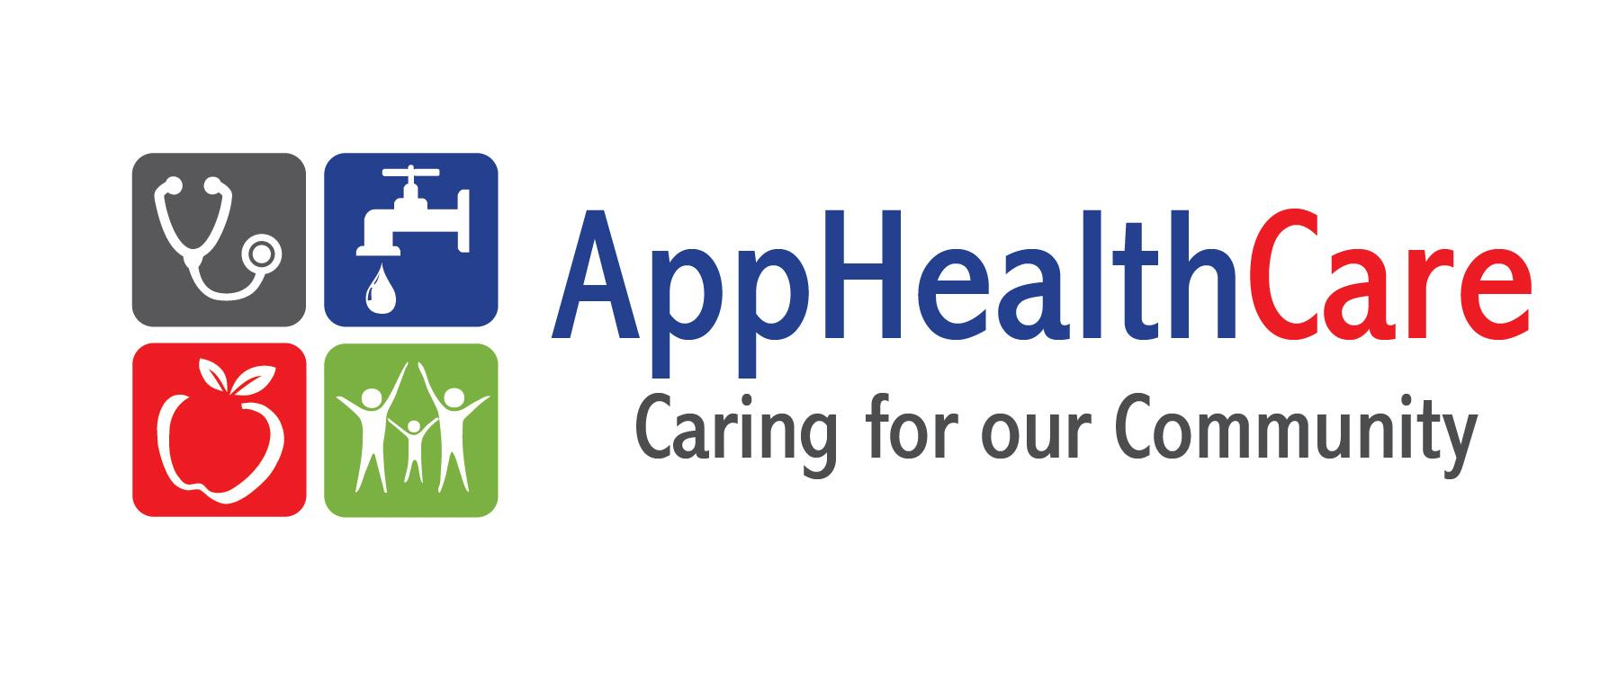
Innovative Approaches
Short Survey for Families of Children and Youth with Special Health Care Needs

AppHealthCare received a grant called, “Innovative Approaches: Community Systems Building Grants for Children and Youth with Special Health Care Needs” from the NC Division of Public Health, Children and Youth Branch.
The Innovative Approaches initiative serves to improve the system of care for children and youth with special health care needs (CYSHCN) age birth – 21. CYSHCN have or are at risk for having on-going physical, developmental, behavioral or emotional health needs that need different services or care than what other children their age may need. For example, these children may need care for asthma, autism spectrum disorder, depression, cerebral palsy or developmental delay.
Thank you for completing this survey, which will help us better meet the needs of families like yours.

Please only complete this survey once. If you have already completed this survey, please do not fill out another one.

All answers will be kept anonymous.

Thank you for sharing with us. Your feedback will be valuable in helping us make our programs even more effective for Watauga, Ashe and Alleghany Counties’ families.

Please feel free to contact Elizabeth Kerley, Innovative Approaches Coordinator, at 828-264-4995 ext 3114 or elizabeth.kerley@apphealth.com with any questions or comments. OR contact Diane Coffey, Parent Outreach Coordinator at 828-264-4995 ext 3140 or diane.coffey@apphealth.com.

Innovative Approaches Family Survey
- What is your county? (Circle one) Alleghany Ashe Watauga

Please tell us about your family.

- What language do you speak at home? (Circle one)
English Spanish Other ______________________
- How old is your child who is receiving special health care services and what is his/her age and sex?
 | Age | Sex (M or F)
Child #1
Child #2
Child #3

- What is the race/ethnicity of your child(ren) receiving special health care services? (Circle all that apply.)

Hispanic / Latino / African-American / Black / Native American / American Indian / Asian / Pacific Islander / White/ Other

- What special health care needs does your child(ren) have? (Circle all that apply.)
Allergies | Behavioral or Conduct Problems | Diabetes | Intellectual Disability
Anxiety Problems | Blood problems such as anemia or sickle cell disease | Down Syndrome | Migraine or Frequent Headaches
Arthritis or other joint problems | Cerebral Palsy | Epilepsy/Seizures | Muscular Dystrophy
Asthma | Cystic Fibrosis | Head injury, concussion, or traumatic brain injury | Vision impairment
Attention Deficit Disorder (ADD) or Attention Deficit Hyperactive Disorder (ADHS) | Depression | Hearing impairment | Other Condition(s)  __________________________________
Autism, Asperger’s Disorder, pervasive developmental disorder, or other autism spectrum disorder | Developmental Delay | Heart problem, including congenital heart disease

- By writing an “X” in the column that best matches, please indicate your level of agreement with the following statements about working with health care providers, which include doctors, specialists, nurses, therapists, etc.
 | 1  Strongly Disagree | 2  Disagree | 3  Agree | 4 Strongly Agree | Don’t Know | N/A
My child is receiving the right level of services.
I am treated like a partner in my child’s health care decisions.
I am treated with respect by my child’s health care provider(s).
My child’s health care providers share information about my child’s needs and progress with me and with each other.
I have a central point of contact who helps coordinate my child’s services with all providers.
Getting referrals for additional treatment is an easy process.

- What are your top 3 challenges in caring for your child’s or children’s special health needs?

- What support networks do you utilize to care for your child or children with special health needs?

- What struggles are you having that you would want us to focus on?

- What type of service concerns you the most?

- What other information or comments would you like to share?

Thank you for completing the survey. By entering your contact information below, you will be notified of the survey results and invitations to attend future Innovative Approaches meetings. Please enter your name and email (or phone number, with area code) in the text box below. This information will be kept separately from the survey data to ensure that your responses are anonymous.

THANK YOU FOR YOUR TIME!

