We Want Your

Shoes!

Your gently worn shoes, that is.

If you’re like most people, your closet’s probably home to multiple pairs of shoes you no longer wear. Here’s your chance to dust them off and put them to good use.

Mecklenburg County 4-H

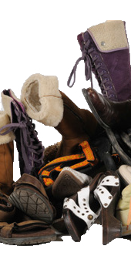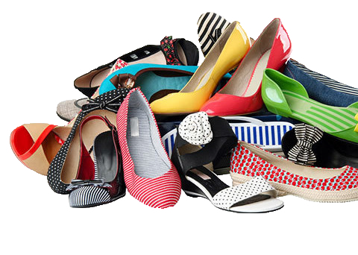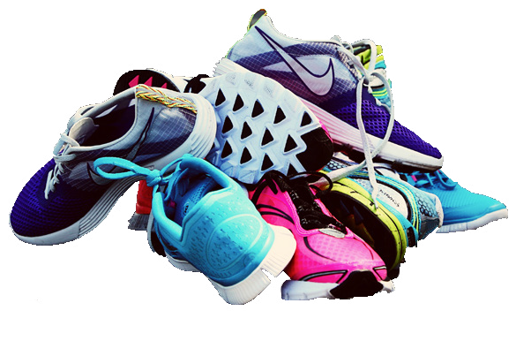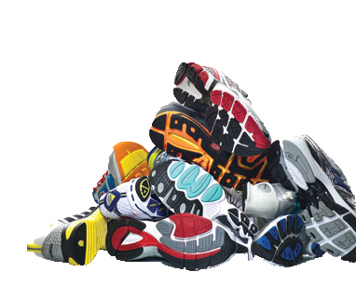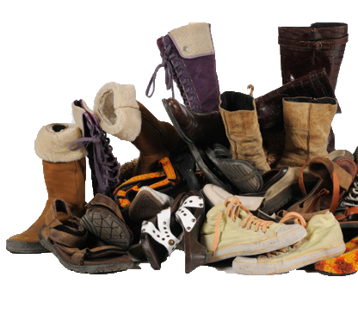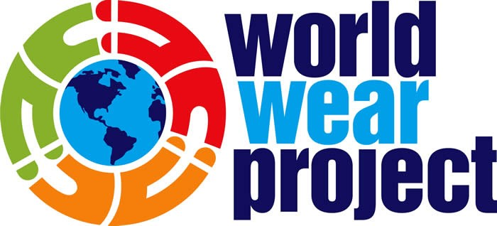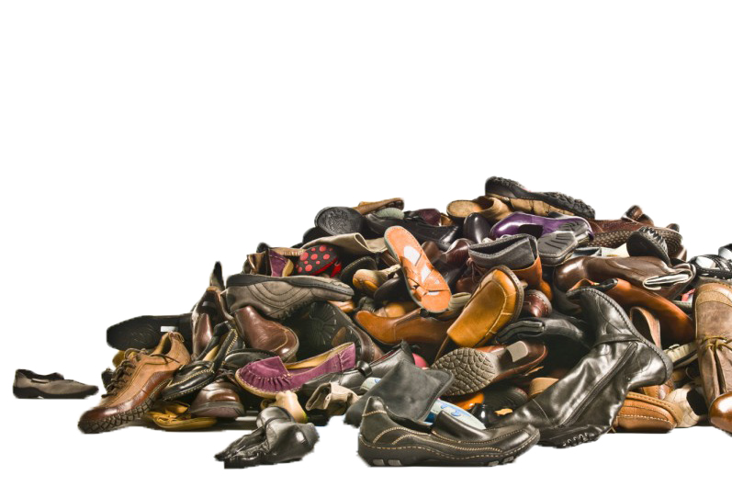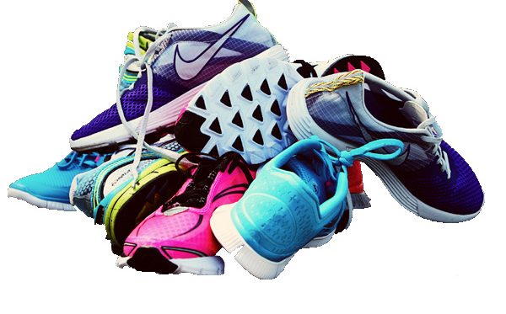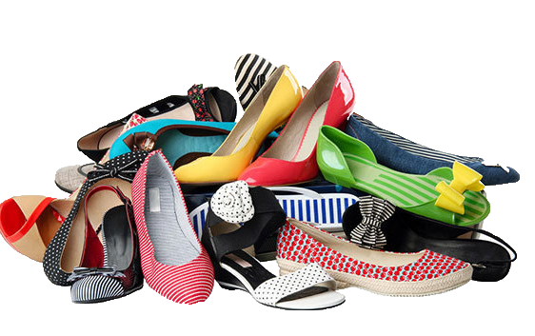

When you drop off your gently worn shoes, you’ll be helping

raise needed funds as well as people less fortunate

throughout the world. World Wear Project makes your shoes available to people living in developing countries such as Cameroon, Mozambique, Tanzania, Guatemala, Chile, Honduras and others.

Donating shoes and clothing

never made more cents.

worldwearproject.com