**2016 LIVESTOCK SHOW**



[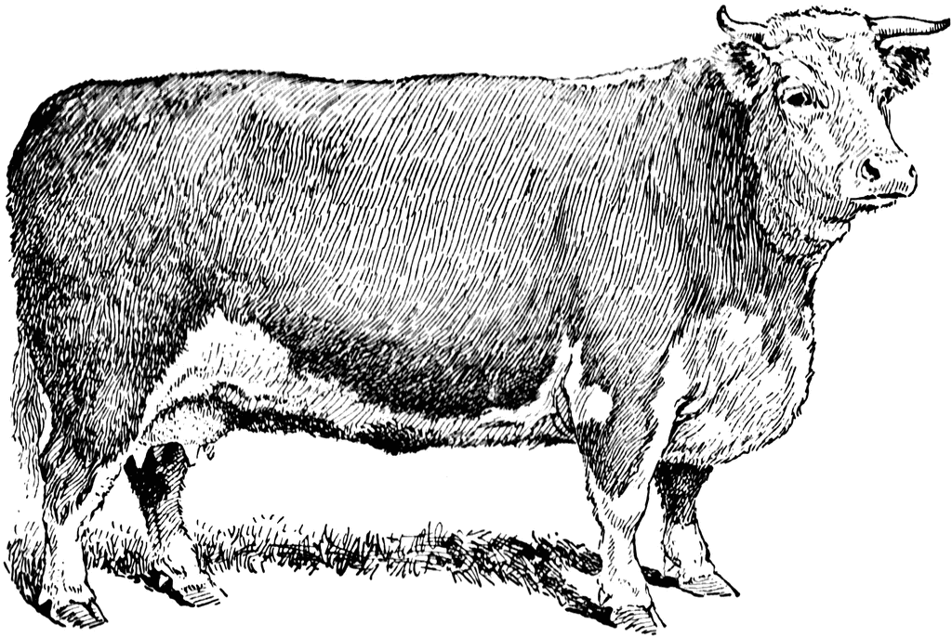](http://images.search.yahoo.com/r/_ylt=A0PDoS0uzdBPvjwAcc2jzbkF;_ylu=X3oDMTBpcGszamw0BHNlYwNmcC1pbWcEc2xrA2ltZw--/SIG=12cf62f7h/EXP=1339112878/**http:/etc.usf.edu/clipart/12000/12092/beefcow_12092.htm)



C:\Documents and Settings\Kim Gibson\Local Settings\Temporary Internet Files\Content.IE5\VSSJOQ08\MC900297217[1].wmf

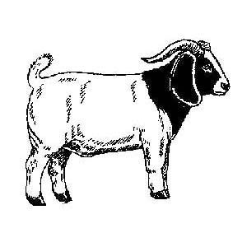



2016

(Anson, Chatham, Guilford, Lee, Montgomery, Moore, Richmond, Stanly & Union)

|  |  |  |
| --- | --- | --- |
| Parents Names:________________________________________ Parents email_______________________________________ | | |
| Address:___________________________________________ | | Phone:_______________________ Cell # ________________ |
| City: _________________ | Zip: _____________ | County: ____________________ |
|  |  |  |

|  |
| --- |
|  |
| If you would like your cloverbud’s animal shown competitively in shows that do not allow cloverbud youth to compete, please put that animal under an older showman’s name, provided they have not already reached their animal limit. |
| If you have a child less than 5 years old, do you want them to participate in the Pee Wee Show? ______ ( Montgomery Only)  **The Pee Wee division is not part of the Circuit. You will need to pay $12 if you want them to have a t-shirt in the Circuit.** |

**CHILD 1**

|  |  |
| --- | --- |
| Child’s Name___________Child’s Cell #__________Child’s Email____________Birthdate_______Age (As of Jan. 1, 2016):_____ |  |
| Circle Showmanship Division: Senior (14-19) Intermediate (11-13) Junior (9-10) Cloverbud (5-8) PeeWee (under 5) | |

|  |  |  |  |  |  |
| --- | --- | --- | --- | --- | --- |
| **Name of Animal** | **Birthdate of Heifer or Doe** | **Age** | **Scrapie Tag Breed**  **or Ear Tag** | | **Type of Animal**  **Market wether, Doe, Lamb or Heifer** |
|  |  |  |  |  |  |
|  |  |  |  |  |  |
|  |  |  |  |  |  |
|  |  |  |  |  |  |
|  |  |  |  |  |  |
|  |  |  |  |  |  |

**CHILD 2**

|  |  |
| --- | --- |
| Child’s Name___________Child’s Cell #__________Child’s Email____________Birthdate_______Age (As of Jan. 1, 2016):_____ |  |
| Circle Showmanship Division: Senior (14-19) Intermediate (11-13) Junior (9-10) Cloverbud (5-8) PeeWee (under 5) | |

|  |  |  |  |  |  |
| --- | --- | --- | --- | --- | --- |
| **Name of Animal** | **Birthdate of Heifer or Doe** | **Age** | **Scrapie Tag Breed**  **or Ear Tag** | | **Type of Animal**  **Market wether, Doe, Lamb or Heifer** |
|  |  |  |  |  |  |
|  |  |  |  |  |  |
|  |  |  |  |  |  |
|  |  |  |  |  |  |
|  |  |  |  |  |  |
|  |  |  |  |  |  |

**CHILD 3**

|  |  |
| --- | --- |
| Child’s Name___________Child’s Cell #__________Child’s Email____________Birthdate_______Age (As of Jan. 1, 2016):_____ |  |
| Circle Showmanship Division: Senior (14-19) Intermediate (11-13) Junior (9-10) Cloverbud (5-8) PeeWee (under 5) | |

|  |  |  |  |  |  |
| --- | --- | --- | --- | --- | --- |
| **Name of Animal** | **Birthdate of Heifer or Doe** | **Age** | **Scrapie Tag Breed**  **or Ear Tag** | | **Type of Animal**  **Market wether, Doe, Lamb or Heifer** |
|  |  |  |  |  |  |
|  |  |  |  |  |  |
|  |  |  |  |  |  |
|  |  |  |  |  |  |
|  |  |  |  |  |  |
|  |  |  |  |  |  |

**CHILD 4**

|  |  |
| --- | --- |
| Child’s Name___________Child’s Cell #__________Child’s Email____________Birthdate_______Age (As of Jan. 1, 2016):_____ |  |
| Circle Showmanship Division: Senior (14-19) Intermediate (11-13) Junior (9-10) Cloverbud (5-8) PeeWee (under 5) | |

|  |  |  |  |  |  |
| --- | --- | --- | --- | --- | --- |
| **Name of Animal** | **Birthdate of Heifer or Doe** | **Age** | **Scrapie Tag Breed**  **or Ear Tag** | | **Type of Animal**  **Market wether, Doe, Lamb or Heifer** |
|  |  |  |  |  |  |
|  |  |  |  |  |  |
|  |  |  |  |  |  |
|  |  |  |  |  |  |
|  |  |  |  |  |  |
|  |  |  |  |  |  |