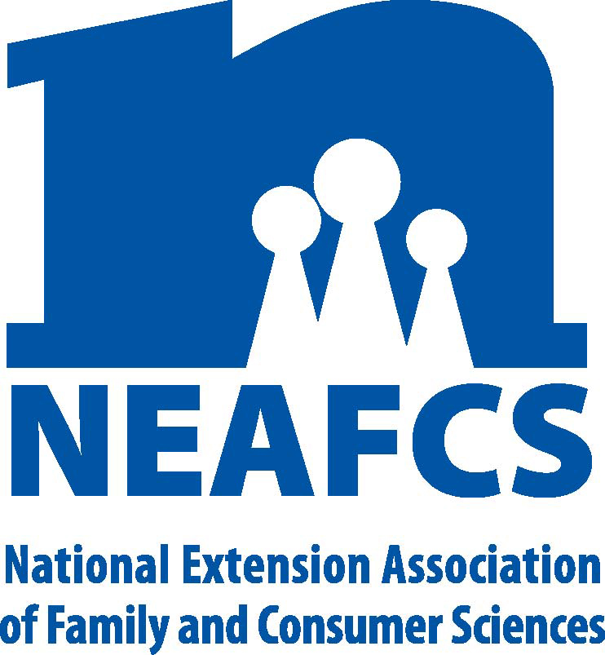

North Carolina Extension Association of
Family & Consumer Sciences

The Professional Association for North Carolina Cooperative Extension
Family & Consumer Sciences Educators
2016 Vice President of Public Affairs Plan of Work

Action Who When/How
Apply to be on a Public Affairs National Committee | State and District VPs for Public Affairs can get involved | Apply by December 31, 2015 on neafcs.com There are three areas: Marketing & Communications, Advocacy, and Education
Submit Impact Statements to the National by February 2016 | State VP of Public Affairs | By February 2016 to National VP for PA
Attend PILD conference | State VP of Public Affairs | April 11 - 13, 2016, funded by NCEAFCS
Promote the Living Well Campaign/Week | State and District VPs for Public Affairs | March 14-18, 2016 Encourage FCS Agents to promote via PSAs
Build support of Family and Consumer Sciences by working with AAFCS North Carolina Affiliate to promote the profession | State VP of Public Affairs with NCAFCS leadership | December 3, 2015, ‘Dining In’ Campaign
Participate fully in all NCEAFCS Board meetings and the Annual meeting. | State VP | Mid-year, January 201  Annual, June 14-16, 2016
Engage District VPs in Public Affairs information available via NEAFCS. Support their District roles. | State and District VPs for Public Affairs. | Throughout the year

Committee:
Courtney Swain, SC
Morgan McKnight, SC
Carmen Long, NC
Dee Furlough, NE
Julie Sawyer, West

Submitted by:
Jayne McBurney
NCEAFCS VP of Public Affairs

