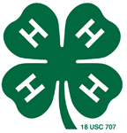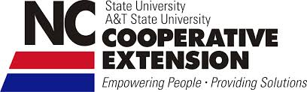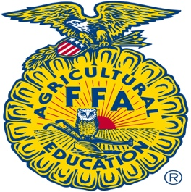

2016 Randolph County 4-H/FFA Livestock Clinic

June 11th, 2016

2368 NC Hwy. 42
Asheboro, NC 27205

Cost: Free to Attend

Entries: Please submit by June 6th, 2016

Register online at www.randolph.ces.ncsu.edu and click on the link for the Google Form.

Schedule
8:30 Registration and Welcome- Allison Walker
9:00 Halter Breaking your Calf- Dr. Brent Scarlett
9:30 Daily Care/Feeding- Jonathan Black
10:30 Break
10:45 Showmanship- Brent Jennings, Dr. Brent Scarlett, Jonathan Black, and Allison Walker
12:00 Lunch On Your Own
1:00 Selecting your Meat Goat Project- Brent Jennings and Michael Harmon
2:00 Daily Care/ Feeding/Parasite Control- Dr. Jesi Leonard
2:30 Break
2:45 Showmanship- Brent Jennings, Jonathan Black, Michael Harmon, and Allison Walker
4:00 Final Questions/Wrap Up

For questions or more information contact Allison Walker (mawalke3@ncsu.edu or 336 318-6000) or Jonathan Black (jonathan_black@ncsu.edu or 336 318-6000).

North Carolina State University and North Carolina A&T State University commit themselves to positive action to secure equal opportunity regardless of race, color, national origin, sex, age, or disability. In addition, the two Universities welcome all persons without regard to sexual orientation. North Carolina State University, North Carolina A&T State University, U.S. Department of Agriculture, and local governments cooperating.

