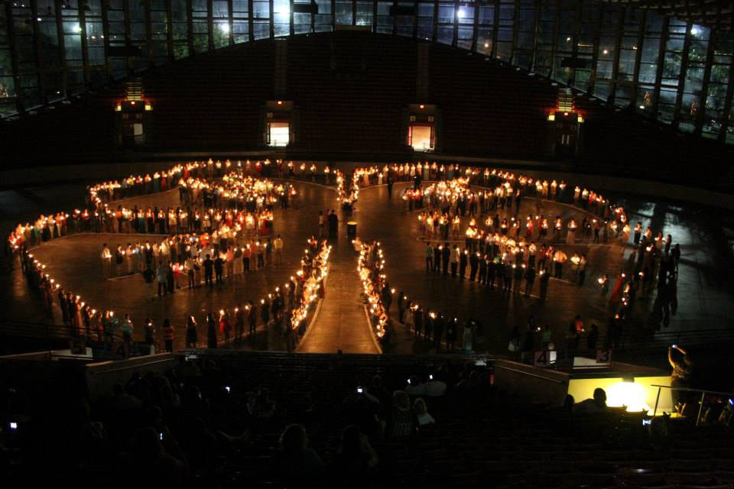
NC 4-H Congress
July 16-19, 2016
Guidelines
Who: Any North Carolina 4-H’er ages 13-18 as of January 1, 2016 is eligible to attend.

Where: NC 4-H Congress activities are held on the campus of NC State University, the Jane S. McKimmon Center, and the North Carolina State Fairgrounds.

What: North Carolina 4-H Congress is an annual state level event.

Costs: $180 (not including Saturday lunch) or $192 (including Saturday lunch). Lodging and some meals are not included in the price.

Registration Information: Registrations must be entered online no later than June 21st at 4:30pm.

What Is Congress?
North Carolina 4-H Congress is an annual educational event sponsored by North Carolina 4-H at NC State University and planned by the State 4-H Council. The council is composed of 20 young people who serve as officers from their respective districts and 4 state officers who are elected at Congress. NC 4-H Congress will be attended by approximately 600 youth ranging in age from 13 to 18 and representing every county in North Carolina.
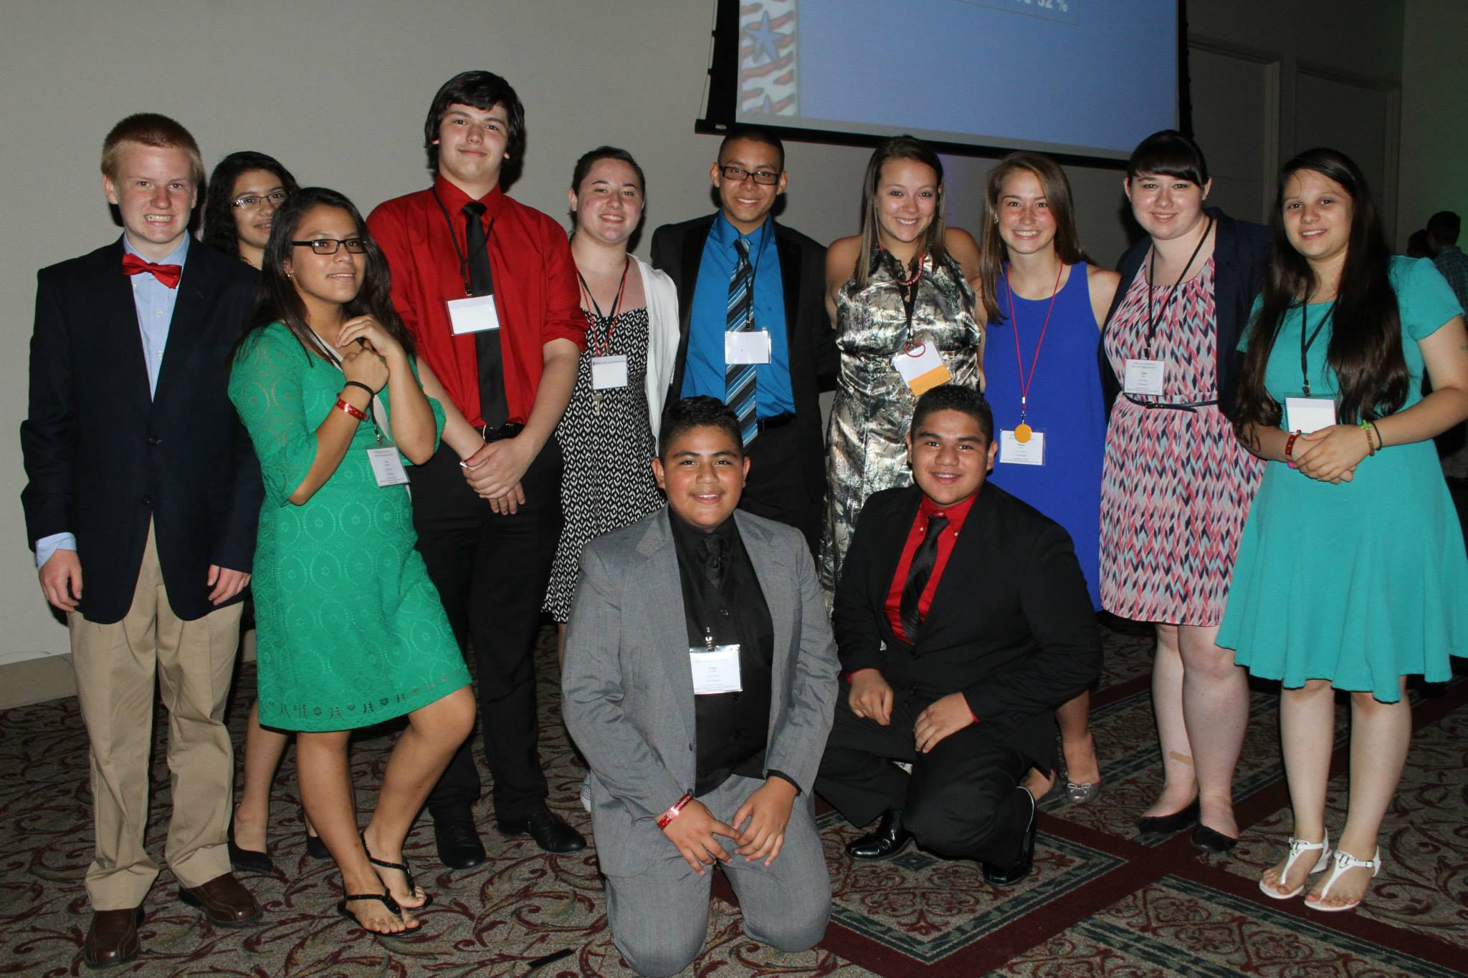
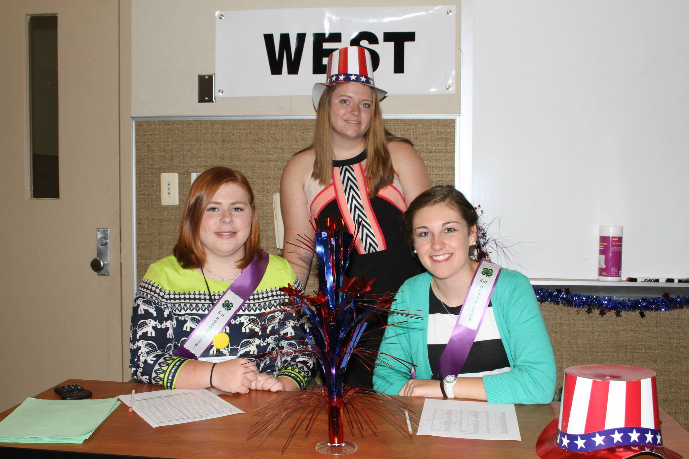
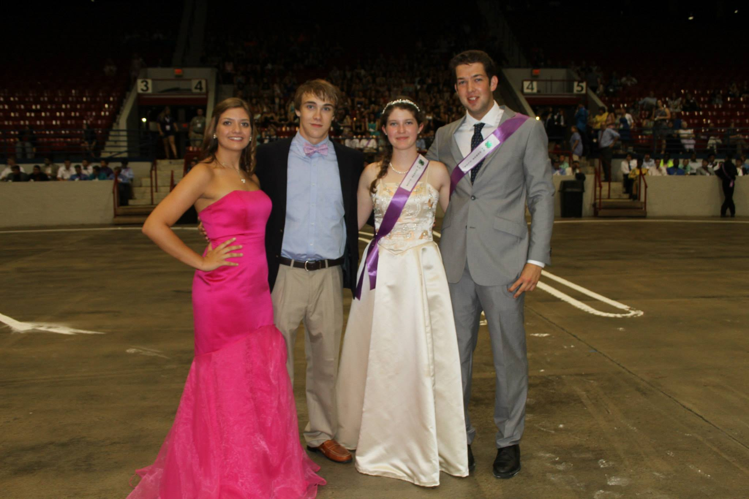
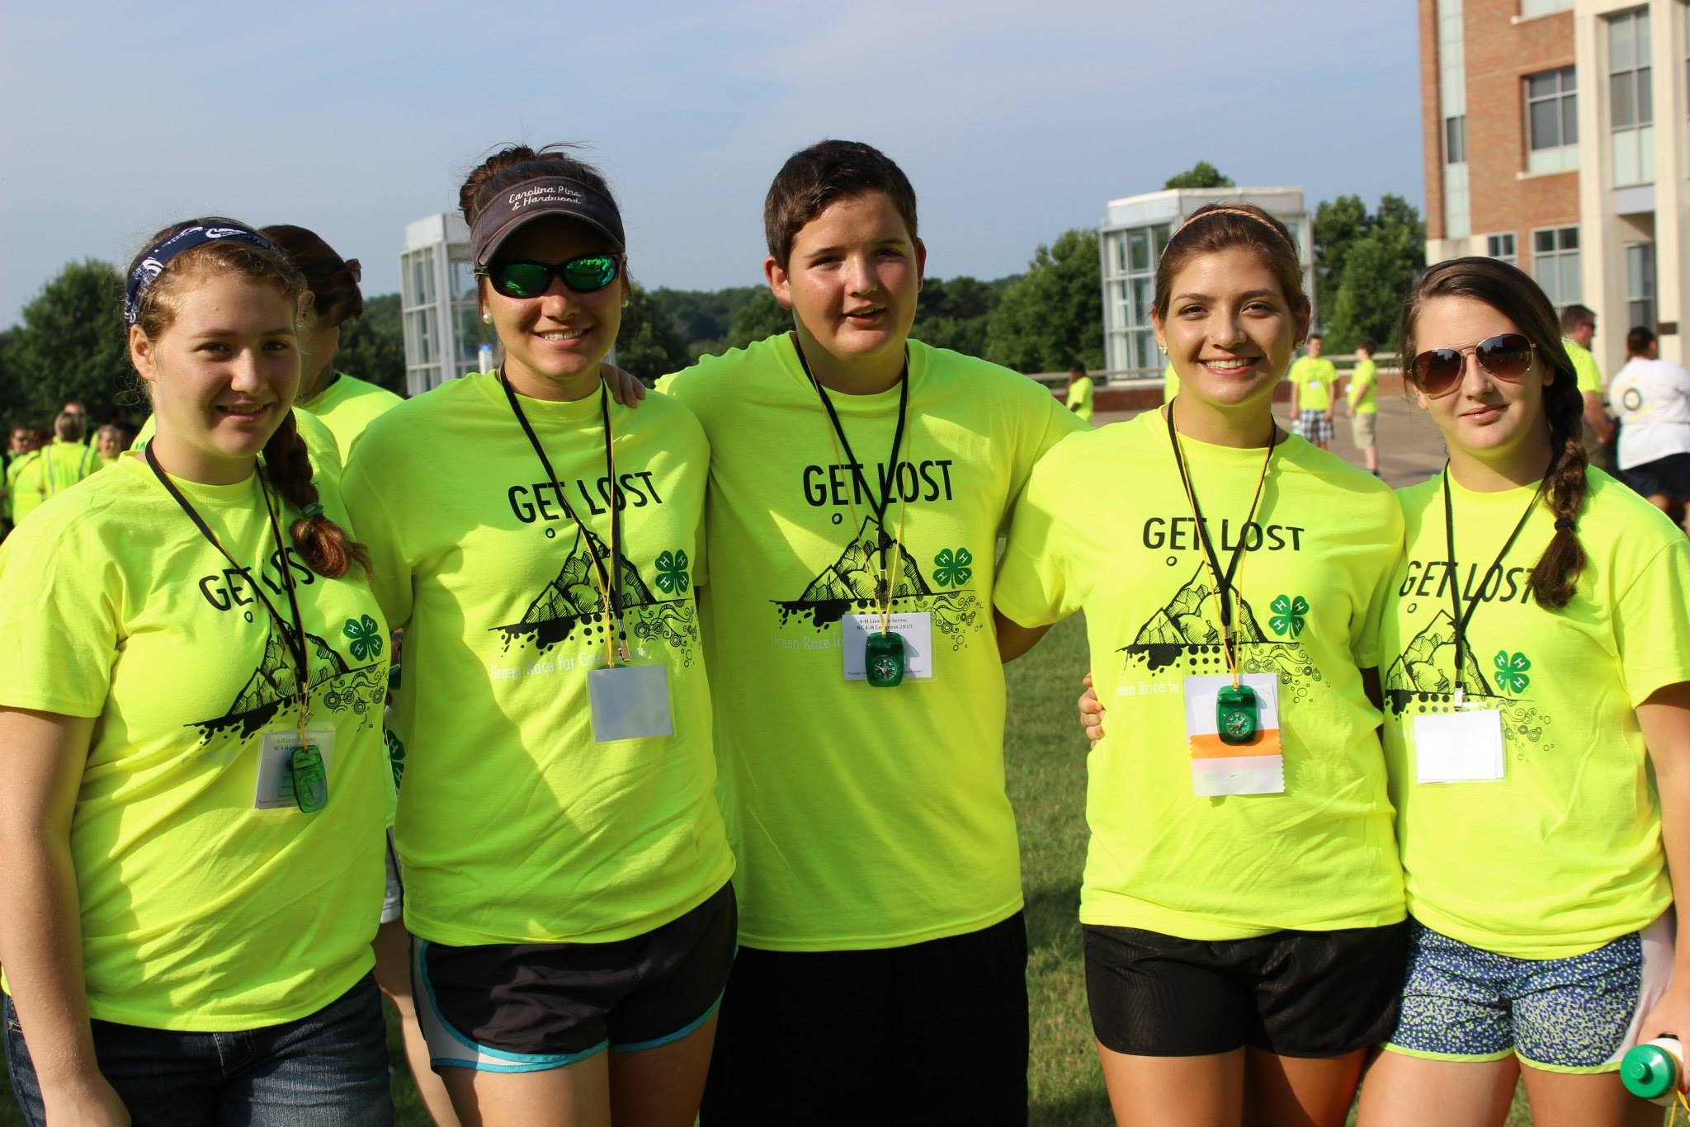
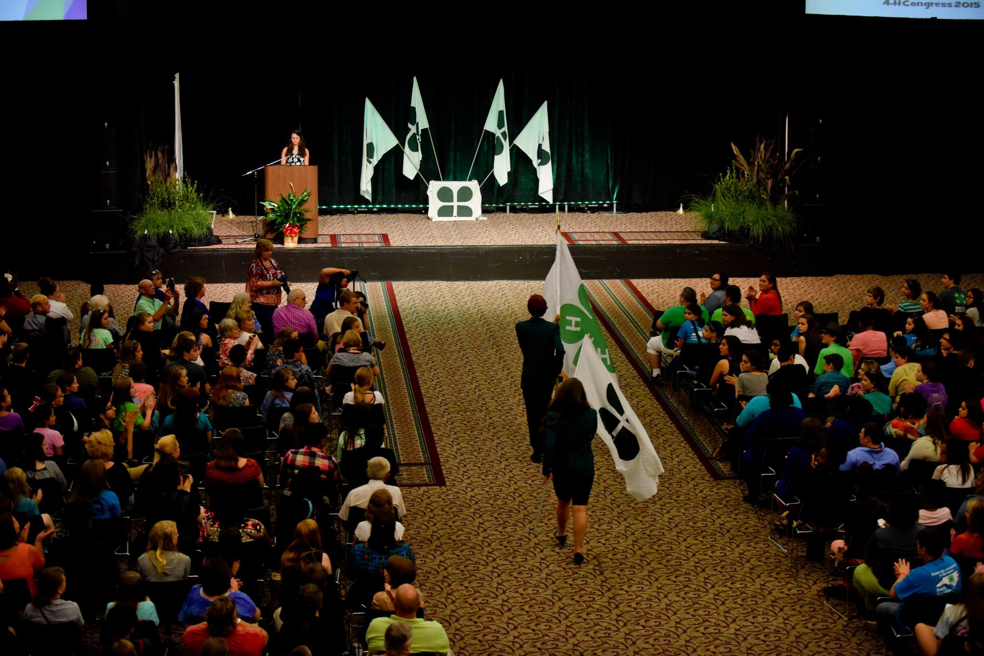
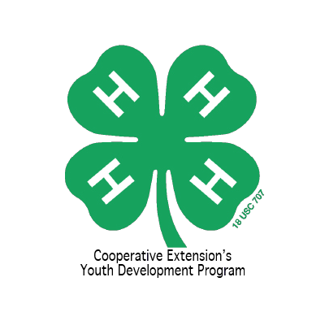

Event Highlights

- Leadership Workshops
- Dances
- Hands To Service Experience
- Downtime with Friends
- State 4-H Presentation Competition
- Candlelight Clover
- State 4-H Officer Elections
- Seeing Old Friends and Meeting New Ones
- Lots of Fun

Contact Information
For more information about NC 4-H Congress, including how to register please contact your 4-H Agent.
www.ces.ncsu.edu

