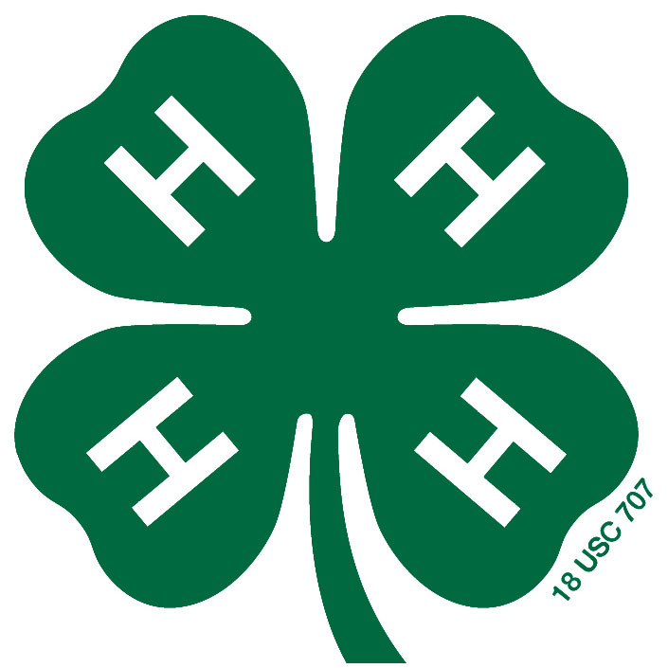
4-H STEM Fair
Registration Form
Science, Technology, Engineering, and Math
Tuesday, March 28th, 2017
Vernon James Center: Plymouth, NC
Name:
County: Phone:
Address:
Birth Date:
Age (As of January 1, 2017):
- $5 Registration Fee Attached?
Fee covers refreshments, awards, supplies, and facility charges!

Title of your project:

In 50 words or less please describe your project:

All registration forms and fees are due in the office
by March 20th!
Please make checks payable to: Washington County 4-H

STEM Fair Rules, forms, and more information can be found here:
https://washington.ces.ncsu.edu/stemfair/

*All youth who enter will be mailed a STEM Fair project workbook to guide their project!

