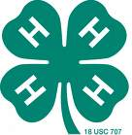 NC 4-H Evaluation Report
North Carolina 4-H Congress

Youth Grow Toward Healthy Life Skills

Context. Today’s youth face both risks and opportunities unprecedented in history. Youth activities out-of-school that involve learning, leadership, and service contribute significantly to school achievement and overall development. For many youth, community clubs and projects provide their primary support from unrelated adults, their introduction to a subject of interest that leads to a career, or their first opportunity to lead a peer group. Participation in community youth organization over several years is one of the best predictors of healthy development and preparation for adulthood. Unfortunately, these experiences are not available or limited in variety to many youth, especially during the summer months.
Response. 4-H Congress provides five-days of hands-on learning, leadership, and service experiences for youth, ages 9-19. Youth 13-19 years typically participate as part of a county delegation housed on NC State University campus. Younger 4-Hers whose special interest presentation or cookery is judged “best in district” commute to Raleigh with parents or adult volunteers to present at State Congress. In addition to healthy recreation and friendship building with peers from across the state, youth learn about leadership and teamwork, communication, and a variety of subjects from university faculty and local experts. Youth engage in a Town Hall discussion, community service projects, and elect organizational leaders. Special activities feature hands-on learning in one area related to the youth-selected theme. In 2006, “Healthy Lifestyle” theme activities included a 4-H fitness and exercise night at Dorton Arena on the NC State Fairgrounds.
Impact. 4-H Congress, July 17-21, 2006 on the NC State University campus, hosted 753 youth, 96 adult professionals and 42 adult volunteers from 85 counties. Two hundred youth presented demonstrations or illustrated talks from their research on subjects ranging from beef barbecue to computer technology. Five hundred teens contributed 4 hours each of community service in the Raleigh area, including the Healing Place of Wake County, UNC-TV, City of Raleigh Parks & Recreation, and Habitat for Humanity of Wake County. As a result of participating in 4-H Congress, 75% of youth delegates planned to become more involved in community leadership, 84% intended to become more involved in community service, 83% indicated plans to expand 4-H project learning. Youth volunteered doing various activities such as salvaging materials from homes, landscaping parks, cleaning facilities, serving lunch, compiling packages, and many other activates that fostered healthy development. According to teen participants, the conference reflected the highest standards of youth development programming through strong adult support, affirmation of youth from all backgrounds, and encouragement of responsibility and social action. Ninety-eight percent of participants affirmed that “serving others and volunteering was important” and 88% expanded their view of things beyond their own community.
Support. 4-H Congress 2006 was funded through NC 4-H Development Fund and user fees, with funding for awards and scholarships from several local and statewide contributors.

4-H Programs Create

a Climate for Positive Youth Development

Among those teens who attended 4-H Congress…

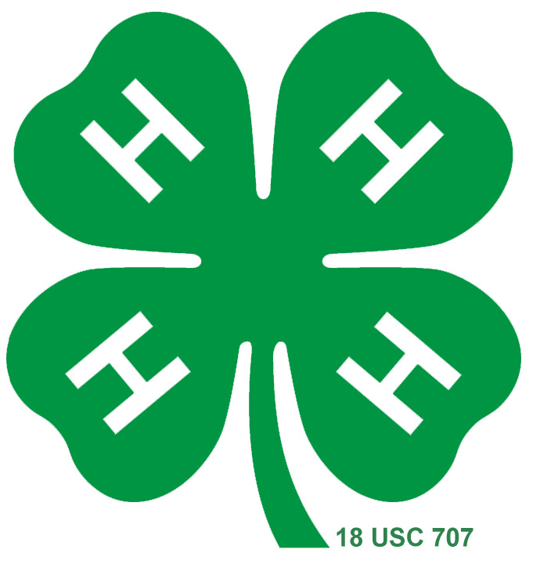
85% felt they could make a difference in the lives of others

94% said they learned to accept differences in others

98% of youth said serving others and volunteering was important

84% agreed that Congress activities were relevant to issues in their club, family, and community

88% expanded their view of opportunities beyond their hometown

80% felt motivated to seek greater knowledge of civic responsibilities

93% agreed that they had learned to work with others as a team

88% planned to attend Congress the next year

96% learned things that would help them do better in school

84% indicated that activities taught them to develop a plan to reach
their goals

100% of youth said they had fun

