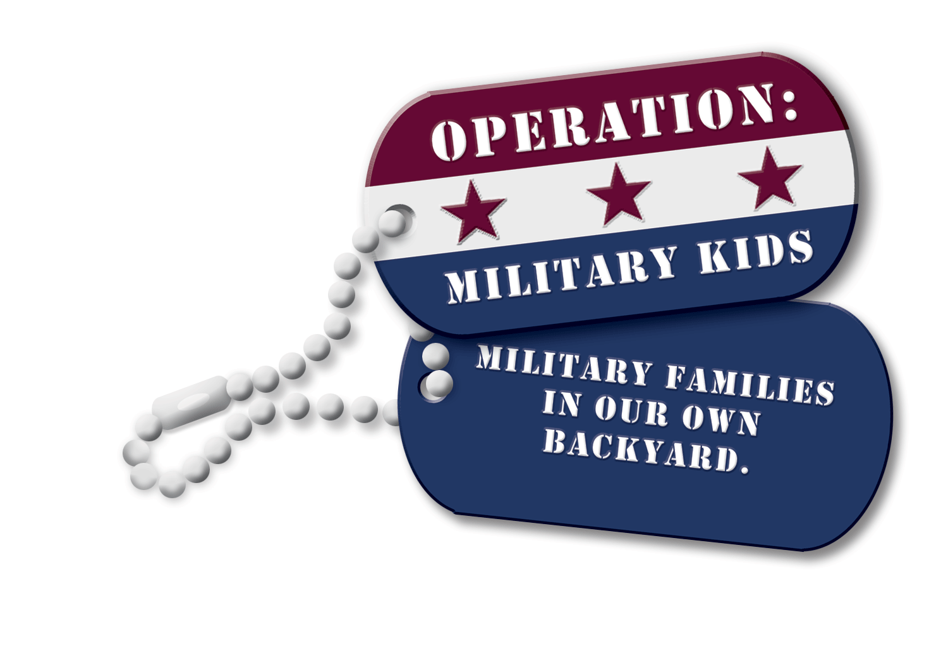

Operation: Military Kids (OMK) North Carolina
NC State University · NC Cooperative Extension Service ·
Department of Youth, Families, and Community Sciences ·
Campus Box 7606 · Raleigh, North Carolina 27695-7606 ·

Telephone: 919.515.8500 · Fax: 919.515.4241

Minutes from 15 January 2015 NC OMK State Team Face-to Face Meeting
Cumberland County Cooperative Extension Office – Fayetteville, NC
10:00a.m. to 2:00p.m.

Team Members Attending:
Linda Gore – Moore County 4-H Cathy Brown – Hoke County 4-H
Alice Dean – NC National Guard Family Programs Jackie Helton – Harnett County 4-H
Kimberly Webb – Army Reserves CYSS Danielle Peschon – Army Reserves CYSS
Barbara High Tyre – Educator/4-H Volunteer J. Scott Enroughty – NC OMK
Eleanore Getz – 4-H Master Volunteer/Military Spouse Dr. Harriett Edwards – NC OMK

Introductions of state team members.

North Carolina Operation: Military Kids would like to welcome our three new state team members:

Jackie Helton – Harnett County 4-H Agent
Cathy Brown – Hoke County 4-H Agent
Eleanore Getz – 4-H Master Volunteer/Military Spouse

Welcome to the team! We are excited to have you on board.

Partnership and Team Building Development:
Dr. Harriett Edwards conducted the Personality IQ and partnership strengthening to the OMK team. Exercise provided team members a better understanding of our strengths and weaknesses so we can be better develop strategies in organizing/planning events and teamwork.
Discussion of upcoming events:

Kimberly Webb & Danielle Peschon from Army Reserves CYSS:
- Family Programs outside of North Carolina
- Last week of Sunday, 22 February and Wednesday, 25 February (Financial Readiness) webinar (Danielle to send Scott info)

Alice Dean from NC National Guard Family Programs:
- Roll of pre-deployment event (Hickory)
- Catawba County 4-H provided Health Rocks; theatre events
- Yellow Ribbon event in Raleigh 17 January 2015
- Yellow Ribbon list
- 1200 to 1500 soldiers being deployed in the next few months
- Kristi has received Master Resilience Training and Alice will receive training end of March.
- Training 50 military teen in resilience 14 skills
- Dr. Edwards asked once training has been completed please let us know how we can help!
- 12-14 June in Raleigh State Volunteer Conference and Youth Symposium
- Found 50 Jr. Hero Packs and will give out during the remaining Yellow Ribbon
- Cathy Brown will announce at Agents meeting on 23 January to help collect items for the Hero Packs to provide to Alice.
- Tammy Fowler will handle Family Matters and posting to web/Facebook
- OMK State Team offered to help with State Volunteer Conference and Youth Symposium (teen aspect – Alice will be in contact with logistics) – Asked OMK to have vendor table.
- Happy about the partnership with Guilford County 4-H and utilizing the NCNG Teen Council.

Linda Gore from Moore County 4-H:
- Start working Celebration of Military Child will let us know of the weekend.
- This will be the 4th year Kiwanis plays a huge roll

Cathy Brown from Hoke County 4-H:
- Military families are joining Target Shooting Sports
- Cathy has asked that she attend and talk once a month to the Service Members at the Armory about 4-H opportunities around the state. Alice Dean will provide contact information to Cathy.

Jackie Helton from Harnett County 4-H:
- Tech Discovery Kit activities to be utilized in Harnett County for their military youth.
- Involved in horse clubs (sporadic attendance)
- Teen Court Program has a military teen participating as part of a youth peer and legal development course
- Child Care and School-Age conference (local) and discussing military opportunities and OMK.

Scott Enroughty from NC Operation: Military Kids:

Teen ADVANCE…A Leadership Workshop – 20-22 March 2015 at the Embassy Suites – Crabtree (Raleigh, NC). Recruiting teens (13-18 years old) who are participating in established teen councils or developing a teen council. Will receive leadership, communication, interview skills, team building and networking skills. Cost is $50/person. A minimum of 4 teens and 1 adult chaperone. Registration Deadline: 6 March 2015. Registration forms are located on www.nc4h.org/military

“Much Ado” Theatre Field Trip to Raleigh Little Theatre – 21 February 2015 (5:15p.m. until 10:30p.m.). Through fun theatre exercises, participants (Teens and Parents) will explore his/her own personal narrative about life, love, dreams, family, communication, separation from loved ones and their connection to home. Teens and Parents will learn staging, costumes, acting and set design as part of their hands-on exercises. Teens and Parents will enjoy dinner and then the play “Much Ado About Nothing”. Registration fee: $27 per Teen and $30 per Parent. Registration Deadline: 10 February 2015. Hotel rooms with the Holiday Inn Express – NC State are available. Reserve by 7 February 2015 to receive your special room rate. Use code “OMK”. Link to hotel can be found at www.nc4h.org/military

“A Day at the Theatre” – Raleigh Little Theatre - 18 April 2015 (12:30p.m. until 6:00p.m.). Military youth (ages 6-12) and their parents are invited to spend a magical day at Raleigh Little Theatre. Enjoy the production of one of the most exciting fairy tales of all time…Sleeping Beauty! Following the show, participants will meet the cast and ask questions about being an actor. Learn the exercises actors do to prepare for the stage and then bring a story to life with you as actors! Participants will then participate in a Stories Alive! workshop.
We will finish off the day at the theatre with dinner! Registration Fee: $19 per youth and $25 per parent. Registration Deadline: 10 April 2015. Registration forms are located on www.nc4h.org/military

“A Day of Musical Wonder for Military Families: Mozart’s Magnificent Voyage” – North Carolina Symphony, Raleigh, NC (12:00p.m. until 2:00p.m.). Designed for 4-12 year old military youth and their parents. Youth and parents will experience hands-on experience with instruments and working with musicians. Then enjoy a performance by the NC Symphony youth orchestra and the cast of “Mozart’s Magnificent Voyage”. Registration is $16 per person. NC OMK has received a generous discount to make tickets for this event affordable. Registration Deadline: 27 February 2015. Registration forms are located on www.nc4h.org/military

NCSU Military Partnership Inaugural “Red, White & Blue” 5K Run/Walk

The NC OMK State Team began to develop the Sponsorship Levels and benefits of sponsorship for the 6 June 2015 Inaugural “Red, White & Blue” 5K. Proceeds will support activities and events for military children and their families across North Carolina.

Finalizations of Sponsorship Levels are being worked on at this time. We hope to have the final Sponsorship Level ready by the end of January 2015. A form will be forward to each NC OMK State Team member.

We need your help to make this event a SUCCESS! Run, Cheer and Volunteer…is just a start. We need sponsorships, donations, volunteers, etc. from state team members, friends, family, colleagues and organizations.

Our goal is to make $10,000 from this 5K. We can do this with your help!

Your contribution on this community event ensures the opportunity to support activities and events for military children and their families offered through NCSU Military Partnership. Your donation will help provide educational, recreational hands-on opportunities for military children and families who experience any of the deployment cycles. Help bring communities and military families together who “live in our own backyard”.

Overall Benefits of Sponsorship:
- Your sponsorship will support the NCSU Military Partnership “Red, White & Blue” 5K Run/Walk
- Association with a 5K race that supports not only people in our community but also those who sacrifice their lives for our freedom.
- Participation in an event that creates community support networks of people, organizations, and other resources to support military youth “in our own backyard”.
- Opportunity to educate the public on the impact of deployment cycle on Service Members, families, dependents and the community as a whole.
- Unique ability to sponsor a race that celebrates the ability to provide support to over 120,000 military families across North Carolina with educational, social and recreational programs to build stronger family bonds.
- Participate in the education of the community to strengthen partnerships, increase awareness and support networks for military youth and their families.
- Support funding of programs in our communities that provide trainings and workshops on resiliency, life skills, leadership and educational opportunities before, during and after a loved ones deployment status.

Contact J. Scott Enroughty at scott_enroughty@ncsu.edu or 919.515.8500 for more information.

NC OMK State Team (in attendance) discussed, voted and passed to move from a conference call on 18 February 2015 to a face-to-face meeting in order to further plan, strategize and create member’s roles for the inaugural “Red, White & Blue” 5K.

