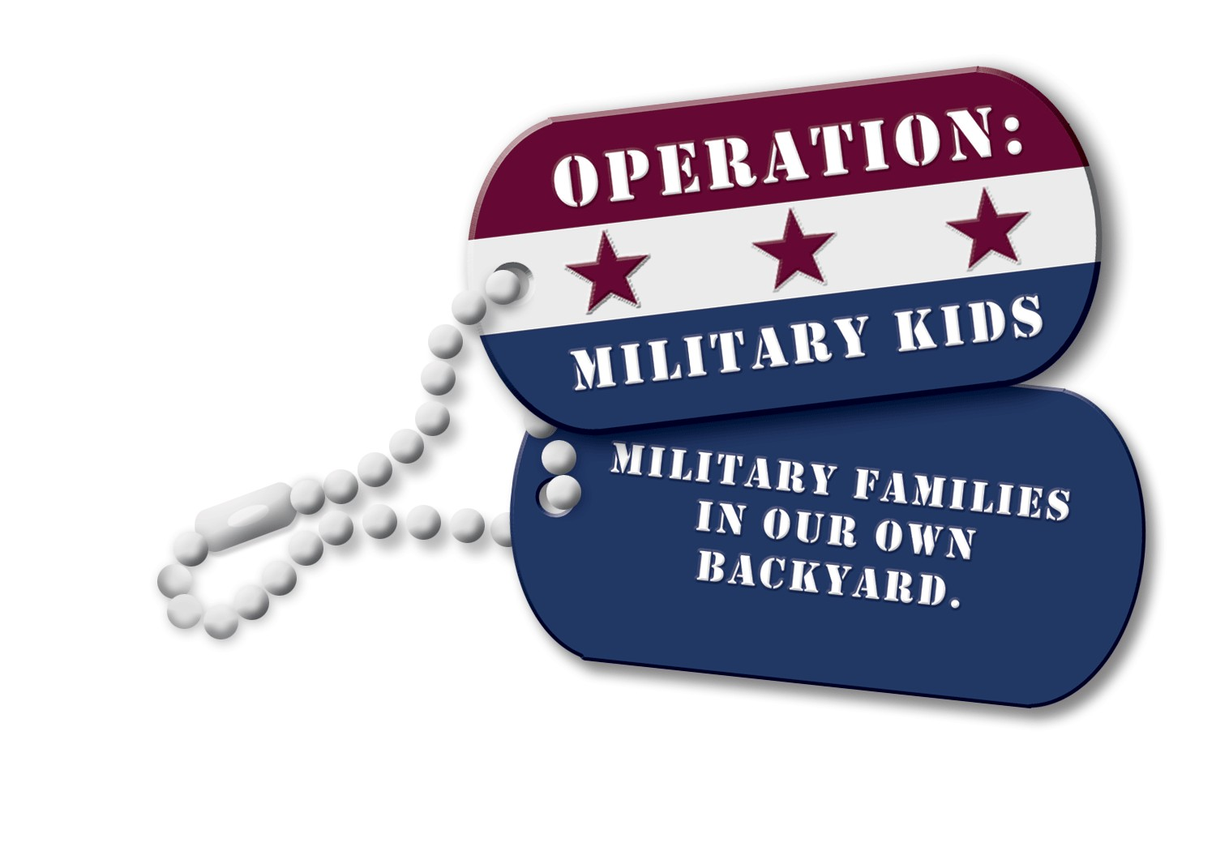
Yes, I accept the invitation to support the
NC 4-H Operation: Military Kids Hero Pack Program
through the NC 4-H Development Fund
NC State University College of Agriculture and Life Sciences
MY TOTAL GIFT AMOUNT WILL BE: (please check)
____$25 ____$50 ____$75 ____$100 ____$250 ____$500 ____$1,000 $_______(other)

- A check for the total amount of $_______ is enclosed.

- I would like to charge my entire gift amount.

Card Type: Visa____ Mastercard____ American Express ____ Discover ____
Name on Card _________________________ Card Number _____________________________

Expiration Date ___________________

Signature_______________________________________Date___________________
My/our gift commitment will be fulfilled in the following manner:
Total pledge of $__________ to be paid over __________ years (not to exceed five) as follows:
First payment of $_________ enclosed__ OR to be made on or about ______________ (date).

Remaining pledge payments to be made on the following schedule:
___ monthly, beginning on _______________ (date).
(Payroll or Bank Draft Deductions – complete the appropriate form.)
___ quarterly, beginning on _______________ (date).
___ semi-annually, beginning on ______________ (date).
___ annually, beginning on _______________(date).
___ other ___________________
Note: Credit card gifts may be made at http://www.cals.ncsu.edu/givenow. Just type a word from the account’s name in the searchbox or select the appropriate department’s checkbox.

A pledge reminder will be sent to you prior to each pledge payment date.

_____ My company/spouse’s company will match my personal gift.
Company Name: _____________________________________________
_____ For gift recognition purposes, please list my/our name as indicated below:
_____________________________________________________________________________________
Print Name: _______________________Signature: _________________________Date: ______
Address: _____________________________________________________________
Phone: __________________________________Email: ________________________________
City: _________________________________ State: _________ Zip: _________

CONTRIBUTIONS ARE TAX DEDUCTIBLE
Please make checks payable to the NC 4-H Development Fund: tax ID #56-6049304
Mailto: North Carolina Operation: Military Kids, NC State, Campus Box 7606, Raleigh, NC 27695-7606
(You will receive an official receipt for your contribution and a pledge reminder if you choose that option.)
If you have any questions or require additional information, please call Scott Enroughty at (919.515.8500) or email scott_enroughty@ncsu.edu

