

North Carolina Supports our Military Children
Month of the Military Child – April

Since 1986, April has been designated as the Month of the Military Child to recognize the important role that military children play in the armed forces community. The special recognition the Department of Defense has given to military children. It is a time to applaud America’s youngest heroes and thank them for the sacrifices they make in courageous support of their military parents.

North Carolina’s Operation:Military Kids (OMK) program is excited to continue the tradition in celebrating our youngest heroes during this time. Listed below are several ideas in which your county program may implement by honoring our military youth during April’s MOMC celebrations.

• Announcement and support of MOMC in the faith-based organization bulletin

• MOMC Parade
(Plan a parade in your hometown to celebrate and honor the military youth)

• Local Businesses Salutes/Honors MOMC
(Encourage local business to hang banners, signs, etc. in support of MOMC)

• School’s Salute/Honor MOMC
(Collaborate with elementary, middle and high schools to honor/celebrate MOMC)

• Spring Family Day
(Cookout and all the trimmings, games, exhibits, rock climbing wall, etc.)

• Pajama Movie Night
(Hold a lock-in with movies, popcorn, soda and more! In between movies, have hands-on
crafts and games)

• Outdoor Movie Night
(Host an Outdoor Movie Night, with games & prizes, hot dogs & hamburgers, etc.)

• Craft & Art Workshop
(Collaborate with local craft stores, hobby shops and etc. where youth can create arts and crafts
for their soldier. Encourage them to submit their craft in the local county fair)
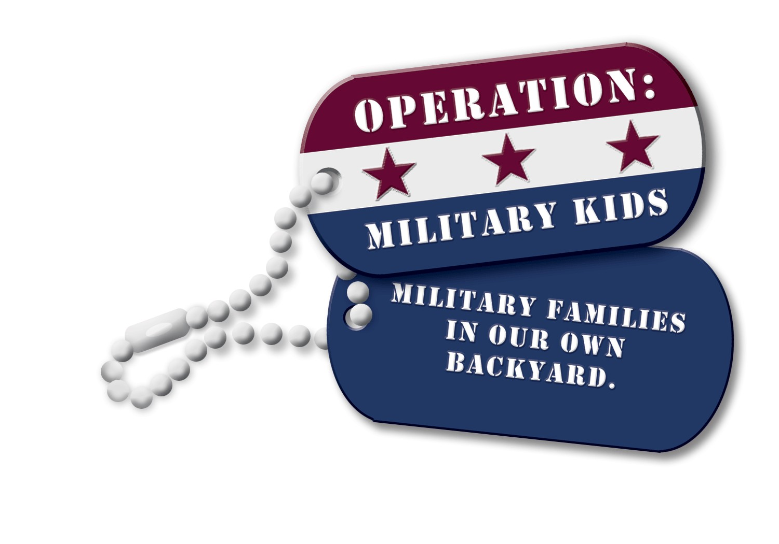
• Local Festivals
(Celebrate during local festivals – float in the parade, honor them as grand marshal’s, proclamation of MOMC on stage)

• Partner with local Library
(Showcase books on military heroes, schedule a reading of local author and/or
service member)

• Under the Same Stars
(Collaborate with local planetarium to host Under the Same Stars night where
military youth experience the same night sky as their deployed loved one)

• Field Day
(Conduct a field day full of fun and challenging games and obstacle courses, award
ribbons/prizes.)

• Military Child Fashion Show
(Kids can model on clothes or have a local mall donate clothes; could hold event at local mall,
armory, extension office or school; include display/model of uniform pieces, history of military
uniforms and include a USO type show/entertainment/performance)

• Arbor Day – tree celebration
(Have trees planted in honor of military youth and/or have military youth plant tree in
honor of their service member)

• Gaming (Video) Night/Contest
(Using age-appropriate, rate E for everyone video games, example Wii games)

• Board Game Night/Marathon/Contest
(Bring back the good ol’ days with Monopoly, Scrabble, Trivial Pursuit, Checkers, Cranium, Jenga,
Pictionary, Sorry!, and etc.)

• Plan a field trip
(Plan a day at the NC Zoo, Planetarium, local museum, picnic at the park, etc.)

• Talent/USO Variety Show
(Host a talent show where military youth can perform; have 4-H members emcee and conduct
as a USO variety…look out Bob Hope!)

• Local paper coverage
(Contact the local paper to do a feature story on MOMC and those in the area, collaborate with the
guard/reserve armory’s in the county to connect with military family)

• Proclamation
(Have your community, city, and/or county officials declare a proclamation for Month of the
Military Child to celebrate and honor the military youth in your area)

Contact your local commissioners, mayor, city council, businesses, schools, faith-based organizations, fire/sheriff/police departments and other civic organizations to plan and salute our military youth during a MOMC celebration event.

Check out the website link below for additional projects and activities:
http://www.monthofthemilitarychild.com/projects/index.html

Month of the Military Child… A Proclamation
April 2013
Use the sample text below to create your own proclamation for Month of the Military Child 2013.

Sample Proclamation #1

WHEREAS, (insert your community’s name) is a community in which (insert number of military youth in your community) make their home; and

WHEREAS, military youth in (insert your community’s name) and throughout the nation are an increasing population with evolving needs; and

WHEREAS, military youth are valuable members of our society who enhance our communities and personal lives; and

WHEREAS, our military youth of today and tomorrow promise to be among the most active and involved populations in our nation’s history; and

WHEREAS, it is the responsibility of this and all U.S. communities to work collaboratively to address military youth’s unique experiences and long-term care challenges; and

WHEREAS, it is crucial that communities step forward to support military youth and provide them resources and support mechanisms for a healthy life; and

NOW THEREFORE, (I/WE) of (City/Town) (State) do hereby proclaim April 2013 to be Month of the Military Child. (I/WE) urge everyone to take time this April to honor our military youth and their family members who care for them. Our efforts can improve the lives of our military youth and help pave the way for future generations.

Dated this _______ day of (Month) 2013

(Name of body approving proclamation)
By __________________

Sample Proclamation #2

Whereas, thousands of brave Americans have demonstrated their courage and commitment to freedom by serving the armed forces of the United States of America in active duty posts around the world; and,

Whereas, more than 40 percent of these military service members have left families with children behind; and,

Whereas, more than one million of America’s children have at least one parent currently serving active military duty; and,

Whereas, these children are a source of pride and honor to us all, and it is our duty to take time to recognize their contributions, celebrate their spirit, and let our men and women in uniform know that while they’re taking care of us, we’re taking care of their children; and,

Whereas, the recognition of the “Month of the Military Child” will allow us to pay tribute to military children for their commitment, their struggles and their unconditional support of our troops, because when parents serve in the military, their kids serve too; and,

Resolved, that the (insert your community’s name) does hereby proclaim April 2013, as The Month of the Military Child in (insert your community’s name) and gives support to activities that honor, support and thank military children.

Dated this ____ day of (Month), 2013

__________________________
(Name of body approving proclamation)

Sample Proclamation #3

WHEREAS, thousands of brave Americans have demonstrated their courage and commitment to freedom by serving the armed forces of the United States of America in active duty posts in Afghanistan, Iraq, and around the world; and

WHEREAS, more than forty percent of these soldiers, sailors, airmen, and Marines have left families with children behind; and

WHEREAS, more than one million of America’s children have at least one parent currently serving active military duty; and

WHEREAS, these children are a source of pride and honor to us all, and it is only fitting that we take time to recognize their contributions, celebrate their spirit, and let our men and women in uniform know that while they’re taking care of us, we’re taking care of their children; and

WHEREAS, the recognition of a Month of the Military Child will allow us to pay tribute to military children for their commitment, their struggles, and their unconditional support of our troops – because when parents serve in the military, their children also serve; and

WHEREAS, a month – long salute military children will encourage support for Kids Serve Too and other organizations and campaigns established to provide direct support to military children and families;

NOW, THEREFORE, I, (insert officials’ name, and title), do hereby proclaim the month of April 2013, to be

THE MONTH OF THE MILITARY CHILD

in (insert your community’s name).

Dated this ____ day of (Month), 2013

__________________________
(Name of body approving proclamation)

