**Gates County 4-H**

**Registration Form**

**Child’s Name**_________________________________________

***(Please Print)***

**Address**__________________________________________________

**Phone #**____________________**Home** __________________**Cell**

**Date of Birth**_________________ **Age**_________ **Grade**______

**Race**__________________________ **Gender** **M F**

**Email Address**_________________________________________

**Parent’s Name** ________________________________________

***(Please Print)***

**Parent’s Signature _____________________________________**

**Please circle dates youth will attend**

**January 19th- $20.00**

**Arts & Crafts with Kristi Groves**

**January 20th- $20.00**

**Roanoke Rapids Hydro Plant, Roanoke Rapids Va**

**Make checks payable to:**  Gates County 4-H

**Mail or Bring to:** Gates County Extension Service

P.O. Box 46

112 Court Street

Gatesville, NC 27938

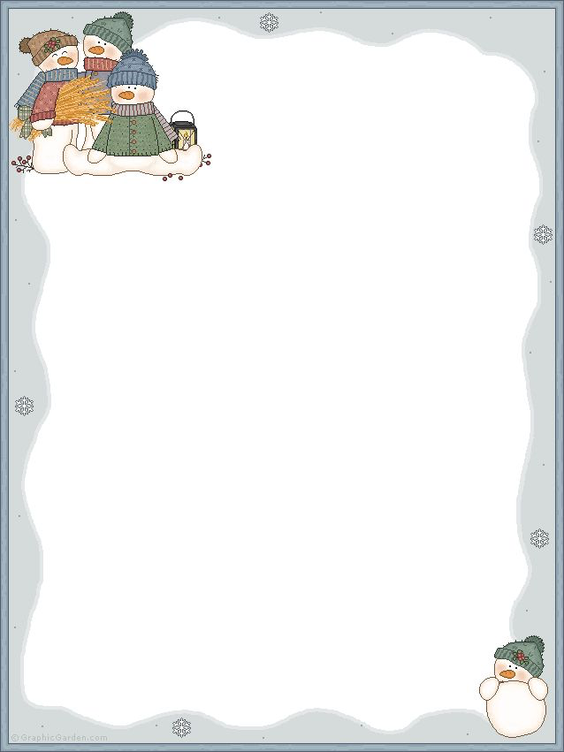 **PAINTING PARTY WITH**

**GATES COUNTY4-H**

**Who: K- 6th graders**

**What: January 19th- $20.00**

**Arts & Crafts**

**January 20th- $20.00**

**Roanoke Rapids Hydro Plant**

**When: January 19th and 20th**

**Where: Gates County Community Center**

**Cost: $20.00 per person**

**Please provide your child with a lunch. All money and registration forms are due to the office by January 14, 2016. Must have a minimum of 10 youth for workshops**

**Space is limited!**

**Contact**

**Keli Boone, 4-H Agent**

**252-357-1400**

[**keli_boone@ncsu.edu**](mailto:keli_boone@ncsu.edu)

[**https://gates.ces.ncsu.edu**](https://gaes.ces.ncsu.edu)

**Facebook: Gates County 4-H**

