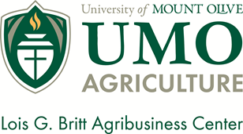
The Young Farmers & Ranchers of Catawba County Farm Bureau, and
The University of Mount Olive Agribusiness Center present
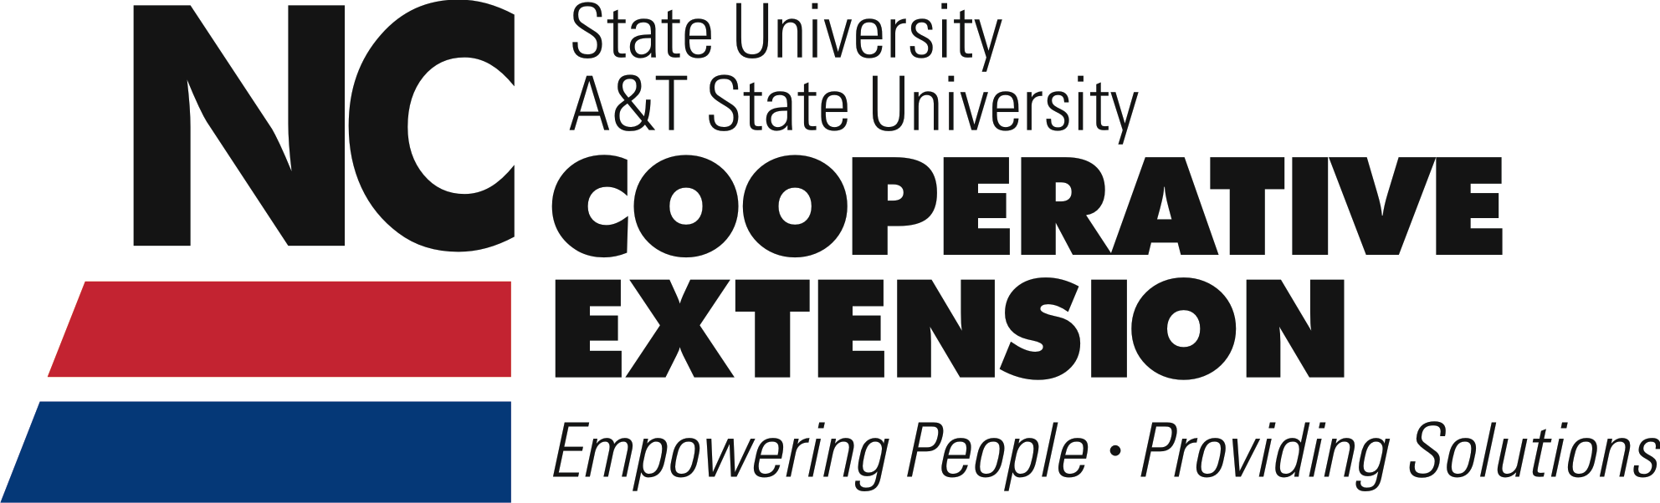
Keeping Farmland Productive and Families Together!!!
3:30 p.m. Registration and Visit Exhibitors

4:00 p.m. Estate Planning, Step-by-Step
Dr. Sandy Maddox, University of Mount Olive

4:30 p.m. Taxes and Estate Planning
Guido van der Hoeven, NC State University Extension

5:15 p .m. Planning the Future of Your Farm: The Legal Architecture
Andrew Branan, Attorney – Branan Law Firm, PLLC

6:00 p.m. Meal catered by BoxCar Grille

6:30 p.m. Connecting Farmland with Farmers
Suzanna Denison, WNC FarmLink

7:00 p.m. Maintaining PUV Taxation on Farmland and Forestland
Micheal Brown & Tony Simpson, NC Dept. of Revenue

7:50 p.m. Financial Planning Services offered by NC Farm Bureau
NC Farm Bureau

Monday, February 1st, 2016
3:30 – 8:30 p.m.
Newton Expo Center (Pin Station)

Farmland Preservation Workshop for
Beginning and Retiring Farmers
Required RSVP to 828.464.2806 or mary.houston@ncfbssc.com by January 25th

