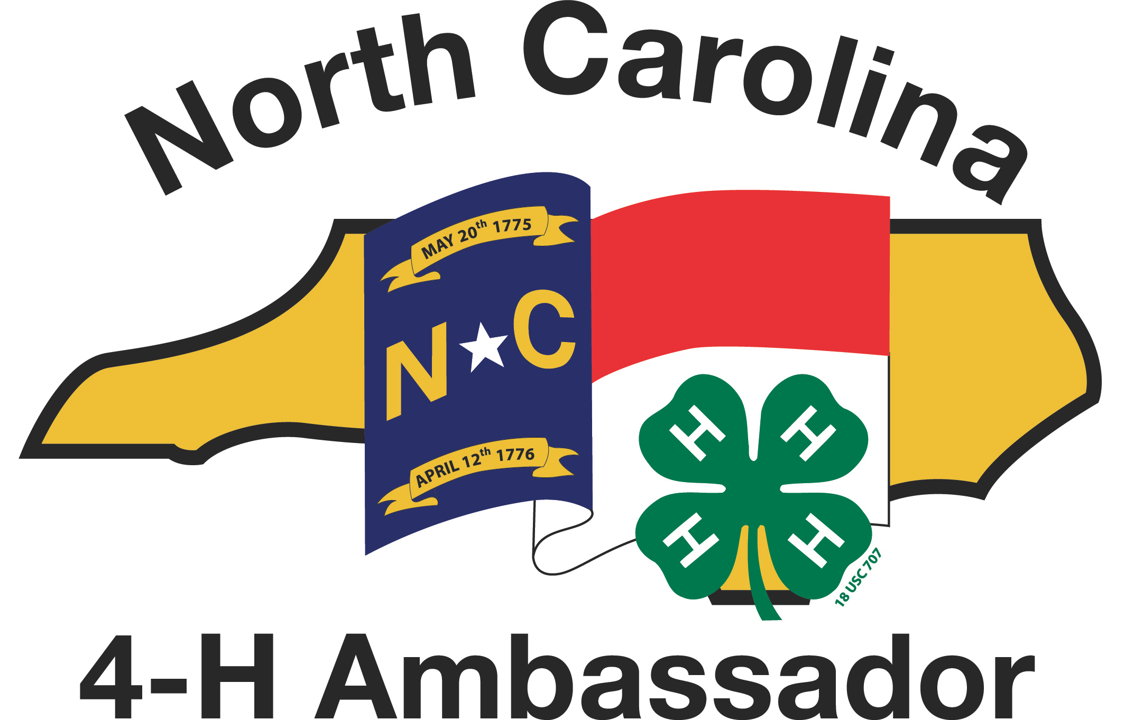
Building Your Ambassador Portfolio

To celebrate your achievements as a NC 4-H Ambassador candidate, you will want to save examples of what you have learned and what you have done in a personal Portfolio.

The portfolio is NOT just a scrapbook – you don’t put everything in it. Instead, you will document your experiences with examples of your best work at each level of achievement.

Assemble your portfolio in a three-ring binder with the following sections:
- About Me! –Write a short introduction of yourself, your family, what you like to do, subjects you enjoy, and what you do as a 4-H member. Be as creative as you like, but do not exceed 3 pages. (One page is fine too!) Include at least one photo of you.
- Bronze Level:
a. Required curricula:

    - Introduction to the Ambassador Program
    - Fundamentals of 4-H Youth Development
    - Public Speaking Basics
    - Parliamentary Procedure
    - Professional & Flag Etiquette

b. Elective Activities
    - At least 2 activities totaling 15 hours of active engagement
- Silver Level:
a. Required curricula:

    - Introduction to Life Skills
    - Teaching & Learning I: Experiential Learning
    - Advanced Public Speaking
    - Leadership I: What is a Leader?
    - Marketing I: Media Relations

b. Elective Activities
    - At least 2 activities totaling 25 hours of active engagement
- Gold Level
a. Required curricula:

    - Youth/Adult Partnerships I: Tic-TAP-Toe
    - Teaching & Learning II: Learning Styles
    - Leadership II: T.E.A.M
    - Marketing II: Donors & Elected Officials
    - Diversity & Inclusion

b. Elective Activities
    - At least 2 activities totaling 35 hours of active engagement
- Emerald Level
a. Required curricula:

    - Youth/Adult Partnerships II
    - Teaching & Learning III – Teaching Practicum – teach one bronze and one silver class
    - Leadership III: The Role of Ethics
    - Marketing Practicum Project

b. Elective Activities
    - At least 2 activities totaling 45 hours of active engagement

EACH LEVEL WILL INCLUDE:
  - For each required curricula:
    - 1 Required Curriculum Report Form (2 sided)
    - Worksheets, certificates, agendas or other items documenting that experience
  - For each elective activity or curricula:
    - 1 Elective Report Form (2 Sided)
    - Worksheets, agendas, programs, pictures documenting that experience.
  - For example, you might have an Required Curriculum report form for “Parliamentary Procedure”, followed by handouts from that workshop at Ambassador Conference, or you might have an Elective Report form for “Planned the 4-H Stay Fit Workshop,” followed by a program from the day, and a photo of you leading exercises at that workshop.
INSERT AN AMBASSADOR ASSESSMENT FORM in the front of your Portfolio, and be sure to get the signature of your County 4-H Agent or appropriate County 4-H Professional.

