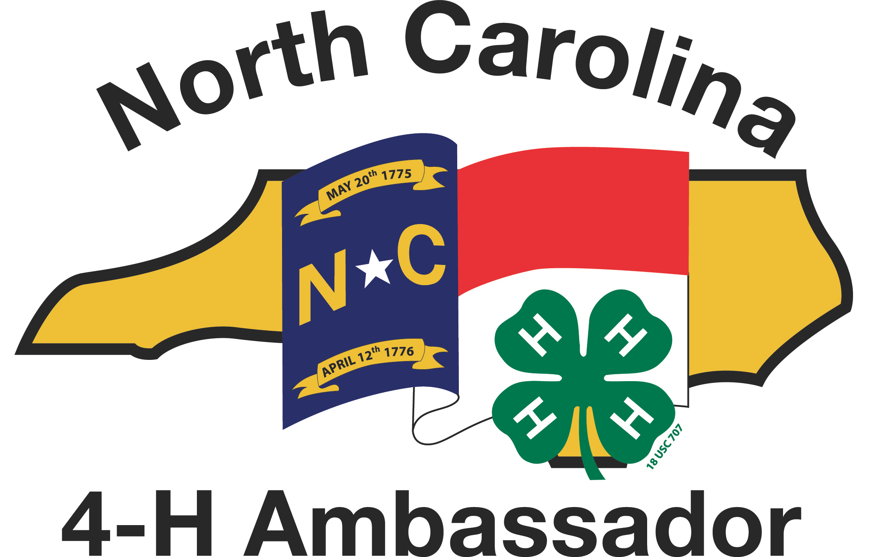
Elective Activity Report Form

Please answer all the questions documenting the specific activity you have completed. Please write neatly and legibly in ink, or type your answers on a computer.

Elective Achievement Report

Name: ___________________________________________ County: _______________________
Ambassador Level (level you are seeking):  Bronze  Silver  Gold  Emerald

Title of Activity/Service: ___________________________________________________________

Date(s): _________________________________ Total Hours for this Activity:_________

In about 100 words, summarize what you did to achieve this elective:
(Include information about leadership roles, results of events, audiences reached, etc. as appropriate.)

Attach any handouts, program, or other information reflecting your activity to this form.
(Over)
Reflection

Share your thoughts, attitudes, and aspirations regarding the elective project you just completed. Feel free to be honest, frank and candid about your feelings; these are your personal thoughts and opinions and no one will hold them against you. Feel free to be as creative as you like if you want to write a poem, draw a picture, create a collage, etc. to support your reflections. Lastly – please complete your reflection with thoughtful and meaningful complete comments. They should be a good paragraph for each section/question if not more. (You may add additional pages if you wish)

You may answer the questions individually, or create a “story” or narrative that includes these ideas in one longer piece of writing.

What new ideas and insights did you learn from this project? Explain.

What did you enjoy most and least about this activity? Why?

How did your experiences as a 4-H Ambassador or Ambassador Candidate help you complete this activity?

How did you work with others, including 4-H volunteers or 4-H professionals, in completing this activity?

How will you use your experiences in this curriculum in your 4-H work? as a 4-H Ambassador? in your school life? in your community?

