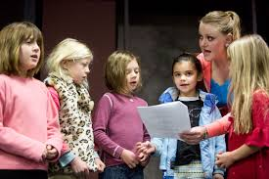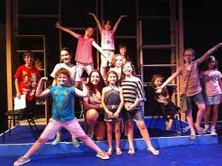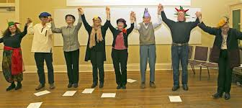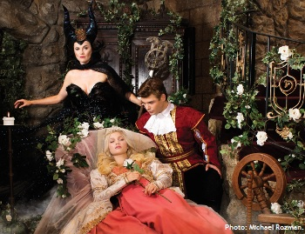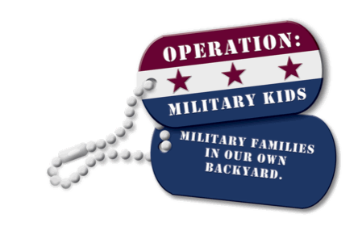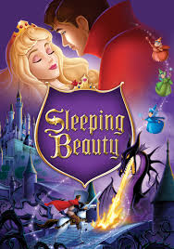

***Military youth (ages 6-12) and their parents are invited to spend a magical day at Raleigh Little Theatre.***

***Enjoy the production of one of the most exciting fairy tales of all time…Sleeping Beauty! Following the show, participants will meet the cast and ask questions about being an actor.***

***Learn the exercises actors do to prepare for the stage and then bring a story to life with you as actors! Participants will then participate in a Stories Alive! workshop.***

***We will finish off the day at the theatre with dinner!***

**WHO:** Military youth 6-12 year olds and their Parents.

**WHERE:** 301 Pogue Street, Raleigh, NC 27607

**WHEN:** Saturday, 18 April 2015

**TIME:** *Check-in*: 12:30 p.m.; *Event:* 1:00 p.m. to 6:00 p.m.

**REGISTRATION FEE:** $19 per Youth (6-12 year olds) and $25 per Parent

**DEADLINE: 10 April 2015 *(SPACE IS LIMITED)***

Download registration form at: www.nc4h.org/military

**OR** [http://go.ncsu.edu/SleepingBeauty](http://go.ncsu.edu/americanindianhertigageday2014" \o "http://go.ncsu.edu/americanindianhertigageday2014 opens in a new window targeting https://www.operationmilitarykids.org/public/statePOCHome.aspx?state=North%20Carolina" \t "_blank)

Hotel rooms with the [Holiday Inn Express – NC State](http://www.hiexpress.com/hotels/us/en/raleigh/rdugs/hoteldetail?qAdlt=1&qBrs=6c.hi.ex.rs.ic.cp.in.sb.cw.cv.ul.vn&qChld=0&qFRA=1&qGRM=0&qGrpCd=OMK&qPSt=0&qRRSrt=rt&qRef=df&qRms=1&qRpn=1&qRpp=12&qSHp=1&qSmP=3&qSrt=sBR&qWch=0&srb_u=1&icdv=99801505&icdv=99801505) are available. Reserve by 2 April 2015 to receive your special room rate. Use code OM1. Link to hotel can be found at <http://www.nc4h.org/military>

*Submit registrations and payment to*: North Carolina Operation: Military Kids (NC OMK)

*Registration and supporting documents are required.*

# Contact:

# J. Scott Enroughty

# Box 7606, NC State University

# Raleigh, NC 27695-7606

# scott\_enroughty@ncsu.edu

Raleigh Little Theatre •  Raleigh, NC •  Saturday, 18 April 2015

A DAY AT THE THEATRE

**