

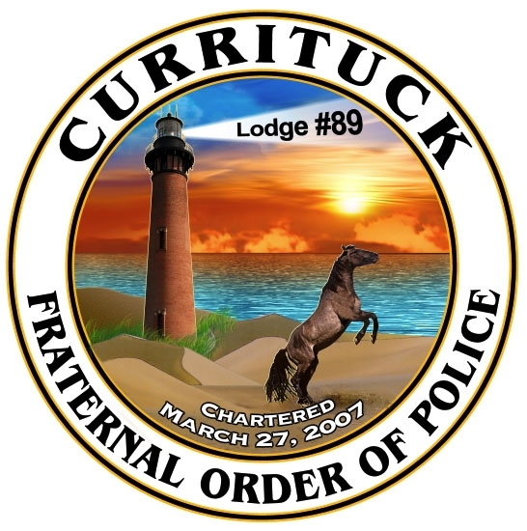

IT’S TIME TO PLAN FOR THE 23rd ANNUAL CHRISTMAS PARADE
DECEMBER 4, 2015

“Currituck’s Night of Twinkling Lights”

The Currituck County Fraternal Order of Police Lodge # 89, in conjunction with the Currituck County Extension are working on plans for the 2015 Parade which will take place on Friday, December 4 th at 7:00 pm. {If inclement weather occurs event will not be rescheduled}

We cordially invite you to participate in this year’s event and have enclosed an entry form and copy of our rules for entering. This years’ theme is “Currituck’s Night of Twinkling Lights”. All floats or vehicles must display lights. This year categories include: Most Creative, Most Custom/Original and Best of Show/ Overall. Trophies will be awarded for each category with an award for the Grand Prize entry. Please make an effort to reflect the theme and avoid commercial advertising.

Please note that there will be a $20.00 fee per entry that wishes to be judged. All others not wishing to be judged will not be responsible for any fee. The fee will be to help defray some of the expenses connected with the parade.

Please return the entry form to: CHRISTMAS PARADE
Currituck County FOP Lodge # 89
P.O. Box 237
Barco, NC 27917

The deadline for entries is Tuesday, November 24, 2015. Please return your signed liability release and the $20.00 entry fee as soon as possible to allow time for processing. Please make your checks payable to the Currituck County FOP Lodge # 89.

Contact James Midgett at 252-453-2670 Ext 4114 or email james.midgett@currituckcountync.gov or Sheila Gregory at 252-232-2262 or email sheila_gregory@ncsu.edu if you have any questions. We hope you will join us in making it a truly memorable and joyful holiday season in Currituck County.

Thank you,

Sheila Gregory, FCS Program Assistant
and Detective James Midgett
Rules and Regulations
- Throwing of candy or any objects from parade entrants on moving vehicles will not be allowed. Participants are however, allowed to pass out candy.

- If being judged, entries must follow the theme of the parade with decorations and dress of the participants.

- Judging will take place along the parade route. In order to be recognized, you must have your assigned entry number posted on the upper right hand side of the windshield or front passenger’s side fender. Your official Parade Number will be provided to you upon receipt of payment. The number must be visible from a distance. If the number is not visible, the entry will not be recognized or judged.

- There will be 3 categories for judging. Each category will be awarded a trophy. The categories are as follows:

- Most Creative
- Most Custom
- Best of Show

