To: Area Cattle Producers
From: Stefani Garbacik
Livestock Extension Agent, Wayne County
Re: Bull Breeding Soundness Exam Day—September 25th, 2015
8:00 am-until finished

Wayne County Cooperative Extension, with the help of Duplin County Cooperative Extension, will host a Bull Breeding Soundness Exam Day on Friday, September 25th beginning at 8:00 am. There will be scheduled appointment times to bring your bulls to the Duplin Livestock Facility. Be sure to take advantage of this great opportunity to ensure your bulls are ready to do their job!
Bulls will be evaluated for the following:
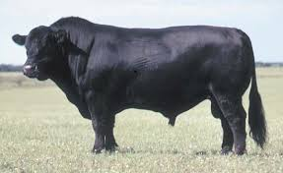
  - Physical examination of the animal
  - Examination of reproductive organs
  - Measurement of scrotal size
  - Evaluation of semen
Dr. Brad Heins, D.V.M., will conduct the evaluations at the cost of $40/bull at the Duplin Livestock Facility located at 275 Fairgrounds Dr., Kenansville, NC 28349.
REGISTER BY SEPTEMBER 22nd!!!
Please call the Wayne County Cooperative Extension office at (919) 731-1525 with the number of bulls that you plan to bring so that we can schedule times to bring them.

