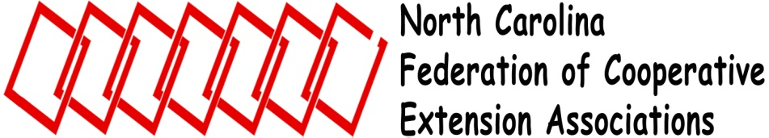

NCFCEA Spring Board Meeting
Wednesday, June 6, 2012
2:00 p.m.

Sign into Blackboard Collaborate

Welcome Eleanor Summers, President

Call to Order/Introductions

Determine Quorum (one representative from each association)

Approval of Agenda

Approval of September, 2011 Board Minutes Donna Holland, Secretary

Treasurer’s Report Linda Gore, Treasurer

Association Reports Association President/Vice President
(3 minutes; give membership totals; full typed copy to secretary
NCCESA _____ NCACES _____
NCEAFCS _____ NCACAA _____
NCAE4-HA _____ ESP/XI _____
NCAEAPAAT _____

Administrative Update Dr. Joe Zublena
Associate Dean, CALS and Director
NC Cooperative Extension Service Extension Administration

Unfinished Business Eleanor Summers
2011 Federation Forum Review
Board Duties and Responsibilities
Officer Rotation
2011 Extension Federation Goals Review Becky Miller, Past President

New Business
NCFCEA Website Transition-Google Sites Will Strader, Webmaster
2012 Horn of Plenty Eleanor Summers
Epsilon Sigma Phi, XI Chapter Integration
Constitution and Bylaws Revisions
Emerging Issues/Assessment for Extension Federation
Concerns of Associations
2012 Goals for Extension Federation/Forum
Fall 2012 Board Meeting Date

Miscellaneous Business/Announcements/Adjourn Eleanor Summers

