2015 JONES COUNTY
4-H SUMMER ADVENTURES

Jones County 4-H, 252-448-9621, 367-A Highway 58 South, Trenton, NC 28585

All programs will be held at the Jones County Extension Center unless otherwise noted.
STEM – June 15th-18th
(10am-12noon / Ages: K-6 / Class Limit: 20 / Cost: $5)

STEM stands for Science, Technology, Engineering, Math, and involves the integration of those disciplines into our daily life. STEM careers include engineers, health care professionals, scientists, architects, computer programmers and many more! Students will participate in hands on activities that allow them to understand how STEM integrates into their daily lives.

Dig It! – The Secrets of Soil – June 19th
(8am-5:30pm / Ages: 8 & up / Class Limit: 10 / Cost: $5)
Join us as we travel to the NC Natural Science Museum located in Raleigh, NC. We will get to explore the museum as well as the “Dig It! The Secrets of Soil” exhibit. This interactive exhibit allows youth to learn the ins and outs of soil. Youth will need to bring a bag lunch and wear good walking shoes.

Cloverbud Beading Basics – June 22nd
(1pm–4pm / Ages: 5-8 / Class Limit: 20 / Cost: $5)
Youth will learn the basics of beading and jewelry making, get inspiration from a variety of sources, and craft their own jewelry piece to take home.

Surf Fishing – June 23rd
(7:30am–2:30pm / Ages: 10 & up / Class Limit: 6 / Cost: $15)
Learn to catch the big ones from the surf with hands-on instruction. All equipment, bait and licensing requirements are covered. This program is rain or shine, with extra activities added in the event of bad weather. Close-toed shoes must be worn for safety. Bring a towel and sunscreen! We will provide water but please bring a bag lunch with you.

Upcycled Sewing – June 23rd-25th
(1pm–4pm / Ages: 9-12 / Class Limit: 10 / Cost: $5)
What is old will become new again as participants learn to apply basic stitching skills to existing garments to give them a fresh look. Students will learn basic sewing and alteration techniques and apply them to a garment of their choice.

Chicken Camp – June 26th
(9am-12noon / Ages 5-8 / Class Limit: 10 / Cost: Free)

Come join us for an interactive youth chicken workshop! We will be learning all about chickens: what they eat, how to take care of them, the parts of a chicken, and how to properly handle chickens. This camp is geared toward youth ages 5-8 years old and only open to the first 10 participants. You will get to work with real chickens!

Simply Natural Creamery Tour – June 30th
(8am-2:30pm / Ages: All / Class Limit: 13 / Cost: $6)

Come join us for an exciting and educational tour of the Simply Natural Creamery and Jersey Farm in nearby Greene County. Our day will include a tour of the milking barn, cow lounging barn, view the milk processing and packaging room, feed a calf, milk a simulated cow and sample some free ice cream! Bring along a bag lunch and we will eat under the picnic shelter.

Design with the Kids - July 2nd
(9:30am–12:30pm / Ages: 9-18 / Class Limit: 13 / Cost: $20)

Join us as we travel to Wine and Design of New Bern for a fun time of painting and design. Youth will get to paint their very own 15 X 20 canvas of a seaside picture. All art supplies are provided and included in price.

Cloverbud Camp – July 7th-9th
(10am–2pm / Ages: 5-8 / Class Limit: 12 / Cost: $10)

Join us for three days of fun-filled activities that will teach you all about the 4-H program! We will be on a mission to discover what the four “H”’s mean and treasure hunting along the way! Each day youth will prepare a healthy snack. 4-H is all about hands-on learning so come prepared to be active and have fun. Please bring a bag lunch July 7thand July 8th. We will do outdoor cooking on July 9th. Be sure to wear clothes that you are able to get dirty.

Cloverbud “Insect” Camp – July 13th-17th
(9am–12noon / Ages: 5-8 / Class Limit: 18 / Cost: $5)
Students will learn about the amazing world of insects, including insect biology, beneficial insects, insect identification, and more. This class is suitable for both students who have attended our insect camps before and those newly interested. Includes insect collecting trips and other outdoor activities: bring water!

Electricity Workshock! – July 29th
(9am-3pm / Ages 9 & up / Class Limit: 15/ Cost: $10)

Join us as we learn the basics of circuitry. We will build a rotor and a can lamp. Please bring a bag lunch and an empty washed out soda can.

Insect Camp – August 3rd-7th
(9am–12pm / Ages: 9-12 / Class Limit: 18 / Cost: $5)
Students will learn about the amazing world of insects, including insect biology, beneficial insects, insect identification, and more. This class is suitable for both students who have attended our insect camps before and those newly interested. Includes insect collecting trips and other outdoor activities: bring water!

Gone Fishing – August 11th
(9am-12noon / Ages 5-8 / Class Limit: 15 / Cost: Free)

Open to all youth ages 5-8, who are interested in learning how to fish. The NC Wildlife Resources
Commission – Conservation and Education Division - will provide all equipment and bait. We will meet at the Lakes of Maysville.

Beekeeping – August 12th
(9am-12noon / Ages 12 & up / Class Limit: 15/ Cost: $3)

Youth ages 12 & up, will observe bees at work in real (enclosed) beehive, study the basics of the bee life cycle, & learn about their history and general hive management.

Gone Fishing – August 13th
(9am-12noon / Ages 9 & up / Class Limit: 15 / Cost: Free)

Open to all youth ages 9 & up, who are interested in learning how to fish. The NC Wildlife Resources
Commission – Conservation and Education Division - will provide all equipment and bait. We will meet at the Lakes of Maysville.

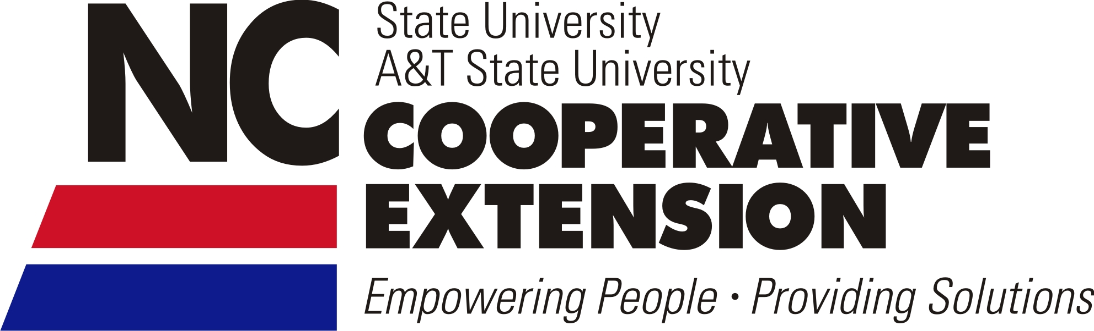
North Carolina State University and North Carolina A&T State University commit themselves to positive action to secure equal opportunity regardless of race, color, creed, national origin, religion, sex, age, veteran status or disability. In addition, the two Universities welcome all persons without regard to sexual orientation. North Carolina State University, North Carolina A&T State University, U.S. Department of Agriculture, and local governments cooperating.

