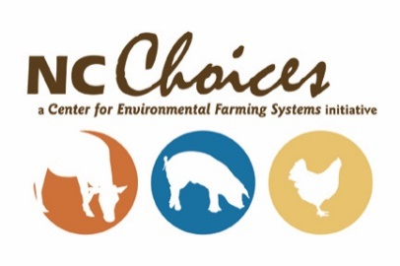
YOUR RESPONSES TO THIS APPLICATION ARE KEPT STRICTLY CONFIDENTIAL

Meat for Market Workshop
(for Women in the Meat Industry)
Application Form

This half-day workshop will focus on Meat for Market, with emphasis placed on marketing pasture-raised beef – from the primals to skillet – for an all-female audience! Topics to be covered in the workshop will include: an overview of the “state of meat” in NC, marketing strategies and how they impact your bottom line, carcass breakdown paired with different cooking techniques for different cuts. The workshop will conclude with some information on pricing your products, risk management as well as a Question & Answer session.

(This workshop is being held in conjunction with:
Amazing Grazing: Pasture Management for Women Cattle Producers - which will occur that morning).
Date: Tuesday, June 2, 2015, from 12:00pm - 5:00pm (Lunch served at noon)
Location: NCSU Beef Education Unit at Lake Wheeler Field Laboratories
Registration Fee: $25 – this fee includes lunch and materials

If you have any questions, please feel free to contact Lisa Forehand at lisa_forehand@ncsu.edu or
(919-513-0954). Space is limited. Please fill out the following application by May 10, 2015 and
return via email or mail to the address below. Decisions will be made by May 13 and the $25 registration
fee is due NO LATER than May 18.

Center for Environmental Farming Systems
Attention: Lisa Forehand
Campus Box 7609/NC State University
Raleigh, NC 27695

Participation Application- Due no later than May 10th, 2015
You May Attach Another Sheet of Paper If Needed
Name: __________________________________________________ Phone Number: ( )_____________

Address:_________________________________________________________________________________

City: _________________________________________ State: ___________ Zip Code:__________________

Email: __________________________ County: _____________________________

Age: ____________________________

Farm or Business Name: ___________________________________________________________

1. Tell us about your Farm/Business or the nature of your work in the meat industry: ______________________________________________________________________________________________________________________________________________________________________________________________________________________________________________________________________________
2. Why are you interested in attending the Women Working in the Meat Business retreat?
______________________________________________________________________________________________________________________________________________________________________________________________________________________________________________________________________________
3. Briefly explain what you would like to learn/ take home from the workshop:
______________________________________________________________________________________________________________________________________________________________________________________________________________________________________________________________________________
4. I am a: Please circle one of the following
Farmer Chef Cooperative Extension
Prospective Farmer Other Food Professional Other:__________________
Meat Processor Meat Buyer ________________________

5. Estimate how many head of livestock you processed in 2014? If you have not and do not intend to process any livestock, you may answer N/A if this question does not apply to you
Swine___________ Beef___________
Poultry__________ Lamb__________
Goat____________ Other__________

7. How many years have you been involved in your meat operation? ________

8. I am also applying for Amazing Grazing: Pasture Management for Women Cattle Producers on Tuesday,
June 2nd, 2015 (Note: This requires a separate application): (Y/N)________

Note: You will be notified by May 13th, 2015 if you are selected to participate in the workshop.
Notification *DOES NOT* reserve your spot.
You will have to submit a check for $25 by May 18th, 2015 to reserve your space.
The Southern Risk Management Education Center funded project, “Integrated Risk Management for Women Producers, Processors,
and Retailers in the Local Meat Product Value Chain,” combines small classroom intensives from production to processing for women under the guidance of NCSU and the Center for Environmental Farming Systems' NC Choices and Amazing Grazing.
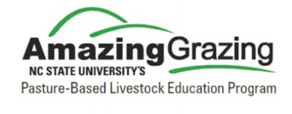 | 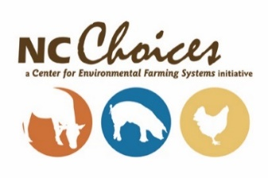 | 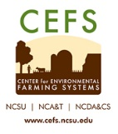
 | 