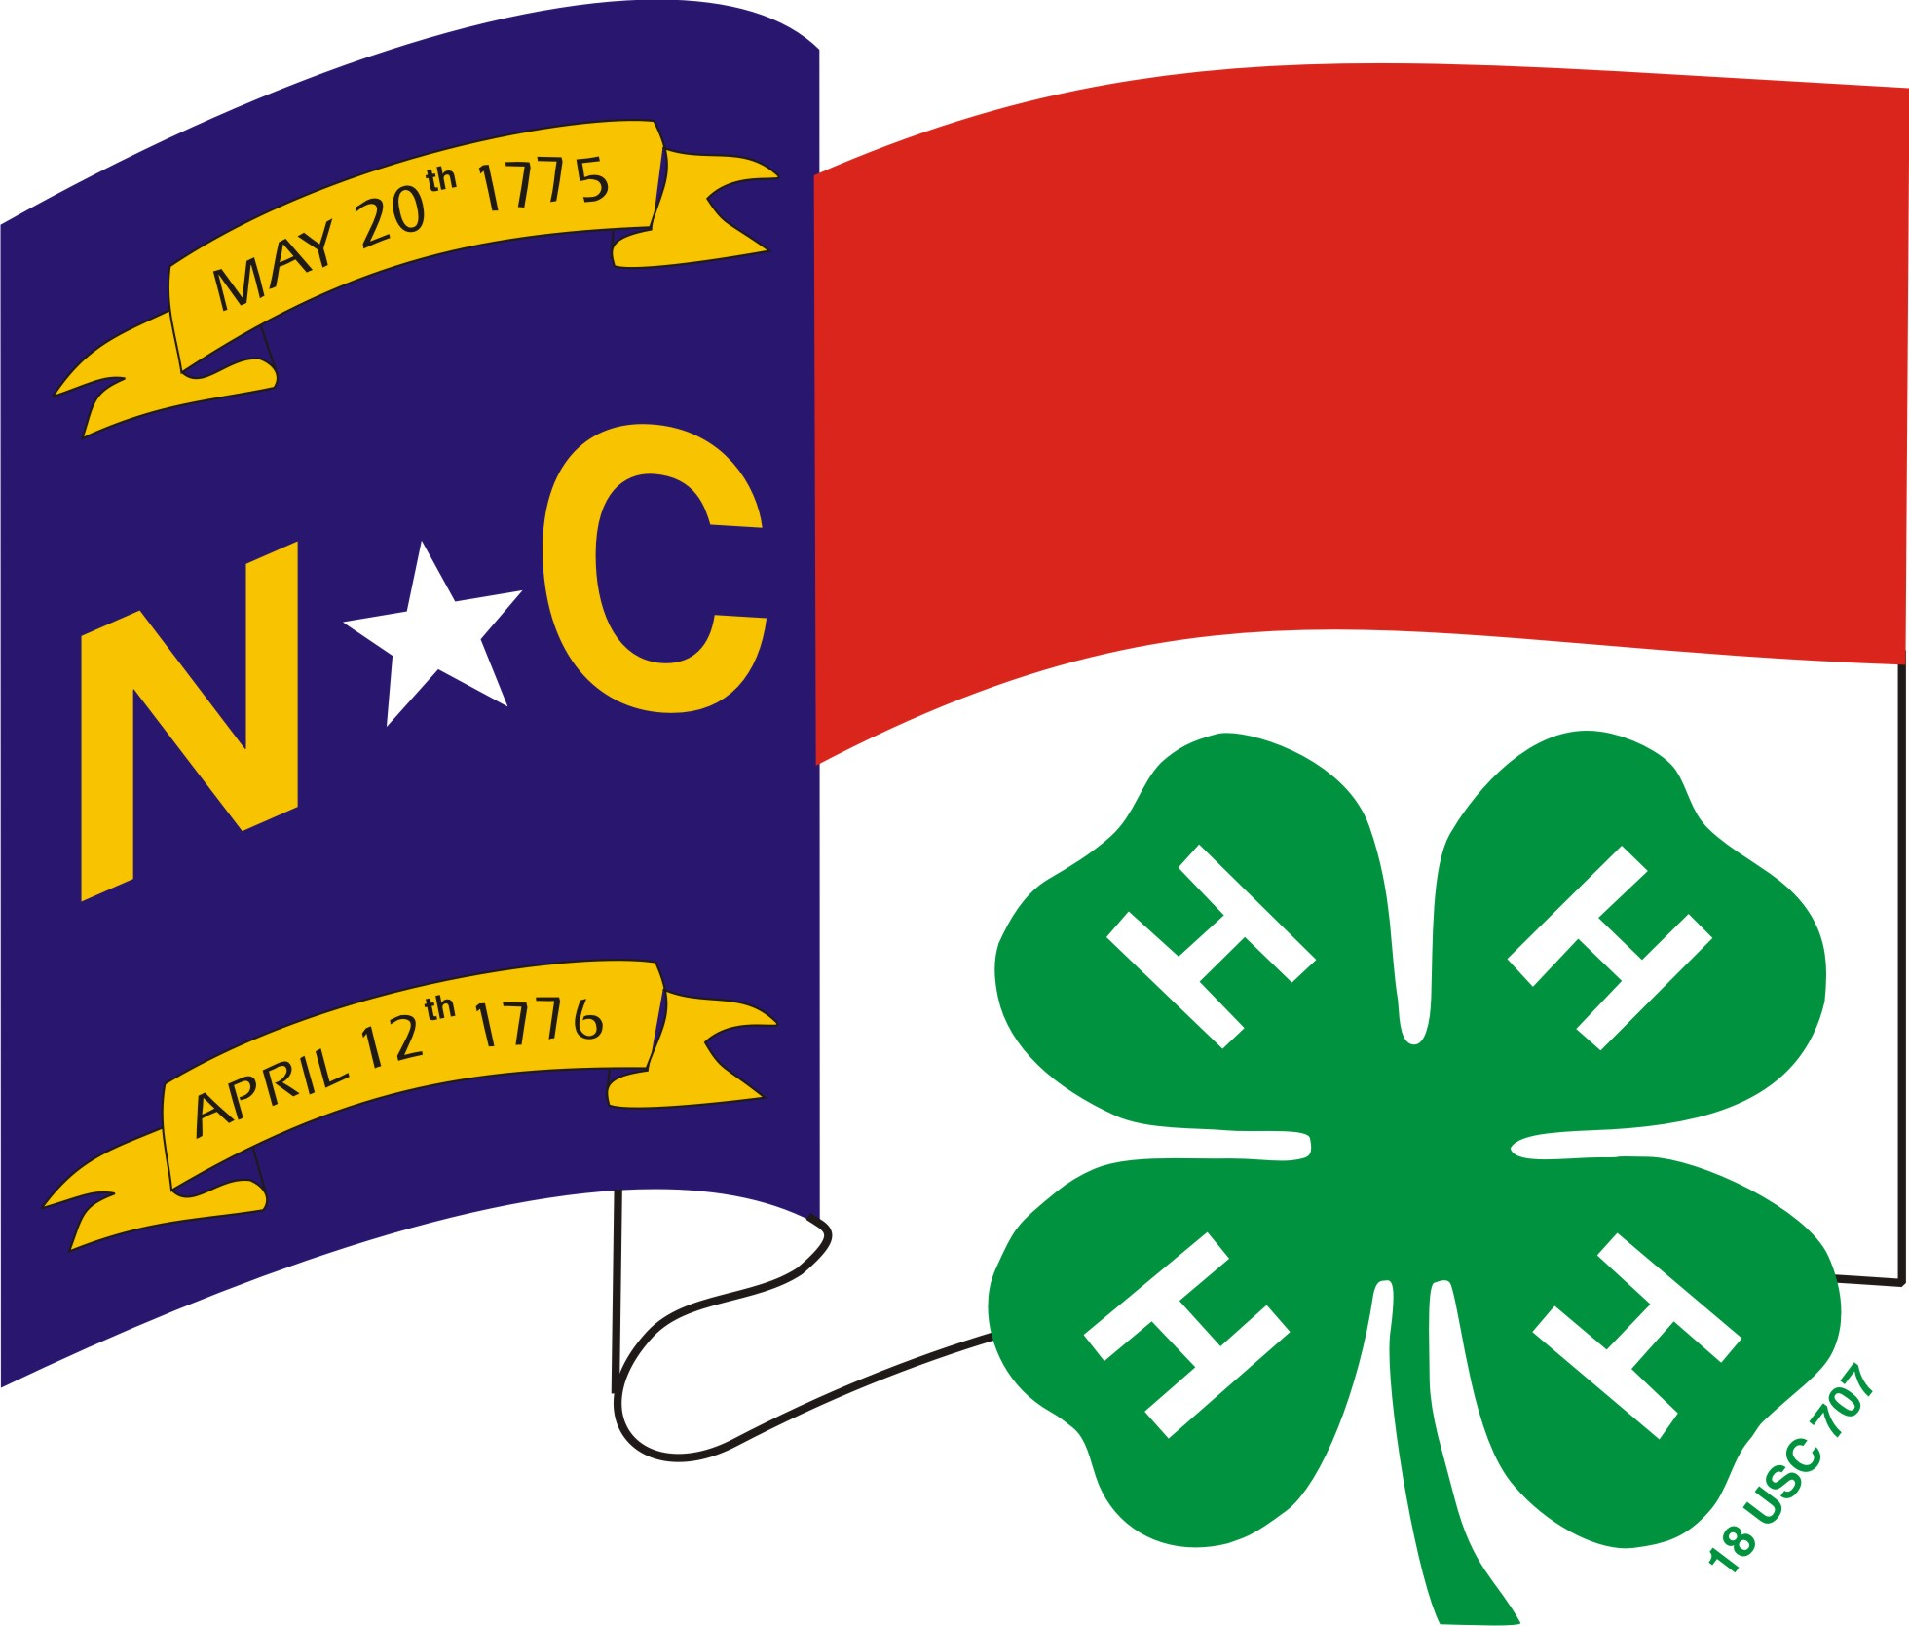


Introduction
4-H Records are an important written summary of what you have learned and the skills that you have gained within your 4-H work as well as other parts of your life. Over a period of years your records will show how you have grown. The information on your 4-H records will be useful as you fill out other forms in your life such as resumes, job applications and college applications.

4-H Projects
A 4-H project is an area of interest that the member spends a significant amount of time and effort on during that year. For example, if a member bakes for the holidays during the year and helps to set the table and clean up after dinner twice a week throughout the year, this does not constitute a Foods project. A project requires that members set goals relating to new things they want to learn and new skills that they want to gain during the club year. They must work in a deliberate manner and spend a significant amount of time to meet these goals. On the Project Record the member must demonstrate that he/she has taken part in learning experiences related to this project and document the skills learned.
All work on 4-H records is to be done by the member. Of course, the member may receive assistance and encouragement from others.

Community Service
Community Service is an important part of any 4-H project. Be sure to include all community service that you do. Community service activities must benefit people who are not related to you. If you receive any sort of compensation for this activity it becomes a job and not a service activity. Compensation includes money, services or favors such as reduction in board or other fees. It is important to be very specific about activities and results. Community Service activities should show increasing complexity and growth over the years.

Leadership
Leadership is an important part of any 4-H project. You should grow in this area by taking on more complicated leadership roles each year. As you grow you should be taking on more responsibilities such as running your club, becoming a junior leader or taking on leadership roles at the county and state levels in 4-H. Extend your leadership skills to other organizations and groups outside of 4-H.
When writing about your leadership experiences, be very specific. It is not enough to say that you are president of your 4-H club. You must say what you did as the president; for example, ran 10 club business meetings, met with leader 6 times to set up yearly program for the club, etc.
In addition, evaluate each activity carefully to determine if it belongs in the leadership section. For example, serving on a committee is not always a leadership experience. Being in a leadership role on a committee would be listed in this section. This would mean that you were in charge of organizing the committee and insuring that the committee worked to accomplish its task. You need to be specific about what you did that enabled the committee to carry out its function.

Citizenship

Citizenship is a very important part of your 4-H work. Responsible citizenship is an individual's demonstration of love and devotion in response to duties, rights and privileges as a member of a community or country. It includes loyalty to one's place of residence (city, state, county); the entitlements and privileges of citizenship, including voting, protection, participation in government; obligations of citizenship; and, appreciating and valuing diversity.
4-H Personal Touch/Express Yourself
This section is devoted to sharing your 4-H project in an expressive way. You can use a variety of ways to share. Pictures, poems, newspaper articles, etc can be used. The sky is the limit. Just be sure to check the page limitations. All pictures, poems, newspaper articles, etc. should be about focused mainly on this one project. However, you should include things under leadership, citizenship and community service as a part of your record.
4-H Story
This is a written narrative about how 4-H has made an impact on your life or the lives of your family or others. Focus on the impact from participating in those events that you did this year. How has 4-H made a difference in your life? Is there something that happened as part of your 4-H experiences that was very significant to you?
This is one of the important parts of your record! It is a chance to really "tell your story" and be creative! It should focus on all areas of 4-H work. Not just one particular project. Make sure that you write in complete sentences and that your grammar and spelling are correct.

4-H PROJECT RECORD INSTRUCTIONS
9-10 YEAR OLDS

What goes in a project record?

Each project record should have the following:

1. My 4-H Project Plan
Include ALL goals for the year, what you hope to learn, and what you hope to do in all your 4-H projects. This includes all projects, county-district-state events planned to participate in, community service activities and so on. INCLUDE EVERYTHING. If you are doing more than one project, make copies of this page to put in each of your books.

2. My 4-H Project Record
This section is about a single project. List everything you learned and did in this project. Be sure to answer all of the questions.

3. My Personal Touch/Mini-Scrapbook

All items should focus mainly on the project you have described in Section 2, MY 4-H Project Record Page. This section will be different for each project record you submit.

4. My 4-H Story
This story should include information about yourself, your family, and at least a paragraph on each 4-H project. Stories should also have a logical sequence, which includes an introduction a body and a conclusion. If you are doing more than one project, make copies of the story to put in each project book.

How should I put my project together?

Place your project in a folder in this order:

1. On front cover – upper right hand corner – Name, County, District, Age Category and Project Category.
- The completed project pages in the order listed above.
3. Include project manuals only if you have recorded information in it.
4. Each project you complete must be submitted in a separate folder.

DO NOT INCLUDE ANYTHING VALUABLE IN YOUR BOOK – take pictures of those items and include that in your Personal Touch Section.
4-H PROJECT RECORD INSTRUCTIONS
11-12 YEAR OLDS

What goes in a project record?

Each project record should have the following:

1. My 4-H Project Plan
Include ALL goals for the year, what you hope to learn, and what you hope to do in all your 4-H projects. This includes all projects, county-district-state events planned to participate in, community service activities and so on. INCLUDE EVERYTHING. If you are doing more than one project, make copies of this page to put in each of your books.

2. My 4-H Project Record
This section is about a single project. List everything you learned and did in this project. Be sure to answer all of the questions.

3. . My Personal Touch/Express Yourself Pages
All pictures, poems, newspaper articles, etc. should be about focused mainly on this one project.

4. My 4-H Story
This story should include information about yourself, your family, and at least a paragraph on each 4-H project. Stories should also have a logical sequence, which includes an introduction a body and a conclusion. If you are doing more than one project, make copies of the story to put in each project book.

5. My 4-H Activities
Tell about your involvement in leadership, citizenship, community service, meetings, and workshops. Include things you=ve done at school, church, or in your community. If you are doing more than one project, make copies of this page to put in each of your books.

Examples

Leadership
Teaching a workshop
Helping with activities
Being a 4-H officer
Serving on a 4-H committee

Community Service
(Any volunteer service activities - cannot be services provided to family members)
Community clean up
Visiting rest homes
Volunteering at the Extension office
Club community service projects
Needy family projects

Citizenship
(Must relate to government or community or world issues)
helping with elections
Attending a county commissioner or town hall meeting
hosting Japanese Exchange student and learning about another country
Learning about a community issue or problem

Learning about another culture
Attending court in session
Learning Roberts Rule of Order
Participate in club elections

How should I put my project together?

Place your project in a folder in this order:

1. On front cover – upper right hand corner – Name, County, District, Age Category and Project Category.
- The completed project pages in the order listed above.
3. Include project manuals only if you have recorded information in it.
4. Each project you complete must be submitted in a separate folder.

DO NOT INCLUDE ANYTHING VALUABLE IN YOUR BOOK – take pictures of those items and include that in your Personal Touch Section.

4-H PROJECT RECORD INSTRUCTIONS
13-15 YEAR OLDS

What goes in a project record?

Each project record should have the following:

1. My 4-H Project Goals
Include ALL goals for the year, what you hope to learn and what you hope to do in all your 4-H projects. This includes all projects planned to work on, county-district-state events planned to participate in, community service activities and so on. INCLUDE EVERYTHING. If you are doing more than one project, have your county make copies of this page to put in each of your books.

2. My 4-H Record of Accomplishments
This is about a SINGLE project. List everything learned, done, and participated in one project, i.e. only horse stuff, only rabbit stuff, only sewing stuff. Be sure to answer all of the questions on this page. Be very specific about what you learned.

3. Express Yourself
All pictures, poems, newspaper articles, etc. should be about focused mainly on this one project. You must include a story 2-6 pages long. Tell about yourself, family, and what you did in 4-H this year. Try to write at least one paragraph for each project you did. If you are doing more than one project, we will make copies of the story to put in each project book. See the Express Yourself Page for other choices such as poems, songs, etc. No more than 10 pages combined with Story and Express Yourself other sections.

4. My 4-H Leadership
Include offices you held, classes taught, events organized & leadership training you=ve attended. This is not limited to 4-H events. If you are doing more than one project, make copies of this page to put in each of your books.

Leadership
teaching a workshop
helping with activities
being a 4-H officer
serving on 4-H committee

5. My 4-H Community Service
Tell what you’ve done to help improve your community. You can include things done outside of 4-H. If you are doing more than one project, we will make copies of this page to put in each of your books.

Community Service
(any volunteer service activities - cannot be services provided to family members)
community clean up
visiting rest homes
volunteering at the Extension office
club community service projects
needy family projects

6. My 4-H Citizenship

Tell about any experiences you were involved in that helped you better understand the government or political process. This can include serving in Student Government, writing letters to representatives, touring government sites, etc. If you are doing more than one project, we will make copies of this page to put in each of your books.

Citizenship
(must relate to government or community or world issues)
helping with elections
attending a county commissioner or town hall meeting
hosting Japanese Exchange student and learning about another country
learning about a community issue or problem
learning about another culture
attending court in session

How should I put my project together?

Place your project in a folder in this order:

1. On front cover – upper right hand corner – Name, County, District, Age Category and Project Category.
2. The completed project pages in the order listed above.
3. Include project manuals only if you have recorded information in it.
4. Each project you complete must be submitted in a separate folder.

DO NOT INCLUDE ANYTHING VALUABLE IN YOUR BOOK – take pictures of those items and include that in your Personal Touch Section.

4-H PROJECT RECORD INSTRUCTIONS
16-18 YEAR OLDS

What goes in a project record?

Each project record should have the following:

1. My 4-H Project Goals
Include ALL goals for the year, what you hope to learn and what you hope to do in all your 4-H projects. This includes all projects planned to work on, county-district-state events planned to participate in, community service activities and so on. INCLUDE EVERYTHING. If you are doing more than one project, have your county make copies of this page to put in each of your books.

2. My 4-H Record of Accomplishments
This is about a SINGLE project. List everything learned, done, and participated in one project, i.e. only horse stuff, only rabbit stuff, only sewing stuff. Be sure to answer all of the questions on this page. Be very specific about what you learned

3. Express Yourself
All pictures, poems, newspaper articles, etc. should be about focused mainly on this one project. You must include a story 2-6 pages long. Tell about yourself, family, and what you did in 4-H this year. Try to write at least one paragraph for each project you did. If you are doing more than one project, we will make copies of the story to put in each project book. See the Express Yourself Page for other choices such as poems, songs, etc. No more than 10 pages combined with Story and Express Yourself other sections.

4. My 4-H Leadership
Include offices you held, classes taught, events organized & leadership training you=ve attended. This is not limited to 4-H events. If you are doing more than one project, make copies of this page to put in each of your books.

Leadership
teaching a workshop
helping with activities
being a 4-H officer
serving on 4-H committee

5. My 4-H Community Service
Tell what you=ve done to help improve your community. You can include things done outside of 4-H. If you are doing more than one project, we will make copies of this page to put in each of your books.

Community Service
(any volunteer service activities - cannot be services provided to family members)
community clean up
visiting rest homes
volunteering at the Extension office
club community service projects
needy family projects

6. My 4-H Citizenship

Tell about any experiences you were involved in that helped you better understand the government or political process. This can include serving in Student Government, writing letters to representatives, touring government sites, etc. If you are doing more than one project, we will make copies of this page to put in each of your books.

Citizenship
(must relate to government or community or world issues)
helping with elections
attending a county commissioner or town hall meeting
hosting Japanese Exchange student and learning about another country
learning about a community issue or problem
learning about another culture
attending court in session

How should I put my project together?

Place your project in a folder in this order:

1. On front cover – upper right hand corner – Name, County, District, Age Category and Project Category.
- The completed project pages in the order listed above.
3. Include project manuals only if you have recorded information in it.
4. Each project you complete must be submitted in a separate folder.

DO NOT INCLUDE ANYTHING VALUABLE IN YOUR BOOK – take pictures of those items and include that in your Personal Touch Section.

