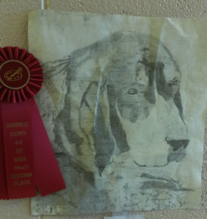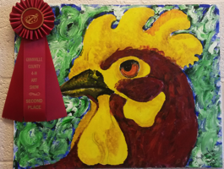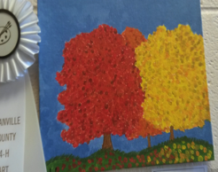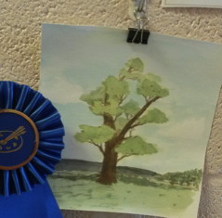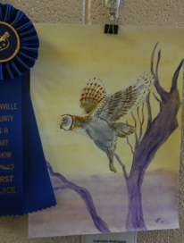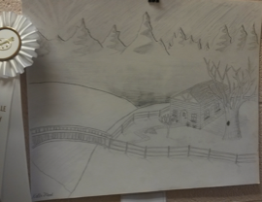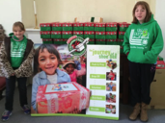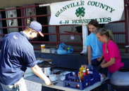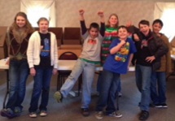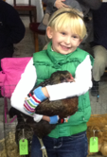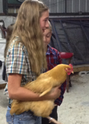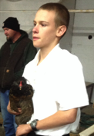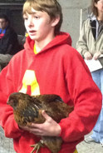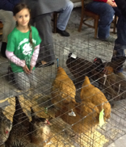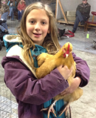

# 4-H Art Contest Results

# In October, 4-H’ers submitted artwork using paints, oils, pencil, marker, etc. to be judged. Winners received Clover Cash! 1st=$50, 2nd=$30, 3rd=$15, Cloverbuds=$10

# **Artwork will be displayed at the Granville County Expo Center for the month of December! Look for another contest coming early this spring for photography!**

***JUNIORS (9-12 yrs)***

1st—Gabrielle Rodriguez, 15 yrs, At-Large Member

3rd—Kolbe Flood, 13 yrs,

Happy Hoppers 4-H Club

2nd—Amber Harvey, 17 yrs,

Happy Hoppers 4-H Club

***SENIORS***

***(13-18 yrs)***

3rd--Anna Currin, 12 yrs,

Explorers 4-H Club

2nd--Amelia Laursen, 9 yrs,

Cluckers 4-H Club

1st--Timothy Flood, 9 yrs,

Happy Hoppers 4-H Club

The Tar River 4-H Club volunteered to help assemble and pack Operation Christmas Child boxes at the Wake Forest Christian Church on November 22.

#### **Tar River 4-H Club**

The Horseflies 4-H Club sold hot dogs at Southern States in Oxford on October 25. The funds they raised will go towards a sponsored family for the Holidays.

#### **Horseflies 4-H Club**

In November, Show Club volunteered at Tabbs Creek Baptist Church to send out over 300 Samaritans Purse Shoeboxes.

#### **S.H.O.W. 4-H Club having fun volunteering!**

Awards received by Granville County 4-H’ers include:

Grand Champion Auracana:

Ian Short

Grand Champion Buff Orpington:

Sydney Fryman

Junior Showmanship (9-13 yrs)

2nd place Abby Holsomback

Senior Showmanship (14-18 yrs)

2nd place Amber Harvey

Project Record Books

9-10 yrs: 1st place Timothy Flood

11-12 yrs: 1st place Corbin Perry

13-15 yrs: 1st place Kolbe Flood

3rd place Travis Harvey

16-18 yrs: 2nd place Amber Harvey

On November 14, 2014, the Four County 4-H Poultry Show & Sale was held at the Warren County Lion’s Den in Warrenton.

Fourteen Granville County 4-H youth raised 10 one-day-old chicks since May, and selected their top 3 to show and auction off. Youth could choose to raise Buff Orpingtons or Auracanas.

At the show, youth participated in project record books, showmanship, and best in breed classes. E.B. Harris, a professional auctioneer, runs the sale. Each bid is a cage of 3 pullets. Prices from this year’s sale ranged from $10-$25 per bird! Checks will be made available around the second week of December.

Four County 4-H Poultry Show & Sale

Results!

North Carolina State University and North Carolina A&T State University commit themselves to positive action to secure equal opportunity regardless of race, color, religion, creed, national origin, sex, age, disability, or veteran’s status. In addition, the two Universities welcome all person without regard to sexual orientation. North Carolina State University, North Carolina A&T State University, U.S. Department of agriculture, and local governments cooperating.

***Granville County 4-H 2014 Recognition Banquet***

For whom? Granville County 4-H members, parents, and volunteers

When? January 23, 2015, from 6:30pm-8pm.

Where? Granville County Expo Center

Other details? We will be recognizing all the hard work Granville County 4-Hers and volunteers have put into making this a successful year. Awards will be handed out for those that have participated in county, district, and state events! If your club would like to have a booth, let Jessica know. No dinner will be served. Desserts will follow the awards.

Dessert Contest: 4-H youth are encouraged to bring a dessert to enter into the dessert contest.

*Here are the rules:*

* 5-8 year olds=cookies, 9-13 year olds=pies, and 14-18 year olds=cakes.
* NO DESSERT MAY BE FIXED THAT REQUIRES REFRIDGERATION (for example: custard pies, dirt cake, etc.). This is only for your food safety.
* Typed or handwritten recipes must accompany the dessert with the entrant’s name on the back of the recipe.
* Clover Cash will be awarded in the following amounts: 1st place=$25, 2nd place=$15, 3rd place=$10.

**Upcoming Events!**



**GRANVILLE COUNTY 4-H** INVITES YOU TO A

Masquerade Ball

SATURDAY, JANUARY 10TH

7PM---9PM AGES 8 and up

208 WALL STREET, OXFORD

ADMISSION IS AT THE DOOR—10 CANS OF FOOD or $10 DONATION.

HOR’DEURVES, DJ, AND GAMES

To benefit the Area Congregation In Ministry can food drive

“CHOOSE A MASK AND WEAR IT WELL, SO YOUR TRUE IDENTITY, NO ONE CAN TELL…”

Parent(s) are encouraged attend, but must also wear a mask and bring admission.