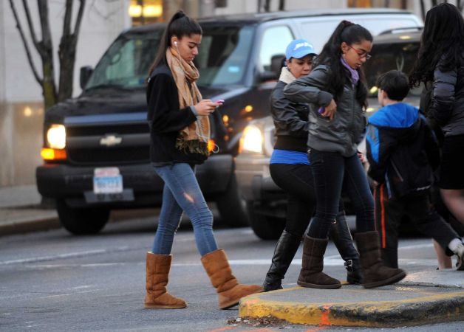

### -

### 

**Walking is a great form of exercise and way to get around, but walk with *SWAG* to be safe.**

S ee them see you: make eye contact with drivers so you know they see you and are going to let you cross.

W alk without distraction, don’t text or talk on the phone while walking. Put it down and walk in a moment of silence

### A lways cross at crosswalks and intersections: don’t cross mid-block. Drivers don’t expect you there. Follow the Rules of the Road. Pedestrians only have the right of way in cross walks at signaled intersections.

G o on the sidewalk or if no sidewalk exist, walk facing traffic as far to the left as you can to be safe.

*if you *SWAG* in the dark, wear the bling and light clothes so drivers can see you.

*Information compiled by Carolinas Center for Injury Prevention and CMS Health Education

Motor Vehicle Drivers Role

# Walk with

# SWAG



## 39% 39% 20% 2% 17% 14%



## Girls were more likely to walk while distracted but not by much!

## One in five high school students crossed the street while distracted. Texting was the most common distraction.