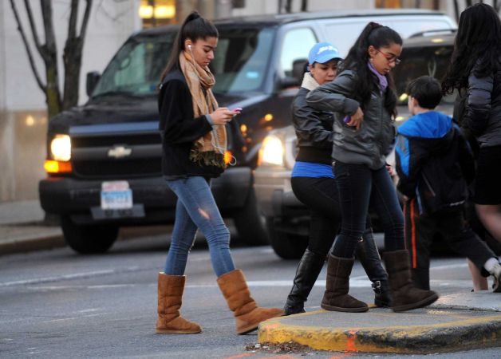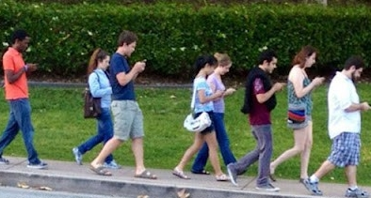

### Walking and Texting?

### Walking and Talking on the Phone?

### Walking and listening to Music?

**Walking is a great form of exercise and way to get around, but there are steps you can take to be safe while walking**

* Headphones should not be worn while crossing streets, driveways, parking lots. Hearing and sight are needed to look for vehicles.
* If you need to use a cell phone, during the walk to and from school, make sure to stop walking and find a safe area to talk.
* On a call and need to cross the street? Ask them to wait a minute for you to cross, it only takes a minute to cross safely.
* Cross streets at corners, using traffic signals and crosswalks. Most injuries happen mid-block or someplace other than intersections. It may take you a minute out of your way and not be the exact area you are looking to get to!
* It’s always best to walk on sidewalks or paths. If there are no sidewalks, walk facing traffic as far to the left as possible.
* Look left, right and then left again when crossing the street. NEVER run or dart out into the street, drivers cannot stop vehicles fast enough
* Never cross between parked cars or around buildings and bushes, drivers cannot see you and don’t anticipate that is where a person may be.
* Make eye contact with drivers before crossing in front of them and watch out for cars that are turning or backing up.
* Crossing a double line at a crosswalk without a stop signal? Stop at the edge of the first car and make sure the second vehicle sees you and intends to stop

*Information compiled by Carolinas Center for Injury Prevention and Safe Kids Charlotte Mecklenburg

Motor Vehicle Drivers Role

# Are YOU

# A Distracted

# Walker?



## 39% 39% 20% 2% 17% 14%



## Girls were more likely to walk while distracted

## One in five high school students crossed the street while distracted. Texting was the most common distraction.