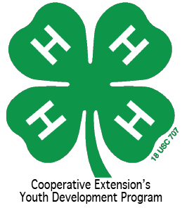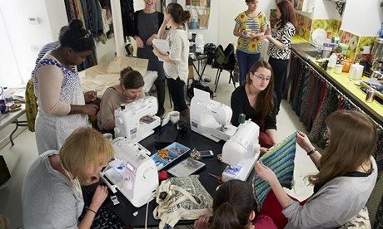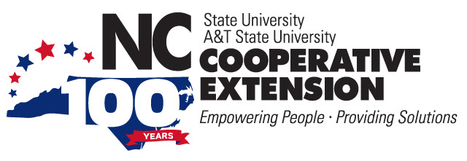

## **Volunteer for a**

## **Good Cause!**

!

North Carolina State University and North Carolina A&T State University commit themselves to positive action to secure equal opportunity regardless of race, color, religion, creed, national origin, sex, age, disability, or veteran's status.  In addition, the two Universities welcome all persons without regard to sexual orientation. North Carolina State University, North Carolina A&T State University, U.S. Department of Agriculture, and local governments cooperating.

# Vance County 4-H is sponsoring an opportunity for anyone handy with a sewing machine to help make pillows for a local nursing home and the hospital to support breast cancer and heart patients. Machines & materials supplied. Call 252-438-8188 by Friday, October 3, for more information and to register.

* Please Come to a Sew-Down !

### Saturday

October 11th, 2014, 9 a.m.