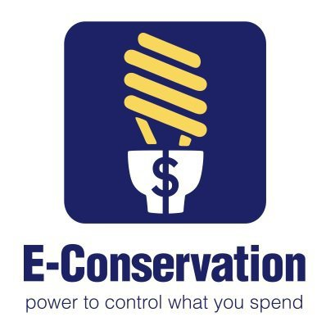
Don’t Let Sweltering Summer Days Put a Sizzle on Your Power Bills
Originally written by Deborah McGiffin
The heat is on. As warm spring days turn into sweltering summer heat don’t let your power bills sizzle your budget. Saving energy means saving money. We have all heard of some tactics like turning out lights in unused rooms and turning down the thermostat when we leave home … but there is so much more that can be done.
The Durham County Cooperative Extension Service will host a free energy conservation lunch-n-learn workshop. Bring your lunch on Thursday, June 19 from 12-1 pm to Conference Room B in the new Durham County Human Services Building located at 414 E Main Street to learn more about energy efficient strategies you can use in any season that will:
• Reduce utility costs.
• Improve the health and comfort of your home.
• Lessen your overall impact on the environment.
• Receive helpful resources and a free energy kit with a CFL light bulb, low-flow shower head & more.
AND, in addition, interested participates can learn about how they can qualify for the E-Conservation Home Assessment and Energy Retrofit Program valued at $800.00 for the reduced rate of $100.00 for retrofitting your home with energy efficient measures like air sealing, caulking, water heater insulation, and air duct repair.
Please contact Deborah McGiffin at 919-560-0521 or deborah_mcgiffin@ncsu.edu by June17 to reserve your place!

