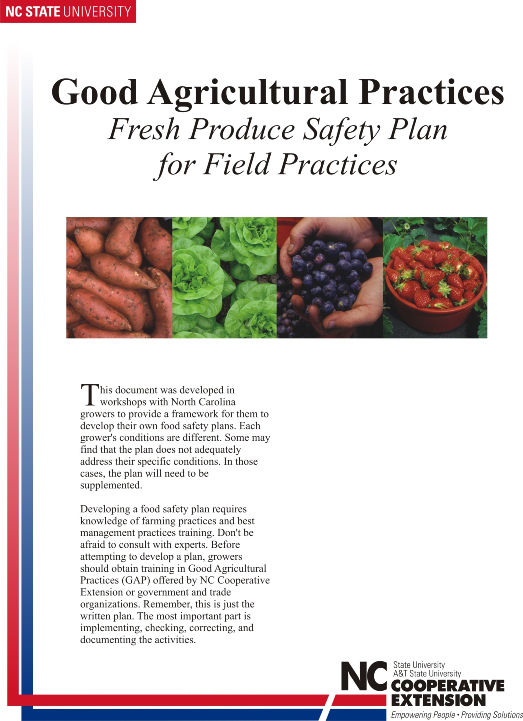
Food Safety Plan
Farm Name
This plan follows the USDA Good Agricultural Practices and Good Handling Practices Audit Verification Checklist categories of General Questions, Farm Review (Part 1) and Field Harvest and Field Packing Activities (Part 2). Individual questions are indicated at the beginning of each policy section.

Commitment to Production of Safe Foods:
Farm name is committed to the production of safe and high-quality foods. We subscribe to the principle that the appropriate method to accomplish this is to minimize the microbial, chemical, and physical contamination of produce at all points of the production process. It is our goal to produce premium-quality fruit/vegetables using good agricultural practices to maximize quality and productivity. To accomplish this, the following documented food safety plan is implemented and will be followed by all employees, contractors, and visitors to Farm name production sites and facilities.

Suggestions to improve this plan are encouraged at any time. This plan will be reviewed and reapproved at least annually or at the beginning of the spring planting season.

Facility Address (Physical and Mailing):

Farm Information:
Farm name is owned by Owner Name, and was started in add year. Farm name is dedicated to the agricultural activities involved in the production, packing, and marketing of list of all commodities produced. Currently, we are farming add number acres. We own add number acres and lease the additional add number acres in production. (Statement of other physical buildings operated in conjunction with this farm’s operations could be included here, such as packing house square footage).

Organizational Chart

Owners | Click here to enter text.
Manager | Click here to enter text.
Assistant Manager | Click here to enter text.
Food Safety Officer | Click here to enter text.
Packing House Manager | Click here to enter text.
Packing House Crew Manager | Click here to enter text.
Office and Bookkeeping Manager | Click here to enter text.
Shipping and Transportation | Click here to enter text.
Traceability and Documentation | Click here to enter text.
Contact Person | Click here to enter text.
Broker | Click here to enter text.

This plan will be considered current for one year following the date of the last review. Authorized changes will be made in writing and recorded below.

Date | Section Changed | Effective Date | Authorized by
Date | Click here to enter text. | Date | Add name
Date | Click here to enter text. | Date | Add name
Date | Click here to enter text. | Date | Add name
Date | Click here to enter text. | Date | Add name
Date | Click here to enter text. | Date | Add name
Date | Click here to enter text. | Date | Add name
Date | Click here to enter text. | Date | Add name

Farm name authorizes/designates Name to make changes and oversee the implementation of this established food safety plan.

Name has participated in GAP/GHP trainings. He/She will be responsible for training employees and is provided with the authority and resources to fully accomplish this task.

All required documents are to be maintained at farm name offices.

All documentation logs will be maintained accordingly in the appendices.

By signing this document, I agree to adhere to all that is set forth in the Good Agricultural Practices Food Safety Plan.

Signature of Owner and Operator Date

