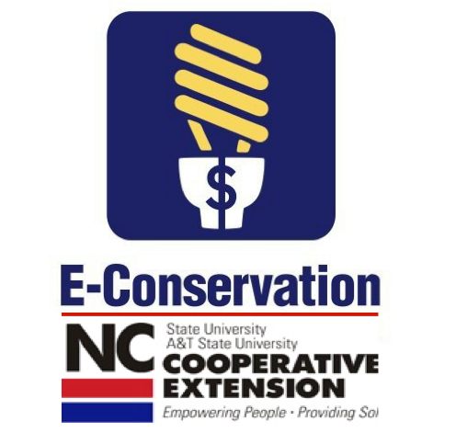
Frustrated With High Utility Bills?
(Your County) County Cooperative Extension will host a free energy conservation workshop at DAY AND TIME at ADDRESS.
Wow, did you see your utility bill last month? If only there was something you could do about it. Well, there is! We all know that saving energy means saving money but it is hard to know which strategies will have an impact. We have all heard some of the strategies like turning out lights in unused rooms and turning down the thermostat when we leave home … but there is so much more we can do.
This workshop will explain which energy conservation strategies have the greatest impact on savings. Learn about many no-cost strategies that only require changes in how you live in your home. Understanding how your home works as a “system” will help you develop energy saving strategies that will decrease energy use, increase home comfort, and make your home a healthier place to live.
This two-hour “WORKSHOP TITLE” workshop will demonstrate how renters and homeowners can reduce their utility bill by using low-cost, no-cost energy conservation strategies. Participants will learn:
- The biggest “boom for the buck” DIY projects that can lower your utility bills!
- Top twenty no-cost ways to lower your utility bills and increase comfort in your home.
- Programs and resources offered to AREA UTILITY (gas, electric, water) COMPANY customers.
- The WHO, WHAT, and WHY of getting an energy assessment for your home.
- Different lighting choices for the home.
- Orientation to FREE online resources that you can refer to any time you need DIYs, savings ideas, tax incentives, rebate opportunities, etc. (Our website has ALL of this. Show participants our website, facebook, and Pinterest)
E-Conservation Website
Pinterest for E-Conservation
Facebook for E-Conservation
Twitter for E-Conservation
- How to improve the comfort of your home.
- Workshop participants will receive helpful resources and a free energy kit with a CFL light bulb, a low-flow showerhead, and more!
This workshop was developed by North Carolina Cooperative Extension E-Conservation Program and is being presented in partnership with (Partners such as local utility company, city, Habitat, etc.)
Registration deadline is DATE. Call NUMBER to reserve your place!!

