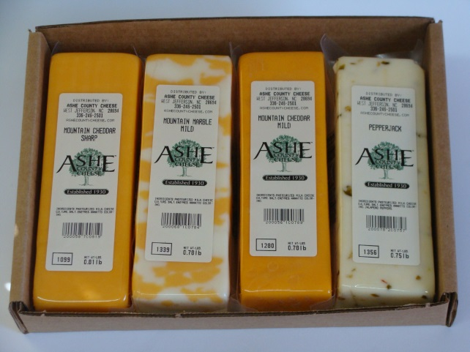Pre-Order Your
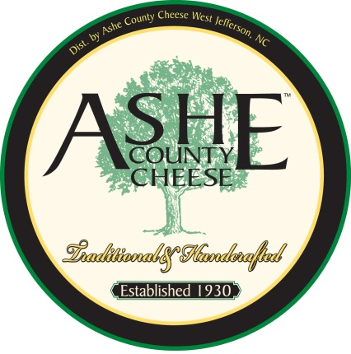NCSU Dairy Science Club
Ashe County
Cheese
A: 1-12oz Mild Cheddar plus1-12oz Sharp
Cheddar $12.00
B: 1-12oz Pepper Jack plus1-12oz Sharp
Cheddar $12.00
C: 1-12oz Colby Jack plus 1-12oz Pepper Jack $12.00
D: 2lb Mild Cheddar Wheel $15.00
E: 2lb Sharp Cheddar Wheel $16.00
X: 12-oz Cheese Curds $ 6.00

Type | No. of Boxes | Rate/Box | Subtotal
A~ 24oz |  | $12.00 | $
B~ 24oz |  | $12.00 | $
C~ 24oz |  | $12.00 | $
D= 2lbs |  | $15.00 | $
E= 2lbs |  | $16.00 | $
X= 12oz |  | $6.00 | $
Total $ Amount of Order= $

All orders must be received with payment by Tuesday, Nov. 26
Checks payable to: NCSU Dairy Science Club (Box 7621, NCSU Raleigh 27695-7621
No orders will be placed without payment.
Please send orders/questions to Hannah Elmore: hmelmore@ncsu.edu phone: 704-838-6914
Coty Redding: ctreddin@ncsu.edu phone: 336-736-7489

Name (print): _____________________________________

Telephone No(s): ___________________________ E-Mail__________________________
Cheese will be available for pick-up the week after Thanksgiving.

