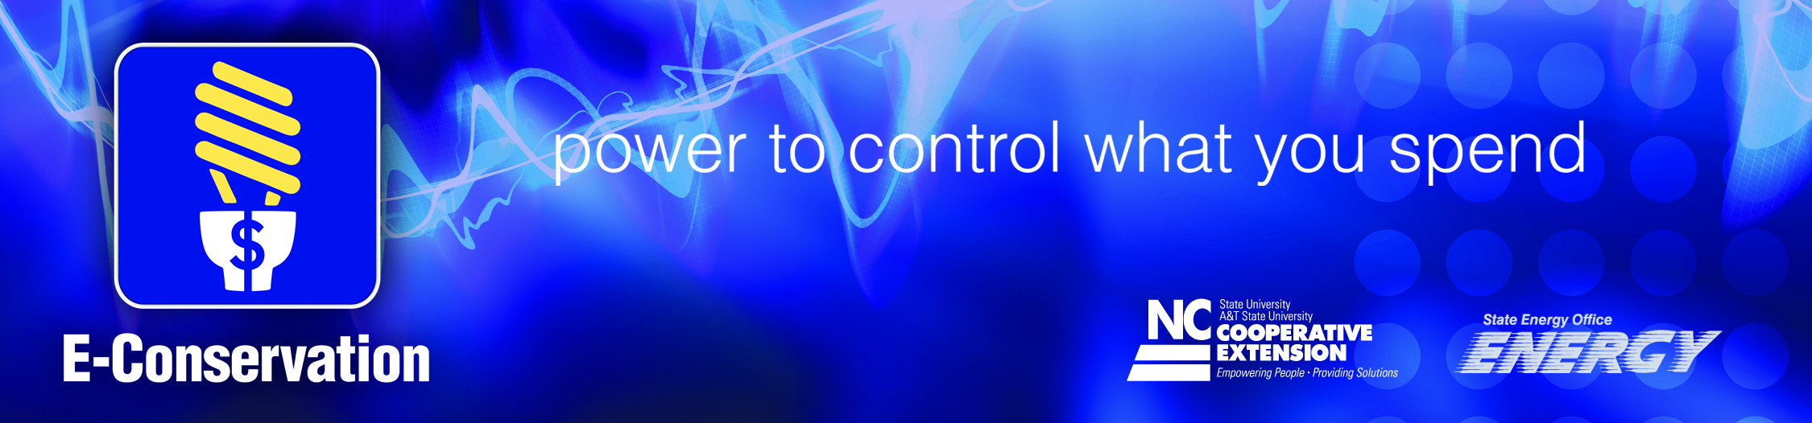
NCCE E-Conservation Program:
- Provides consumers with education about ways to reduce energy use and increase energy efficiency in the home/residence
- Teaches consumers to be proactive in reducing energy consumption through no/low cost measures, maximizing utility and government energy efficiency offers, behavioral changes, and home retrofits
- State Energy Office Funding
- Reaches consumers through outreach efforts of local county Cooperative Extension Offices
  - Offices located in every county in North Carolina
  - Trusted and unbiased
  - Established partnerships with local government, schools, and community
- Reaches consumers through:
- Home Energy Assessments
- Workshops
- Website
- Social Media (Facebook, Pinterest, Twitter)
- Newsletters
- Fact sheets
- Media Releases
- Community service activities
- Energy Master Program
  - Introductory overview of energy efficiency and renewable energy for homeowners who want to expand their knowledge and provide community support through volunteerism
  - Intended to empower homeowners to make wise energy decisions and to provide the background information needed to understand basic energy conservation issues
  - Educates volunteers for the benefit of their communities
  - Course Content: Residential Energy Efficiency
  - Provides information on home energy efficiency including how energy is used in North Carolina homes, low and no cost things consumers can do to reduce energy demands, costs and payback periods for various energy efficiency upgrades, and “how to” instruction on conducting a basic walk-through home energy assessment.
  - Intended for homeowners, retirees, recent college graduates, realtors, and interested members of the general public.

