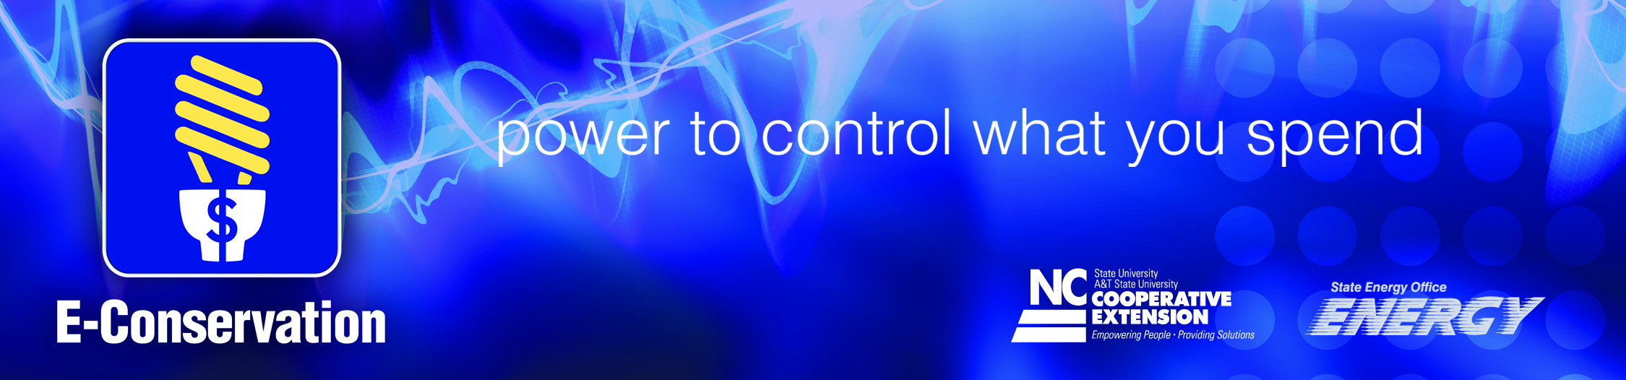

Project Overview
In order to reduce energy usage and lower utility expenses, trained volunteers will provide home assessments, education, and basic retrofit measures to residents participating in the E-Conservation Volunteer Energy Conservation Initiative (VECI). Participating residents will receive information that educates them about ways to reduce their utility usage through low cost measures and changes in energy use behaviors. Participants who own a home will have the opportunity to receive a home assessment, basic retrofit, and in-home one-on-one energy conservation consultation from a trained VECI volunteer. Homeowners participating in the retrofit component of the program are also required to contribute $50 toward the retrofit materials, provide utility usage data, and participate in a series of questionnaires, designed to determine program impacts. If the homeowner is unable to contribute $50 for the retrofit, the VECI team may pursue other funding sources to cover the retrofit costs.
The goal of the program is to reduce overall energy use and household energy costs by educating residents and, in some cases, installing a package of energy conservation measures in participating homes. In addition to the installation of the energy conservation measures, an important component of VECI is the one-on-one energy consultation. Each resident will receive educational materials on energy efficiency techniques and will be encouraged to make behavioral changes that will help them reduce and control their energy usage.

Project Objectives
- Conduct an energy assessment of the resident’s home to identify energy saving opportunities.
- Install a package of energy conservation measures (ECM) that will reduce overall energy use and household energy costs.
- Provide residents with energy conservation information, strategies, and implementation skills that will encourage and empower them to make behavioral changes that will reduce their energy use.

