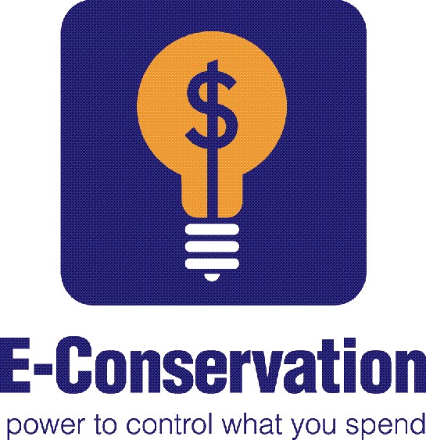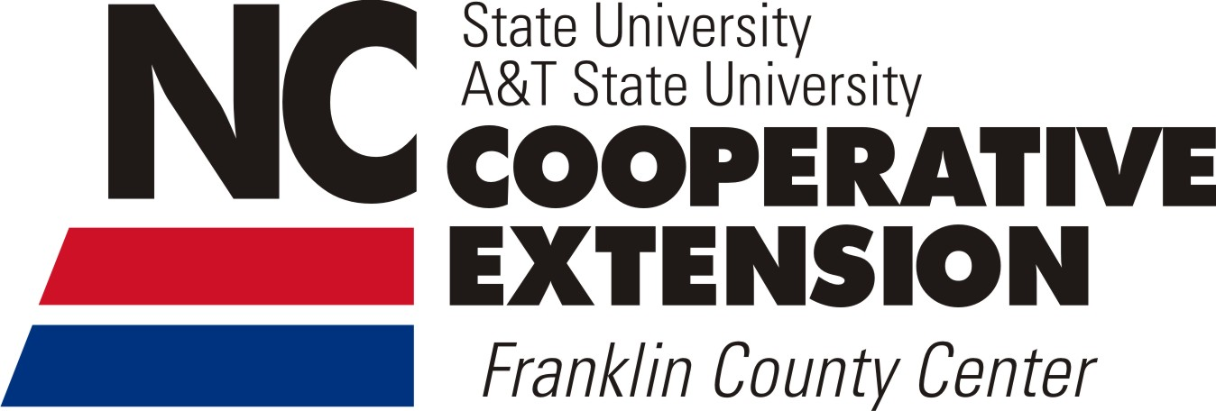

Save Energy, Save $$

### Or to arrange a one hour workshop for your group of more than ten participants,

### please contact Rachel Monteverdi at 919-496-3344 or

### via email Rachel_monteverdi@ncsu.edu

### Contact us for details

North Carolina State University and North Carolina A&T State University commit themselves to positive action to secure equal opportunity regardless of race, color, creed, national origin, religion, sex, age, veteran status, or disability. In addition, the two Universities welcome all persons without regard to sexual orientation. For accommodations with persons with disabilities, contact

Rachel Monteverdi at 919-496-3344 no later than ten business days prior to class.

# You will learn simple, efficient and fairly inexpensive ways to reduce costs of your monthly bills

# Learn multiple cost-effective techniques to make your home more energy efficient & help you stay cool during the summer

# Possibly WIN a door prize!

Save the Environment

2013

**Franklin County Cooperative Extension**