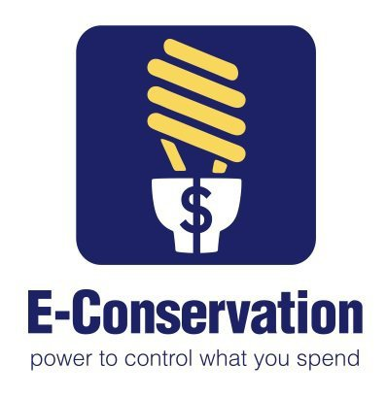
Marketing the E-Conservation Program
Created Fall 2013
HEMS E-Conservation Marketing and Partnership Development

Who in your county is interested in energy conservation?
Have you built relationships with them?
Are they willing to partner with you?
What are the benefits of partnering?
- They can help you market your program and can often help you find resources to help homeowners with the $100 cost of an energy audit.

Who is interested in energy conservation?

- Habitat For Humanity
- Community Action (find your county CA group at http://www.energync.net/ and click on "North Carolina Weatherization Assistance Program" link on the right column. County CAs can be found at the end of the document)
- Power/Utility Companies
- Senior Services
- Social Services
- Churches
- ECA
- Groups organized around topics such as the environment, gardening, etc.
- City/County employees
- Neighborhood Groups

Benefits of Partnering:

- Builds relationships for other programs and activities
- Promotes both you and the partner in the community
- Avoid duplication of services
- Extends man power
- Possible funding source
- Makes for stronger data collection
- Local resource for you and clients

Don’t Forget The Media:

- Write news releases
- Develop flyers
- Post on neighborhood listservs (can be obtained through city govt)
- Inserts for partners’ publications
- Radio & TV Spots
- Email listserves and alias (community groups, school groups, churches, city/county employees, etc)
- Post to NCCE web calendar and you County homepage
- Facebook, blogs, twitter, etc

