Certified Plant Professional
Training Registration Form

Name:________________________

Address:_______________________

______________________________

City:__________________________

State:__________ ZIP:___________

Phone:(work)___________________
(home)___________________
(cell)_____________________
Email: _________________________

Training Fee:
$160 including manual
$100 if you already have the paperback manual updated in 2002.


PLEASE CALL DANNY LAUDERDALE (252.902.1701) IMMEDIATELY IF INTERESTED FOR REGISTRATION PURPOSES. The CPP Training must have at least 10 participants in order to hold the class. We will notify you if the class is cancelled due to low interest.

Make checks payable to Pitt County Mutual Exchange and mail with form by August 22, 2013 to:

NC Cooperative Extension
Pitt County Center
Attn: Danny Lauderdale
403 Government Circle, Suite 2
Greenville, NC 27834
Wilson County Agricultural Center
1806 SW Goldsboro St
Wilson, NC 27893

Pitt County Agricultural Center
403 Government Circle
Greenville, NC 27834

Materials Required:
Calculator
Clipboard
Notebook
Pen
Pencil
Highlighter

Optional materials:
Camera to take pictures of plants and characteristics.

Distributed in futherance of the acts of Congress of May 8 and June 30, 1914. North Carolina State University and North Carolina A & T University commit themselves to positive action to secure equal opportunity regardless of race, color, creed, national origin, religion, sex, age, or disability. In addition, the two Universities welcome all persons without regard to sexual orientation. North Carolina State University, North Carolina A & T University, US Dept. of Agriculture, and all local governments cooperating.

2013 Certified Plant
Professional Training Course
(Participants must attend all classes listed below!!!)

Date: Location:

September 5 Pitt County
Ag. Center

September 12 Wilson County
Ag. Center

September 19 Pitt County
Ag. Center

September 26 Wilson County
Ag. Center

October 3 Wilson County
Ag. Center

October 10 Pitt County
Ag. Center

October 17 Pitt County
Ag. Center

October 23 Exam Review

Class Time: 9 AM – 4 PM

Prepare for the Certified Plant

Professional Exam to be given in

Greenville on October 24, 2013 at the

Pitt County Agricultural Center.
What is Certified Plant Professional?

Certified Plant Professional (CPP) in North Carolina is a written and plant identification test that seeks to recognize proficiency in the nursery workforce, upgrade the status of the nursery professional, and provide the public with a means of identifying qualified nursery professionals. To become a CPP, an applicant must pass the written test and the plant identification test by correctly answering 70% of the questions on each and document 12 months of experience in plant production or sales. If one exam is failed, it may be retaken at a later date.

Benefits of Certification

- Promotes professionalism within the wholesale and retail nursery industry.
- Validates nursery skills.
- Creates opportunities for career advancement within the industry.
- Step toward Registerd Landscape Contractor Title

Test Registration
Registration for the training does not include cost of exam registration and does not register you for the exam. Exam registration must be done through the NC Association of Nurserymen by calling (919) 816-9119 to receive a registration form. Deadline for registration for the
Greenville exam is October 13, 2013.
Training Requirements

Due to increased difficulty of the exam, plant identification and the CPP manual will be covered in this training. Participation in the training helps in passing the exam but does not guarantee it. Participants must be willing to come to all training dates, be on time, not leave early, ask questions, speak in botanical names, and study outside of class. This training has been completely revised to help you prepare for the exam. However, you must be committed and do all the things listed above if you expect to pass the exam.

Be prepared to be outside regardless of weather.

Quizzes will be given weekly and graded by the instructors.

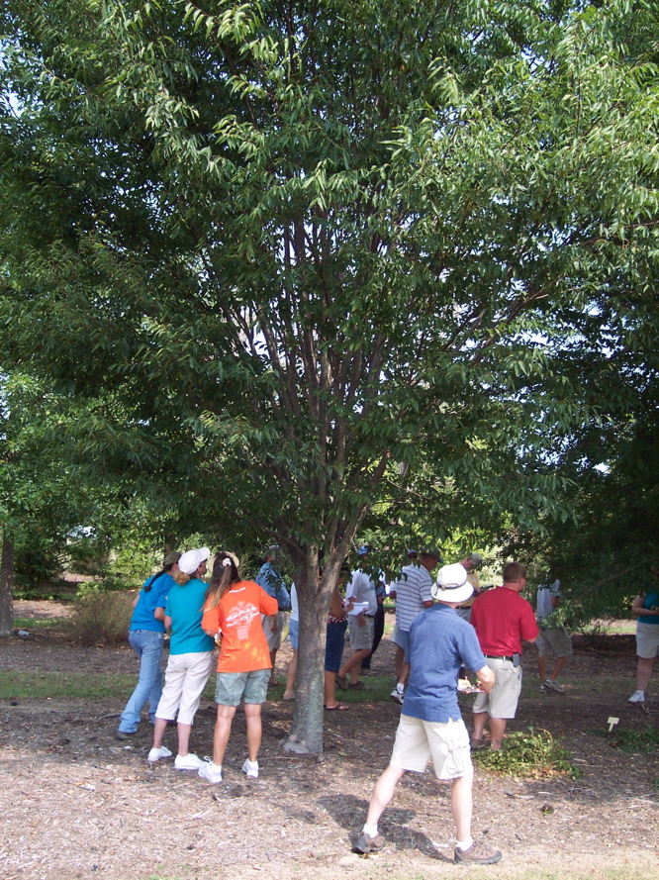

Instructors

Cyndi Lauderdale
Extension Agent
Agriculture-Horticulture


Cyndi is responsible for coordinating and implementing educational programs for commercial ornamental/turfgrass and consumer horticulture in Wilson County. She is a Certified Plant Professional and a Certified Landscape Technician.

Danny Lauderdale
Extension Agent
Agriculture-Horticulture


Danny believes education is one of the keys to success in the green industry. Danny takes pride in his ability to offer hands-on training to professionals in this exciting field. He is a Certified Plant Professional, Certified Landscape Technician, Certified Turfgrass Professional, Certified Arborist, and Registered Landscape Contractor.

