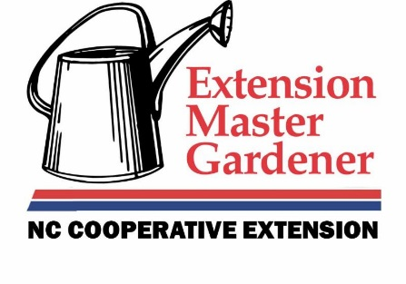

Pender County Extension Center
801 S Walker Street
Burgaw, NC 28425
(910)259-1235

NC State Extension Master Gardener Volunteer Program
(Application)

Name______________________________________________________________
Address____________________________________________________________
City_____________________________________State___________Zip_________
Phone (Home) _________ (Cell)_________ Best time to call____________
Email______________________________________________________________

Current employment status:
__ retired __ work full time __ work part time __ not employed for pay

Please circle your highest education level:
6 7 8 9 10 11 12 College: 1 2 3 4 5 6 7 8

Years of gardening experience in this area: _________________

Why do you want to become an Extension Master Gardener Volunteer?
____________________________________________________________________________________________________________________________________________________________________________________________________________________________________________________________________________________________________________________________________________________________________________________________________________________________________________________________________________________

List your top three areas of gardening interest: Example: vegetables, roses, houseplants, etc.
__________________________________________________________________________________________________________________________________________________________________________________________________________________________________________

List any gardening groups in which you are currently active:
__________________________________________________________________________________________________________________________________________________________________________________________________________________________________________

List any formal training in horticulture/gardening:
__________________________________________________________________________________________________________________________________________________________________________________________________________________________________________

List programs/services you have received or participated in from NC State Extension:
__________________________________________________________________________________________________________________________________________________________________________________________________________________________________________

List volunteer roles you are most interested in performing:
__________________________________________________________________________________________________________________________________________________________________________________________________________________________________________
List any special skills that might be useful in a volunteer capacity. Examples: computers, graphic design, teaching, etc.
__________________________________________________________________________________________________________________________________________________________________________________________________________________________________________

Indicate the best day and time for you to do volunteer work. Example: Friday mornings.
__________________________________________________________________________________________________________________________________________________________________________________________________________________________________________

List any previous work experience that might assist you in the NC State Extension Master Gardener Volunteer program:
__________________________________________________________________________________________________________________________________________________________________________________________________________________________________________

Previous volunteer Experience:
Organization Position Number of Years
__________________________________________________________________________________________________________________________________________________________________________________________________________________________________________

How did you find out about the Extension Master Gardener Volunteer Program?
____________________________________________________________________________________________________________________________________________________________

We use the internet extensively for research and for program communications. How often do you:
Use the internet? ______________times/week
Check email? ____________times/week
Your answer will not affect you acceptance in the program
Please provide two personal references we can contact (no relatives, please):
Name_________________________________________________
Phone_____________________
Name_________________________________________________
Phone_____________________

I wish to become a participant in the Extension Master Gardener Volunteer Program. I understand the applications will be screened to select the best candidates to assist with consumer horticulture educations. If accepted, I agree to volunteer a minimum of 40 hours of service to the Pender County Extension Master Gardener Volunteer program within one year following class completion, including at least 20 hours on the info line at the Burgaw Extension Center. I understand that there will be a non-refundable training fee due on the first day of class.

Signature:________________________________________________ Date:________________________

Please return to:
Tim Mathews
Pender County Extension Center
801 S. Walker Street
Burgaw, NC 28425

North Carolina State University and North Carolina A&T State University commit themselves to positive action to secure equal opportunity regardless of race, color, creed, national origin, religion, sex, age, veteran status or disability. In addition, the two Universities welcome all persons without regard to sexual orientation

