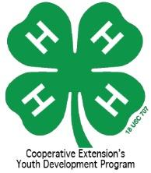
Rowan County 4-H’er of the Year Application

Winner will receive $100 in Cloverbucks to go toward district, state or national
4-H event(s) of the winner’s choice!

This application MUST be completed by the 4-H’er.
Parents and club leaders SHOULD NOT complete this application for them.

Please read the following carefully as some details of this award have changed. All portions of the packet must be turned in to the 4-H office by Friday, January 22, 2020.

This award will recognize ONE outstanding “4-H’er of the Year” for Rowan County who has gone above and beyond in his/her 4-H career.

Before 2019, this award was given in 2 age divisions: Junior (ages 9-13 as of January 1) and Senior (ages 14-18 as of January 1). This year, the winner must be age 13-18 (as of January 1). If you have previously won this award in the senior division (ages 14-18 as of January 1) or the new 13-18 age division, you are not eligible for this award.

Criteria to be used in judging will be the applicant’s 4-H career, participation on various levels (county, district, state, etc.), leadership abilities, and how well the 4-H’er exemplifies the qualities of 4-H. A winner will be chosen by a panel of judges and will be announced at the annual 4-H Achievement Night.

There are three parts to this process:
- Complete the application with the help of your parents and leaders, as needed. Make sure it is neat and legible.
- Submit up to ten pages (or 5 pages front to back) of awards, photos, personal stories, etc. that represent your 4-H career.
- Attend an interview with the panel of judges. Applicants should dress appropriately and be prepared to answer the judges’ questions, plus give an introduction of yourself and why 4-H is important to you. Each applicant will also be given the opportunity to make closing remarks and to thank the committee for their time.
  - **If there is only 1 applicant and his/her application is complete, the interview component may not be held.

If you need any help with your application, please feel free to contact Laura Allen, 4-H Extension Agent, at laura_allen@ncsu.edu or at 704-216-8970.

Again, the application MUST be turned in by Friday, January 22, 2021.
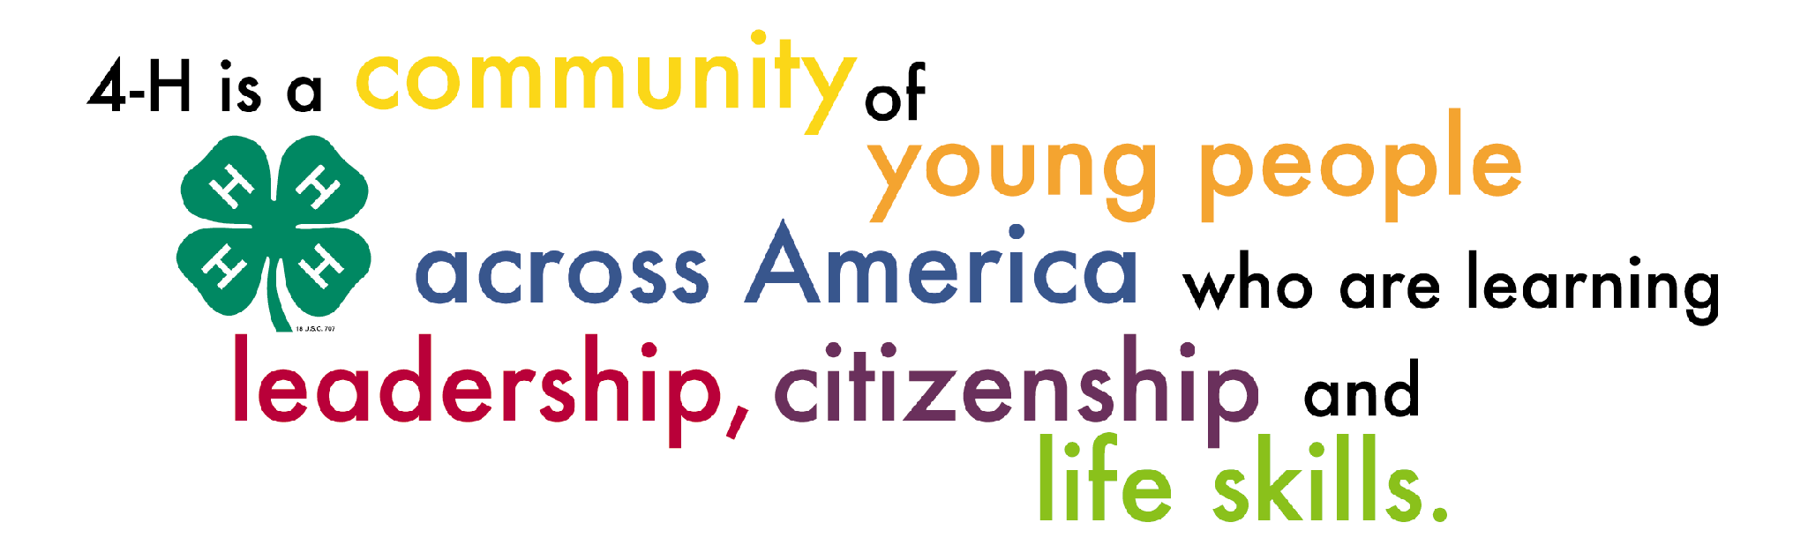

Rowan County 4-H’er of the Year Application

Name: ___________________________________________________________________________________
Address: __________________________________________________________________________________
Your E-mail: ______________________________________ Phone: _____________________________
Parent’s E-mail: ____________________________________________________________________________
4-H Club(s): ______________________________________________________________________________
Age as of January 1: _______________ Are you registered in 4HOnline? Please circle: Yes No

If you have received 4-H’er of the Year in the past, please list the year(s): ______________________________

As the parent or legal guardian of ______________________________________, I am aware they are applying for Rowan County 4-H’er of the Year. I will work with my child, support them, make sure they are ready to attend the interview on the time and date set, and that they will also attend 4-H Achievement Night.
Parent Signature: ______________________________________ Date: _______________
As the 4-H leader, I have reviewed the above individual’s application and agree to support him/her in this process.

Leader Signature: ______________________________________ Date: _______________
As the 4-H Agent, I verify that the above individual is a member in good standing in the Rowan County 4-H Program.

4-H Agent Signature: ______________________________________ Date: _______________
Instructions for completing the application:
Information should be placed in the most appropriate category. Please do not duplicate information. If more space is needed, you may insert an additional page or use the back of the page. Please include information for your entire 4-H career. You may handwrite or type your application. If you type your application, please reduce the font size in the charts to size 12.

Categories include:

- Community Service
- Citizenship
- 4-H Promotion
- 4-H Leadership/Teaching Experiences
- 4-H Offices & Committees
- 4-H Project Records
- 4-H Portfolios (ages 13 & above)
- 4-H Presentations
- 4-H Exhibits & Displays
- Special 4-H Activities/Awards
- Personal Statement

Community Service
Community service involves contributing to the quality of life in your community. Like many 4-H'ers, you may have participated in community service activities for your club or by yourself. Please list all community service projects completed. Please include the year the activity was completed (starting with the most recent) and the number of hours of service. In the column labeled “Level,” please indicate if it was an individual, club, county, district, or state level project. If you are listing non 4-H community service activities, please list only those for which 4-H has helped you prepare. Examples include: volunteering at your local animal shelter, participating in a food drive, holding a fundraiser for your 4-H club, etc.

Year | Community Service Project | # of Hours | Level

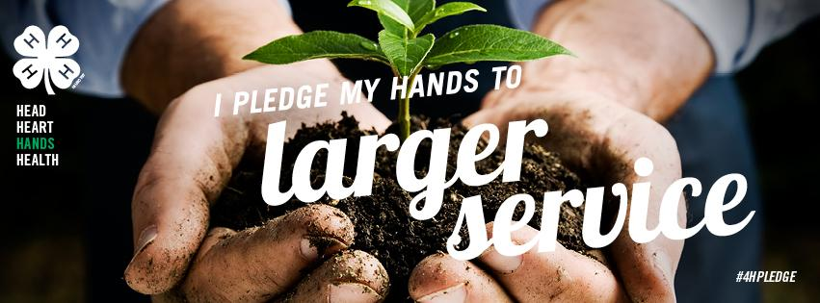
Citizenship
As a 4-H’er, it is important to participate and be involved in the political process and make a civic contribution in your community. Please list all citizenship activities that you completed here, including the year completed. Please start with the most current year first. If you are listing non 4-H citizenship activities, please list only those for which 4-H has helped you prepare. Examples include: attending a town meeting where you were representing 4-H; sending a message to your state legislator about 4-H teen issues that have been identified on the state 4-H program level; promoting 4-H and Cooperative Extension to county commissioners or other government representatives, etc.

Year | Citizenship Project

4-H Promotion
Please list the ways you have helped to promote 4-H and list the year. Please start with the most current year first. Examples include: radio, TV, newspaper, speaking to civic groups, etc.

Year | How I promoted 4-H
4-H Leadership/Teaching Experiences
Leadership involves teaching workshops, volunteering at 4-H day camps, leading/facilitating club programs, organizing events and meetings, recruiting new members, serving as a 4-H Ambassador, and motivating peers to set a goal and take action. List ways you have been a leader and/or have learned about leadership. If you are listing non 4-H leadership activities, please list only those for which 4-H has helped you prepare. Please list your 4-H Leadership/Teaching Experiences here, along with the year. Please start with the most current year first. Also include the number of people you reached through each activity.

Year | 4-H Leadership/Teaching Experiences | Number Reached

4-H Offices and Committees
Leadership also involves holding offices and serving on committees. Please list all offices you held and all committees you have worked on, along with the year. Please start with the most current year first. In the column labeled with “Level,” please indicate if it was a club, county, district, or state level office or committee.

Year | Office or Committee | Level
4-H Project Record Books
4-H Project Record Books are an important written summary of what you have learned and the skills that you have gained within your 4-H work as well as other parts of your life. List all 4-H project record books completed by year. Please start with the most current year first. In the column labeled with “Level,” please indicate if it competed at the county level only or both the county and district levels.

Year | Project Category/Subject of 4-H Project Record Book | Level

4-H Portfolios (ages 13 & above)
4-H Portfolios are an important written summary of what you have learned and the skills that you have gained within your 4-H work as well as other parts of your life over a three year period. List all 4-H Portfolios completed by year. Please start with the most current year first. In the column labeled with “Level,” please indicate if it competed at the district level only or both the district and state levels.

Year | Portfolio Category/Subject of 4-H Portfolio | Level
4-H Presentations
The 4-H Presentation and Public Speaking contests are held each year at the county, district, and state levels. Please list the year, title of your presentation, and check the appropriate boxes indicating at which level you gave your presentation. Please start with the most current year first.

Year | Title | County | District | State

4-H Exhibits and Displays
There are many opportunities in 4-H to exhibit items related to your project area, whether it is showing animals, exhibiting food, or participating in contests. Please list all of the activities and events you participated in to showcase your project, and check the appropriate boxes indicating at which level you gave your presentation. Please start with the most current year first. Examples include: activities such as livestock/horse shows, judging teams, fair booths, quiz bowl competitions, food shows, expressive arts contest, poster contests, photography contests, shooting sports competitions, etc.

Year | Description of Exhibit/Display | County | District | State | National
Special 4-H Activities/Awards
In this section, please include any 4-H activity or event that has not been included elsewhere. Also include any awards or recognition you have received through 4-H. Please list the most recent year first indicate the level of the activity/award (club, county, district, state, regional, or national).

Year | Activity | Level

Personal Statement
Please write a personal statement which includes how 4-H has impacted your life, how your 4-H participation has helped others, and who has helped you in your 4-H journey. Your statement must be a minimum of two paragraphs and a maximum of one page.

