

Youth ages 9-18!

4-H Sewing Classes

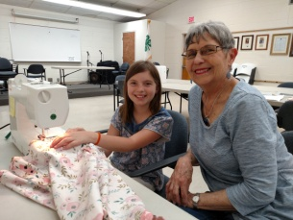

*Sewing for the first time?*

*Already know the basics?   
Come join us in class! Have a great time sewing and gain valuable knowledge!*

* **When:** Classes will be held in May, July, September, November. Classes begin the first week of the month and are a four week series meeting weekly on Thursday afternoons with the choice of two different times.   
   **Session 1**: 1:00-3:00  
   **Session 2**: 3:30-5:30  
  *July classes will begin June 27th to accommodate July 4th.
* **Where:** Held at the NC Cooperative Extension, Henderson County Center.   
  100 Jackson Park Road, Hendersonville, NC 28792
* **Registration:** $25 per class (pattern, sewing kit, machines, and adult teachers provided).

**May and July classes:**

Garment sewing, projects will be chosen from provided patterns

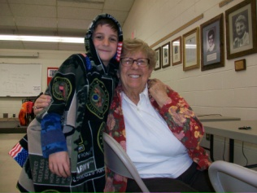

For questions about classes, registration, and other 4-H programs contact Hannah Worrell.  
Email: hlworrel@ncsu.edu or phone: (828) 697-4891

NC State University and N.C. A&T State University commit themselves to positive action to secure equal opportunity and prohibit discrimination and harassment regardless of age, color, disability, family and marital status, genetic information, national origin, political beliefs, race, religion, sexual identity (including pregnancy) and veteran status. NC State, N.C. A&T, U.S. Department of Agriculture, and local governments cooperating.

State University and N.C. A&T State University commit themselves to positive action to secure equal opportunity and prohibit discrimination and harassment regardless of age, color, disability, family and marital status, genetic information, national origin, political beliefs, race, religion, sexual identity (including pregnancy) and veteran status. NC State, N.C. A&T, U.S. Department of Agriculture, and local governments cooperating.



*4-H Age (as of January 1, 2019)* _______  
*July class will begin June 27th to accommodate July 4th.

*Sewing Registration Form*

Circle Class Month: **May July September November** Session: **1:30-3:00 3:30-5:30**

Name of Youth: ___________________________ Birth Date: _____/______/_______

School:__________________________ Grade:_____ Gender:_______________  
  
Parent/Guardian Name:____________________________   
  
Mailing Address:___________________________________

Circle all that apply:  
 White or Caucasian Alaska Native  
American Indian Native Hawaiian Black/African American Asian

  
City:_____________________ State:_______________ Zip Code: ________   
  
Email:___________________________ Phone number:_________________   
  
Emergency Contact Number:________________________   
  
Is your child allergic to any food or medicines? Please describe:__________________________  
______________________________________________________________________________  
Does your child have any special needs the staff should be aware of? Please describe:_________  
______________________________________________________________________________  
My son/daughter has permission to participate in the 4-H activities checked below. In case of a medical emergency, I understand that every effort will be made to contact me. In the event I cannot be reached, I hereby give permission to the Physician selected by Extension personnel to hospitalize, secure proper treatment for, and to order injection, anesthesia, or surgery for my child as named above.  
  
  
I authorize Cooperative Extension to use my child's image in newspaper articles, brochures, social media, and any other marketing efforts to promote the 4-H Youth Development Program.  
  
Parent/Guardian Signature:______________________________ Date:_________________  
  
Please describe youth's past sewing experience:______________________________________  
____________________________________________________________________________

For Office use:  
Amt paid: ________  
Cash paid: ________  
Check #: __________

**Class Drop Policy:**

**If a student drops out of a class, and there is less than one full week (7 days) before the class begins, no refund will be given.**

If you are a person with a disability and need accommodations to participate in this activity please call (828)-697-4891 at least 3 days prior to the event. The business hours are 8:30 a.m. - 5:00 pm (Monday-Friday).