Helpful Hits for Presenting of Zoom:
This sheet is intended to help you prepare to present a 4-H Presentations over a virtual platform. This sheet will provide you with some helpful tips as well as some links to resources on how to give and design a PowerPoint presentation for Zoom platforms.
Creating your PowerPoint Presentation
  - Keep it simple!
    - Avoid wordy text. Don’t write out your presentation on the slides. Only brief bullet points should be included on the slides.
    - Don’t flood your slides with images and clip-art. Keep a maximum of three images per slide. Make sure they don’t overlap text.
    - Don’t use crazy or bright overbearing themes. With Microsoft PowerPoint, you can make the slides any color of the rainbow. However, you don’t want to drown your viewer in color.
    - Avoid crazy transitions. The transitions between slides look cool, but can distract from the presentation.
  - Include a introduction and closing. Introduce yourself, your county, your club and your topic that you plan to address during your presentation.
  - Include a summary slide and a list of your resources.
  - DON’T FORGET VISUAL AIDS! Just because you are on a Zoom call doesn’t mean you can forget about the visual aids! If they are too large to show behind the computer screen, include pictures of your visual aid.
For more helpful tips on designing a PowerPoint Presentation, view these videos on YouTube.
Mind-blowing PowerPoint - Creating Effective Visual Presentations
https://youtu.be/6yiJyMAF6IE

Webinar Recording: amazing PowerPoint techniques
https://youtu.be/b52davdp9eE

How to Do a Presentation - 5 Steps to a Killer Opener
https://youtu.be/dEDcc0aCjaA

How to avoid death By PowerPoint | David JP Phillips | TEDxStockholmSalon
https://youtu.be/Iwpi1Lm6dFo

Giving Presentation on Zoom:
Giving a presentation via zoom can be a little nerve racking for first timers, but have no fear! Zoom is an easy platform to use and can make giving presentations a breeze. Here are some helpful hints for those users that are new to the platform on how to give PowerPoint presentations and look like a pro!

- Practice on your own blank meeting space. Be sure to record so you can critic yourself!
  - Create a meeting by selecting the “New Meeting” tab on the home screen. This will take you into a new meeting that will contain just yourself.

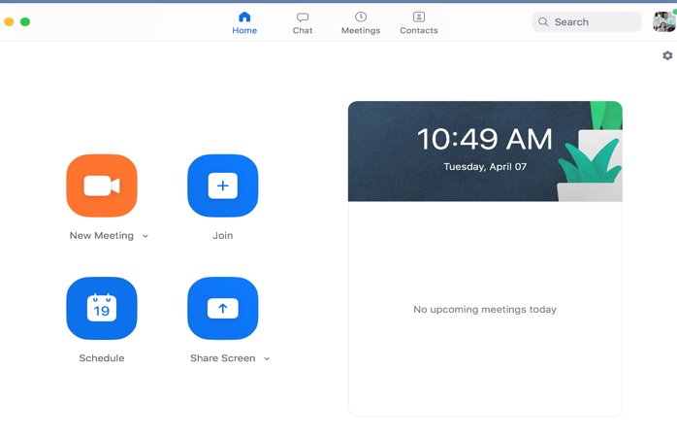

- When joining a meeting, make sure that you are unmuted and your video is on when giving your presentation.
  - There is a video and microphone icon in the bottom left-hand corner of the screen. When there is a red cross mark through these icons, your audio and visual inputs are muted. You can change these settings by simply clicking on the icons to unmute your microphone or to make your webcam live.

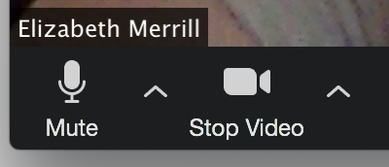
Video / Camera: This function allows you turn your camera/ webcam feed on and off. This icon is showing a live feed and you should be able to see yourself on screen.
Microphone: Controls your audio input. By clicking here, this allows others to hear you. This is showing a live mic.

Microphone / Video Opinions: This control allows you to control from what device your audio / visual input is coming from. If you are having audio or visual issue, check here first to make sure you have the correct device selected.

- Make sure that you can be well seen on your screen.
  - Don’t cut half your head off! Good rule of thumb is to make sure that your shoulders and above can be seen.
  - Don’t sit to close to your screen, but sit close enough that if you are using computer microphone you can be heard clearly.

- Be careful in the use of virtual backgrounds! These can be distracting to the person observing the presentation!
  - Zoom gives the feature of “virtual background” behind the speaker. You can choose from a various about of backgrounds loaded by Zoom. However be careful choosing or using these backgrounds. Some can be distracting. If you are going to use a background, use one that is relevant to your presentation. You can upload your own picture.
  - To add a virtual background, click the Video opinions tab and select “Select Virtual Background”.

- Chat box is where people can communicate during your presentation or ask questions. You can also use the chat box to share documents and handouts.
  - To access the chat, just select the chat box at the bottom of the scene.
  - At the bottom of the chat, you will see the text box. Here you will have the opinion to talk to the group or share documents.

- Recording a presentation can be done through the use of the recording feature of Zoom. The Record button is found next the chat button on the control bar.
  - To record, just click the record opinion. We you are finish recording, just select finish recording.

- When giving your presentation, you want others on the video conference call to be able to see it! This is where the share screen feature will come in handy!
  - To share screen, you must have permission from the host if you are not the host of the session. Be sure the host has given you permission if you are not the host.
  - Share screen allows everyone to see all tabs and windows open on the device…. Be careful what you share!

- You can also see the names of the individuals that are “participants” in your zoom sessions. In the case of presentations, it may be just you. This might be helpful on higher level competitions.
  - In the participants button located at the bottom of the screen, you will notice a number. This tells you how many people are currently “participating” in your zoom.
  - By clicking this button, you can bring up a dialog box that tells you the names of each participant.

More helpful tips can be found on the Zoom website at:
- https://support.zoom.us/hc/en-us/categories/200101697

