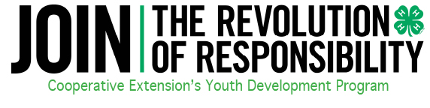
FILING OF IRS 990N

The e-Postcard is due by the 15th day of the fifth month after the close of your tax year. Since we operate on October – September, then we are to file Feb. 15 this year. What happens if you don’t file? You risk losing your tax-exempt status!

HOW TO FILE THE FEDERAL TAX FORM 990N AND/OR e-POSTCARD
1. Go to www.irs.gov.
2. Type in 990-N in the keyword search box.
3. Form 990-N (e-postcard) will appear as a search result - click on it.
4. At this page - click on link to file under “How to File”.
5. User will be advised they are leaving the IRS site and going to a site hosted by a private IRS vendor called “Urban Institute”.
6. Register as a new user - the user must have the individual club’s EIN to register.
7. Once registered, an e-mail will be sent to the user with an activation link. Click on the activation link and use the log-in ID that was established in step 6.
8. Create your form 990-N (e-postcard)
9. Submit your form 990-N (e-postcard).
10. Once filed - an e-mail confirmation will come indicating the filing occurred. User should keep this confirmation to present to County Extension Agents as proof of filing, which will now be a condition to charter 4-H clubs.

At any point during the process where the entry of the EIN is required, if an error message pops up indicating the EIN is not found – print oﬀ the error page as proof of your attempt to file and keep. If a late notice is generated this will be your proof that the system would not permit the filing.

To complete a 990-N e-Postcard, qualified 4-H Clubs & Aﬃliated 4-H Organizations will need to provide the following information.
1. Organization’s legal name - as legally chartered or otherwise formally tied to the organization’s EIN
2. Any other names your organization uses (not relevant for most 4-H Clubs & Aﬃliated 4-H Organizations)
3. Organization’s mailing address - as tied to the organization’s EIN.
4. Organization’s website address - if you have one.
5. Organization’s Employer Identification Number (EIN). This is a unique number that identifies the organization to the IRS, much like our personal Social Security Numbers identify individuals to the IRS - each club or group must have their own EIN
6. Name and address of the principal oﬃcer of your organization - this will be the club manager, treasurer etc.
7. Organization’s annual tax year - The North Carolina 4-H tax year is October - September, annually
8. Confirmation that your organization’s annual gross receipts are still normally $25,000 or less
