We are excited to announce that our Johnston County 4-H Fall Showcase will be in-person this year! However, given COVID-19, this program is subject to change and if needed will be held virtually. All information on how to register and participate can be found below. If you have any questions please contact Courtney Stanley at courtney_stanley@ncsu.edu or by phone at (919) 989-5380.

To participate, youth must be 5 years old as of January 1, 2021 and must be currently enrolled in the Johnston County 4-H program in 4-H Online. To register your child visit https://v2.4honline.com/.

The age categories as of January 1, 2021:
Cloverbuds: 5-7 years old - (Non-competitive)
Junior: 8-13 years old
Senior: 14-18 years old

ENTRY CLASSES
Crafts - Cloverbud, Junior & Senior – *Photography is included in cloverbud crafts
Photography - Junior & Senior
Entomology- Cloverbud, Junior & Senior

Youth are able to enter up to two items per category. Each entry that places 1st, 2nd or 3rd in each class will receive an award. Best of show will also be awarded per class in the Junior and Senior age category.
All Fall Showcase & NC State Fair entries must have been created by the 4-H member between
October 22, 2020- October 1, 2021.

FALL SHOWCASE SCHEDULE
- Register for Fall Showcase by completing the form below – all entries must be submitted by September 24th.
- Drop-off your items on October 5th or 6th at our office between 8am-5pm.
- Fall Showcase – October 7th at 6:30pm in the Extension Auditorium
- All entries registered for the NC State Fair will be taken to the fairgrounds on October 8th & entries not being taken to the fair may be picked up on October 7th.

Fall Showcase Registration Form
Please complete this form with a list of all your entries by September 24th
and email it to Courtney Stanley at courtney_stanley@ncsu.edu.

To enter your items into the NC State Fair, you must complete the following forms and mail them to the NC State Fair Entry Office by September 15th, 2021.
NC State Fair entry information can be found here!

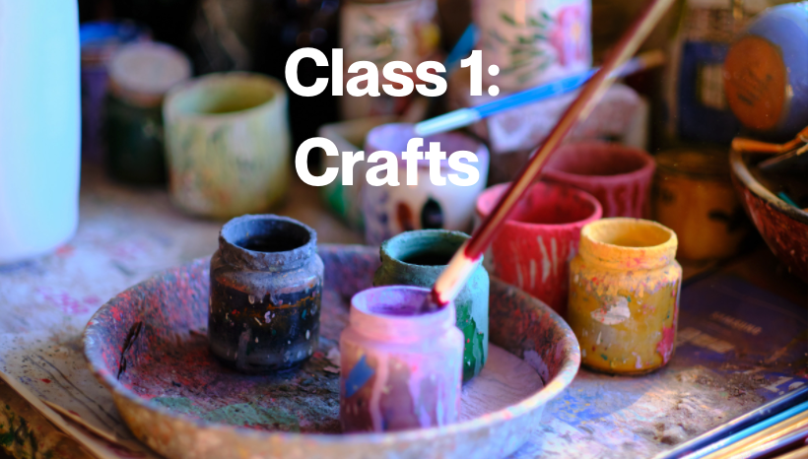
CRITERIA FOR JUDGING
Craftsmanship- 40 points
Originality and Creativeness- 30 points
Practicality and Usefulness- 30 points

CLOVERBUD CATEGORY- 5-7 YEARS OLD

Basketry (honeysuckle, reed, cane splits, or pine needles)

Block Printing

Braided Articles

Candle making

Crocheted or Knitted Articles

Cross-Stitch

Fabric Painting - Original Design

Fabric Painting - Pattern or Kit (no iron on decorations)

Handweaving/ Hand spinning

Hooked Articles
- Jewelry – Paper, Plastic, Fabric, Metal
- Leather Articles

Mechanical Crafts - (Robots, Rockets)

Metal - Embossed, Tooled, Etched, Tin Punched

Mosaics - Tile with Grout

Natural Materials

Needlework (needlepoint, crewel, embroidery, etc. or combination of a variety of stitches or techniques)

Pottery – Coil Slab, Wheel Thrown
- Pottery – Sculpted Animals
- Pottery – Pre-form Mold

Quilted Articles

Stained or Leaded Glass (no painted glass)

Stenciling

Stuffed Animals & Dolls

Tie Dyeing, Batik

Woodcarving – Original Sculpture, Animal, Toys, Bowls

Woodworking – Toys
- Woodworking – Accessories (shelves, small furniture, desk set, trays)

Wood Objects – From Kits

Recycled - any objects made from recycled materials

Miscellaneous - Any item that cannot be entered in the above categories.
- Artwork (Tempra, water color, oil, drawings, collages, ect.)
- Photography

JUNIOR CATEGORY – 8-13 YEARS OLD

Basketry (honeysuckle, reed, cane splits, or pine needles)

Block Printing

Braided Articles

Candle making

Crocheted or Knitted Articles

Cross-Stitch

Fabric Painting - Original Design

Fabric Painting - Pattern or Kit (no commercial iron on decorations)

Handweaving/ Hand spinning

Hooked Articles
- Jewelry – Paper, Plastic, Fabric, Metal
- Leather Articles

Mechanical Crafts - (Robots, Rockets)

Metal - Embossed, Tooled, Etched

Metal - Tin Punched

Mosaics - Tile with Grout

Natural Materials

Needlework (needlepoint, crewel, embroidery, etc. or combination of a variety of stitches or techniques)

Pottery – Coil Slab, Wheel Thrown
- Pottery – Sculpted Animals
- Pottery – Pre-form Mold

Quilted Articles
- Artwork (Tempra, water color, oil, drawings, pen/ink, collages, ect.)
- Digital Art (computer generated art) A wide range of photography in which digital media or technology is used to enhance or blend the images in a way to produce a new image

Stained or Leaded Glass (no painted glass)

Stenciling

Stuffed Animals & Dolls

Tie Dyeing, Batik

Woodcarving – Original Sculpture, Animal, Toys, Bowls

Woodworking – Toys
- Woodworking – Accessories (shelves, small furniture, desk set, trays)

Wood Objects – From Kits

Recycled - any objects made from recycled materials

Miscellaneous - Any item that cannot be entered in the above categories. No clothing constructions, including aprons.

SENIOR CATEGORY – 14-18 YEARS OLD

Basketry (honeysuckle, reed, cane splits, or pine needles)

Block Printing

Braided Articles

Candle making

Crocheted or Knitted Articles

Cross-Stitch

Fabric Painting - Original Design

Fabric Painting - Pattern or Kit (no commercial iron on decorations)

Handweaving/ Hand spinning

Hooked Articles

Jewelry – Paper, Plastic, Fabric, Metal

Leather Articles

Mechanical Crafts - (Robots, Rockets)

Metal - Embossed, Tooled, Etched

Mosaics - Tile with Grout

Natural Materials

Needlework (needlepoint, crewel, embroidery, etc. or combination of a variety of stitches or techniques)

Pottery – Coil Slab, Wheel Thrown
- Pottery – Sculpted Animals
- Pottery – Pre-form Mold

Quilted Articles
- Artwork (Tempra, water color, oil, drawings, pen/ink, collages, ect.)
- Digital Art (computer generated art) A wide range of photography in which digital media or technology is used to enhance or blend the images in a way to produce a new image

Stained or Leaded Glass (no painted glass)

Stenciling

Stuffed Animals & Dolls

Tie Dyeing, Batik

Woodcarving – Original Sculpture, Animal, Toys, Bowls

Woodworking – Toys
- Woodworking – Accessories (shelves, small furniture, desk set, trays)

Wood Objects – From Kits

Recycled - any objects made from recycled materials

Miscellaneous - Any item that cannot be entered in the above categories. No clothing constructions, including aprons.

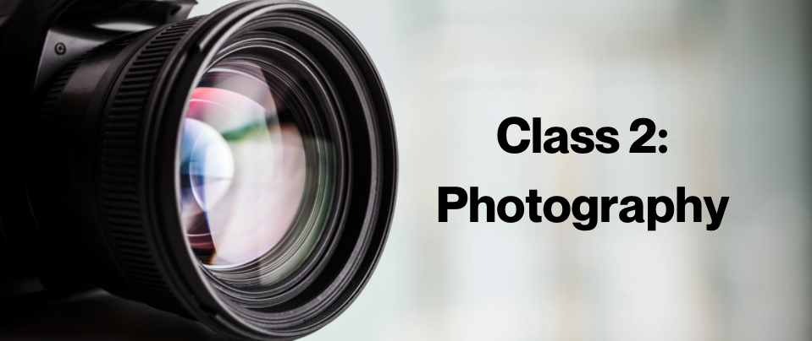

CRITERIA FOR JUDGING

Storytelling ability (Contains few or no distracting or unnecessary elements. - All the elements within the picture are arranged to tell the story.) - 50 points

Photographic Quality (Clear and sharp and shows detail in areas where appropriate.) - 30 points

Mounting (no larger than 8x10 mounted and are mounted neatly and securely) - 10 points

Captions (Pictures have appropriate captions) - 10 points

*CLOVERBUD PHOTOGRAPHY IS INCLUDED IN CLASS 1

SENIOR CATEGORY – 14- 18 years old
Color

Landscape or Seascape

Buildings

People (individual or group)
- Animals, Birds, or Insects
- Miscellaneous

Black & White
- Black & White

Picture Stories
116 Computer Enhanced Photography (using technology to enhance your photographs)
- Photographs of 4-H projects/activities

JUNIOR CATEGORY – 8-13 years old
Color

Landscape or Seascape

Buildings

People (individual or group)
- Animals, Birds, or Insects
- Miscellaneous

Black & White
- Black & White

Picture Stories
- Computer Enhanced Photography (using technology to enhance your photographs)
- Photographs of 4-H projects/activities

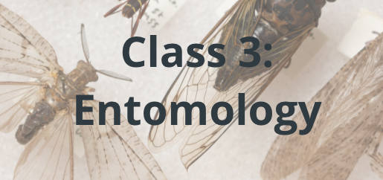

CRITERIA FOR JUDGING
- General appearance and neatness of arrangement
- Care in preparation of the insects
- Placing and completeness of labels
- Number of orders and specimens of North Carolina insects correctly identified

Class 107: Entomology – Insect collection

Cloverbud 5-7 (Non-competitive)
- Junior 8-13
- Senior 14-18

Class 108: 4-H Entomology - Special study or exhibit

- Junior 8-13
- Senior 14-18

