Section 1: My 4-H Project Plan
(5 thru 7 Year Olds)

_____________________________
_____________________________
_____________________________

Names of Projects
(you may add lines for more projects)

Name Date of Birth Age

(as of January 1, 2020)

Address

County Extension District

Name of 4-H Club, After-School

Program, or Group

Years Enrolled in 4-H

Name of Parent(s) or Guardian(s)

Date Plan Started Date Plan Completed

I have reviewed this plan and agree to support its completion:

(Parent or Helper) (4-H Leader)

Welcome to the wonderful world of 4-H. We are excited that you’ve joined the
world's largest educational youth program. As a 4-H member, you get the opportunity to
create your own plan. In this plan, you'll record everything you'd like to do in 4-H during
the year. Then you'll begin to do the things you planned. You'll be learning new skills,
doing new activities, and sharing what you've learned and done. You'll even apply what
you learn in one project to another project or to some school activity.

This planning form has been prepared especially for you, the 7 or 8 year-old
4-H'er. To make sure you have the correct form, please find out when your county
projects are submitted for county competition. If you are 7 or 8 on January 1 of the
same year you are submitting the project for competition, you are using the correct form.
If you aren't sure, ask your helper for guidance.
Please ask a helper to assist you in making your own plan for this year. This
helper might be a parent or guardian, an older friend, your 4-H leader, or another 4-H'er.
You and your helper can select 4-H subjects about which you'd like to learn this year. List
those subjects in the blank spaces above labeled "Names of Projects."
4-H is fun! Have a great time as a 4-H member.

Planning My 4-H Year
What would you like to do in 4-H this year? You might want to go fishing with your club or
learn how to launch rockets. Perhaps, you'd like to clean up your neighborhood or learn to make pizza. The possibilities are endless.
This page is designed for you to record what you want to do and learn this year. The things
you plan to learn and do are called "goals." Goals can be completed alone or with your friends.
To begin, list the things you'd like to learn or do. List things like participating in specific projects, going to 4-H camp, modeling in a fashion show, serving as a 4-H helper for your leader, and serving as an officer. You will want to include goals for each project you are planning to do.
You also might think of new goals during the year. If you do, just add them to your plan
along with the month you think you'll do them.

MY 4-H PLAN

What things do you want to learn or do? | Month to do them
Examples:
Go to 4-H Camp | July
Be in a health skit | May
Make a lamp | March
Enter a rodeo | When it’s scheduled
Make and shoot a rocket | Spring

Record your plans below:

_________________________________________________________________________________

_________________________________________________________________________________

_________________________________________________________________________________

_________________________________________________________________________________

_________________________________________________________________________________

_________________________________________________________________________________

_________________________________________________________________________________

_________________________________________________________________________________

_________________________________________________________________________________

Reminder: You may add additional pages and you may add to the plan during the year as
you think of other things you want to do. Attach a copy of this 4-H Project Plan and your
Story to each Project Record.

Section 2: My 4-H______________________
Project Record
(5 thru 8 Year Olds)

(9

My Name __________________________ My 4-H Club Name ___________________

A separate Project Record should be completed for each project you did this year. List the specific things you learned and did in this project during the past year. List new knowledge you gained. Be sure to include the things you learned how to do. Use numbers to show how much you did, how many items you made, how much money you earned or saved, etc.

Note: This page should be completed for each project you have done this year. If a project
record is included in your project book, complete the record and attach it to this sheet.

1. Things I Learned and Did in This Project | Date(s) When I Learned/Did
Example: | May 15
How to write safety skit | May 15
Went to 4-h Camp at Swannanoa—used safety rules | July 4-8
Rode my bicycle in rodeos
Learn bicycle safety rules | March 10, May 1, Nov. 8
Learn proper bicycle hand signals | Feb. 16; Mar. 4 & 19, Apr. 7

_________________________________________________________________________________

_________________________________________________________________________________

_________________________________________________________________________________

_________________________________________________________________________________

_________________________________________________________________________________

___________________________________________________________________________

_________________________________________________________________________________

_________________________________________________________________________________

_________________________________________________________________________________

_________________________________________________________________________________

_________________________________________________________________________________

_________________________________________________________________________________

_________________________________________________________________________________

(You may add additional pages. Please turn the page to record more 4-H successes in this project)

2. Did you "show or tell" any other people what you did in your project this
year? If so, how? (family, "show and tell" at school, church, community,
neighbors, friends, etc.)

_________________________________________________________________________________

_________________________________________________________________________________

_________________________________________________________________________________

_________________________________________________________________________________

_________________________________________________________________________________

_________________________________________________________________________________

3. Did other people help you with your project? If yes, how did they help?

_________________________________________________________________________________

_________________________________________________________________________________

_________________________________________________________________________________

_________________________________________________________________________________

_________________________________________________________________________________

_________________________________________________________________________________

_________________________________________________________________________________

_________________________________________________________________________________

(You may add additional pages)

My Personal Touch:
Creating a Mini-Scrapbook

Use your creativity in this section to tell special things about your project in Section 2. You might include pictures, news clippings, drawings, collages, poems, or anything else you have collected or done in 4-H this project. (You may add up to six pages in this section. Note that each side of a page counts as one page)

Reminder: You may use additional pages for questions 1 - 3. Be sure that you follow the page guidelines for the Personal Touch Section. Attach a copy of your Personal Touch items to the 4-H Project Plan, My 4-H Story, and Project Record.

My Name___________________
Section 4: My 4-H Story
(5 thru 7 Year Olds)

Please write a story about yourself, your family, and your friends. Include what you did in 4-H this year. Be sure to write at least one paragraph on each project you completed. What did you enjoy most? What did you learn about? What special events did you attend?
Include sections that help the reader understand your contributions to activities and to other people in your group. If you were involved in community service or citizenship, be sure to explain what you did.
Let your creativity help you tell your 4-H story in a unique way. Please pay attention to your spelling and grammar.

_______________________________________________________________________________

_______________________________________________________________________________

_______________________________________________________________________________

_______________________________________________________________________________

_______________________________________________________________________________

_______________________________________________________________________________

_______________________________________________________________________________

_______________________________________________________________________________

_______________________________________________________________________________

_______________________________________________________________________________

_______________________________________________________________________________

_______________________________________________________________________________

Remember: Attach a copy of this 4-H Story along with your 4-H Project Plan and 4-H Activities to each Project Record.
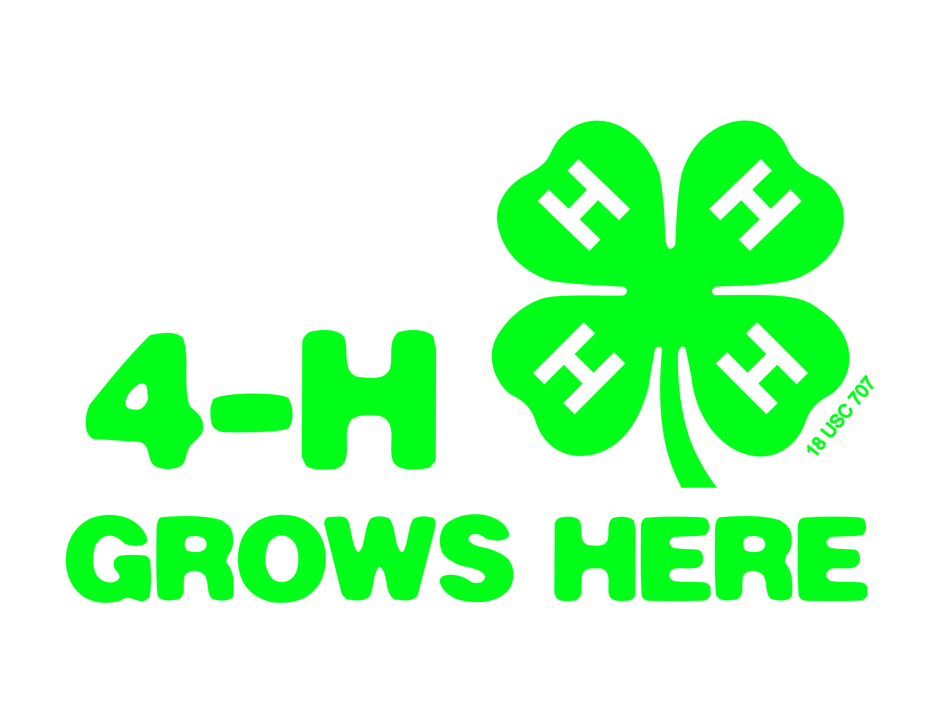


North Carolina State University and North Carolina A&T University commit themselves to positive action to secure equal opportunity regardless of race, color, creed, national origin, religion, sex, age, veteran status or disability. In addition, the two Universities welcome all persons without regard to sexual orientation. North Carolina State University, North Carolina A&T University, U.S. Department of Agriculture, and local governments cooperating.

