Cloverbud Chicken Project
(7 year olds)

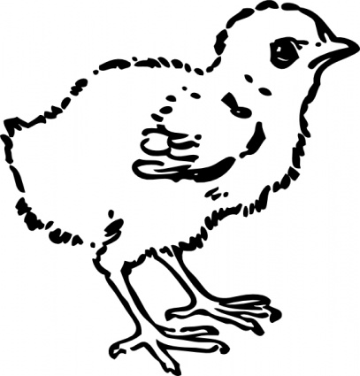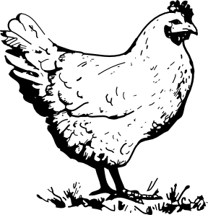

Name:_________________________________________________________________

Age: ___________________________ (as of January 1)

County: _______________________________________________________________

North Carolina State University and North Carolina A&T State University commit themselves to positive action to secure equal opportunity regardless of race, color, religion, creed, national origin, sex, age, disability, or veteran’s status. In addition, the two Universities welcome all person without regard to sexual orientation. North Carolina State University, North Carolina A&T State University, U.S. Department of Agriculture, and local governments cooperating.
4-H Chicken Project for Cloverbuds
“The Incredible Baby Chicks”

My name is ___________________________________________.

I live in ________________________________________ County.

I am _______________________ years old.

I got _______________________ baby chicks to raise.
(How many?)

They are _____________________________________________.
(What breed?)

Please draw or attach a picture of your chicks here.

What you will learn about this project:

- How to prepare for the arrival of your chicks
- How to take care of chicks
- The development of chicks (how the chick grows)
- How to identify body parts of a chicken and parts of an egg
- Making wise decisions and being responsible
- How to identify different breeds of poultry

Objectives:

- Learn to care for chickens as they grow
- Share what you learn with your friends and family
- Learn to handle chicks and chickens safely and correctly
- Learn what being responsible for your chickens means
- Complete your Cloverbud Pullet Project Record

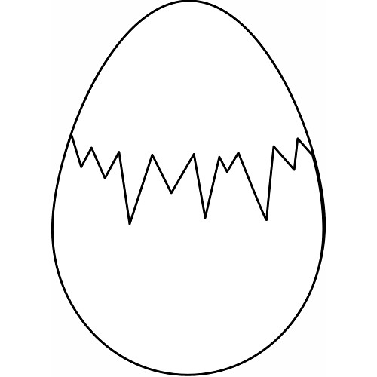

Preparing for baby chicks:
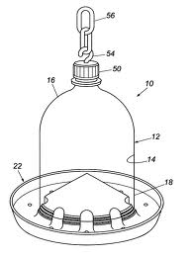
Get help to prepare for your new baby chicks when the new chicks hatch or arrive at your door- you need to be prepared. This is the most important stage of the chick’s life: from the time of arrival to the time the chicks are at least six weeks old. You will need the following: brooder box with a bedding lamp as a heat source, a feeder jar, special feed, and a water jar.

Circle which ones you have for the chicks:

Chicks need food
and water at all times. Waterer

Feeder tray or jar

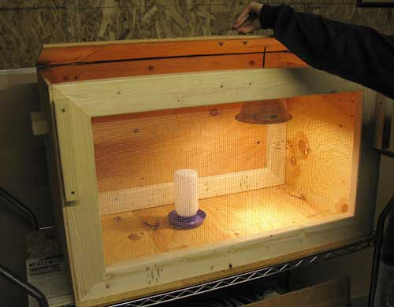
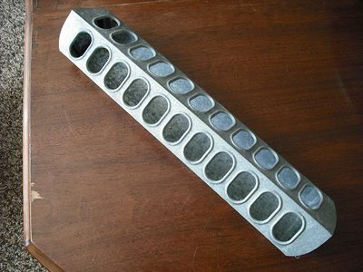
Brooder Box with bedding-
clean daily

Make sure you have Starter Feed for your baby chicks
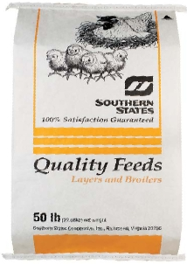
Lamp- a heat source and light
are needed for the first week or two.

Match these with the correct answer:
_____ brooder box A. light to keep chicks warm
_____ heat source B. use to water baby chicks
_____ water jar C. use to put feed in for chicks
_____ feeder try or jar D. what baby chicks eat
_____ starter feed E. to keep chicks in at first
Where my Chickens Came From:
Label these and color them. (Rooster, hen, chick and egg)
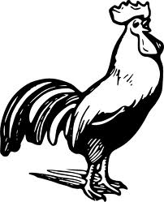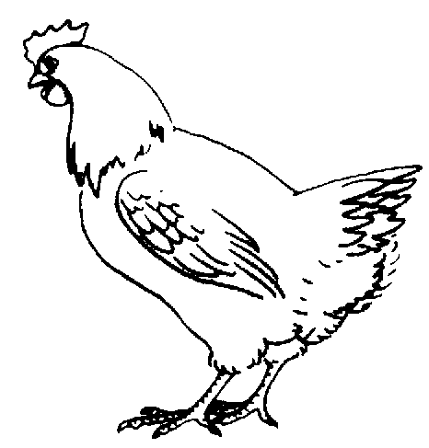

____________________ ______________________
Male chicken Female chicken

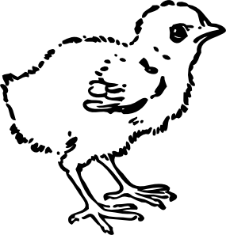

____________________ ______________________

Young chicken Fertile egg

Label the parts of the egg below, then color the egg.

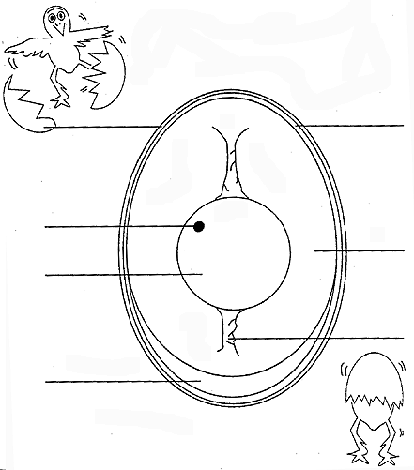
Egg parts:
(look these up in the
glossary if you
need to)

Chalaza
Albumen
Yolk
Germ spot
(germinal disc)
Shell
Air cell
Shell membrane

Draw a line to the correct part of the chick below then color it.

Breast

Wing
Back

Head
Toe

Eye
Beak
Sharing how to care for my baby chicks:

Sarah has learned a lot about doing her 4-H Chicken Project. She has written a story about how she cares for her baby chicks, but she needs your help to fill in the correct answers to complete the story. Use the word bank below to fill in the blanks.

I feed my ________________ several times each day while they are young.

They eat ___________________, a special feed that I get from the feed store.

They need clean ___________________ to drink at all times.

Until they are a few weeks old, I keep them in a ___________ _____________

with a ________________ to keep them warm. I use ___________________
for bedding and keep it clean daily. I do not use slippery paper because it will
cause them to slip and hurt their _________________. When my chicks are

older, I will put them outside in a fenced yard with a chicken ______________

for them to roost at night. They grow very fast! I really like to spend time with

my chickens. I learn all I can about them to make my __________________

project a success. I plan to show 1 of my chickens at our 4-H Chick Chain Show

this fall. I can’t wait until they are 18 to 22 weeks old and start laying

_________________. We may use some, share some, and sell some.

Lamp/light Water

4-H Straw/shredded paper

Feed Brooder box

Legs Coop

Baby chicks Egg

Find the words listed below and circle them.

A G T H A N D S B U P U F L R
V N G H E K Z W Y K D Y E V N
H A Z L Z G P Y O P M M E T T
R M M M E U G R L E H B D A R
T C Q L S A E S K G B E E Z A
U A V T J D R X B R A A R Z E
R R I M O Q V N J E M K E K H
K E S O R O O S T T Y R D M Z
E I R G F F N J J S R H B P Y
Y B E A N E H O B O T C N U O
S H E A D J F G O O L C M L Z
T V S K C I H C K R U O F L M
X N L D K C U D C H O O D E I
N H T L A E H V I L P P Z T X
G E Q B H W R N E S T A H S B

Beak | Feeder | Nest
Brooder | Hands | Poultry
Care | Head | Pullets
Chicks | Health | Roost
Coop | Heart | Rooster
Duck | Hen | Turkeys
Eggs | Learn | Yolk

Write a story about your flock.
What have you learned? Would you ever take another poultry project? What did you like or not like about your project? What would you change about your project for the future?

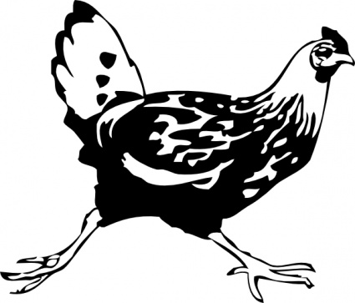
________________________________________________________
____________________________________________________________
____________________________________________________________
____________________________________________________________
____________________________________________________________
____________________________________________________________
____________________________________________________________
____________________________________________________________
____________________________________________________________
____________________________________________________________
____________________________________________________________
____________________________________________________________
_______________________________________
_______________________________________
_______________________________________

Pictures of me and my flock, or pictures of poultry in newspapers and magazines. Include a short sentence about each picture.

As your baby chicks grow, they will need a bigger area. They can be moved outside, but they will still need you to care for them. The chicks will need food and water every day. They will also need a safe place to stay. A chicken coop will keep them safe from other animals. You need to feed them a good medicated starter feed for the first 6 to 8 weeks, then change to a chick growth feed until they start laying around 18 to 22 weeks old. The pullets (female chicks, not yet a year old) will begin to lay eggs and will need a nesting box. Four or five pullets (or hens) will use the same nest.

Check with your 4-H leader or Extension Agent for more information. You can also get a book from the library that will tell you about raising poultry. Get ready for the Chick Chain Show using this checklist to help you.

A Good Showman’s Checklist:

- Pick your best pullet/hen for the show

- Know what breed your chickens are

- Know what you feed them

- Know where the beak, wing, leg, breast, and comb of your chickens are located

- Know where you keep your chickens in a coop or fenced yard

- Complete your 4-H Project Record Book

- Remember to have fun as you learn to care for your chickens

Do your best….. To Make the Best Better!!!

Finances:
Keeping track of the money you spend and the money you make on your chickens is important. The goal for a poultry project is to make more money from your chickens than you spend. Here are some things to think about:

I received _________ chicks.

A bag of chick starter feed costs _________ dollars.

I bought (circle one) 1 2 3 4 5 6 bags of starter feed.

A bag of layer hen feed costs ___________ dollars.

I bought (circle one) 1 2 3 4 5 6 bags of layer hen feed.

I am hoping to show and sell _________ chicken.

I would like to sell my chicken for __________ dollars each.

I had to buy other chicken supplies for _______ dollars.

Fun Things I Did:
Things you (and your helper) have done in this project book. Discuss each activity and check the ones you did.

[ ] We did the preparing for the baby chicks fun page

[ ] I learned about keeping my chicks in a brooder box with a light

[ ] I learned how to feed and water my baby chicks

[ ] I learned how to handle my chicks safely and correctly

[ ] I completed the poultry find-a-word page

[ ] I completed the caring for my baby chicks story

[ ] I completed the where my chicks came from activity

[ ] I took pictures of my chicks

[ ] I attended a clinic to learn how to show my chicken

[ ] I completed the good showman checklist

[ ] I shared what I learned with friends and family

Parent/Child Fun Things To Do:

- Check out library books on poultry and read about different species

- Visit a farm that raises poultry

- Visit a museum – learn something new

- Visit other farm animals and learn about them

- Take pictures or make a video of you and your chickens

- Visit poultry at the fair

- Practice showing your chickens

- Learn about different breeds of chickens

Glossary

Albumen – the white of an egg; the liquid portion surrounding the yolk

Beak – the horny mouth part of chickens, turkeys, or other fowl

Bedding – straw, wood shavings, shredded paper, or other materials used to cover the floor of a chicken coop or brooder box to absorb moisture and manure; also called litter

Brood – to sit on or hatch eggs; the chicks themselves

Brooder – a heating device used to imitate the warmth a mother hen gives her chicks

Chalaza – two white cords attached to each side of the yolk to hold the yolk in the center of the egg

Chick – a newly hatched chicken of either sex

Cock – adult male fowl

Cockerel – a young cock

Coop – a place where chickens are kept

Germ spot or germinal disc – the white spot on the surface of the yolk where the embryo will form

Hen – a female chicken one year of age or older

Poultry – domesticated birds kept for eggs or meat

Pullet – a female chicken less than one year old

Rooster – adult male domestic fowl

Starter feed – the feed for newly hatched poultry

Yolk – the round, yellow portion of an egg

North Carolina Cooperative Extension
Wilson County
1806 SW Goldsboro Street
Wilson, NC 27893

Tel: 252-237-0113
Fax: 252-237-0114

This Cloverbud 4-H Chicken Project Book was developed and designed by
Joseph Carpenter, 4-Her
Jane Carpenter, 4-H Volunteer
and updated in 2018 by Jessica Manning, 4-H Extension Agent

August, 2019

