DIY Bird Feeders

Submitted by: Sylvia Gorham and Betty Wagner, Wake Co. EMG

This is a good winter activity when few gardening activities are possible. We focused on pine cone feeders, but we have included pictures of other DIY feeders. All pictures were downloaded from Pinterest.

Materials for Pine Cone Feeders
- Large pine cones, at least 1 for each participant
- Small screw eyes or thumb tacks (for attaching string to pine cone)
- String, wire, or jute (for hanging)
- Paper clips or clothes hanger segments (as S hooks to hang from branch)
- Raffia, yarn, ribbon (for decorating)
- Shortening
- Peanut butter (optional - can be melted and mixed with shortening)
- Bird seed
- Paper or foam plates or cake pans (to distribute shortening around table)
- Large sheet pans (for rolling cones in bird seed)
- Plastic spoons or craft sticks (to put mixture onto pine cone)
- Bird pictures, examples of different bird feeder types
- One completed pine cone feeder to use as model

Prep Work (depending on dexterity of participants)
- If pine cones are closed, put them on sheet pan in low oven (300) for 20-30 minutes until heat dries them and makes them open fully. Over-dried cones become brittle.
- Cut piece of string or wire to length desired; cut one per pine cone. Form paper clips or hanger segments into S hooks.
- For hanging, insert screw eye into flat side of each cone.
- Cut raffia, yarn, or ribbon into lengths appropriate for tying bows.

Activity
- Ask participants about the importance of birds in the garden.
- Share bird pictures and ask for identification or what kinds of birds they are familiar with.
- Ask what gardeners can do to attract birds to the garden.
- Show examples of different feeder types: hopper, tube, suet, meal worm, etc.
- Distribute materials to each participant.
- Attach strings to cones and decorate with ribbon or raffia BEFORE adding shortening and seeds. Cones are difficult to handle once they are coated in shortening and seeds.
- Spoon shortening into 3 or 4 cake pans or onto paper plates and distribute on table so that 3 or 4 participants can share.
- Pour bird seed into 3 or 4 sheet pans and distribute equally along table for sharing.
- Spoon shortening onto pine cones, getting it into the crevices of cone.
- Roll the pine cone in the bird seed on the sheet pans to coat the shortening.
- Attach S hook to string and close it up some so that it won’t slip off; the size of the S hook can be modified to fit hanging branch.
- Field Trip - find a place to hang each feeder!

Pine Cone Feeder
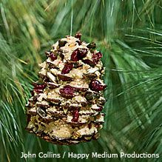

We found it easier to hang them from the other end.

Extension
There are other DIY bird feeders that participants can make. Examples can be seen on Pinterest or other web sites. Mini Bundt pans would work well for individuals. Heart-shaped cookie cutters would be great for Valentine’s Day. Recipes for suet can be found online.

Bundt Pan Feeder Coffee Can Feeder Cookie Cutter Feeder
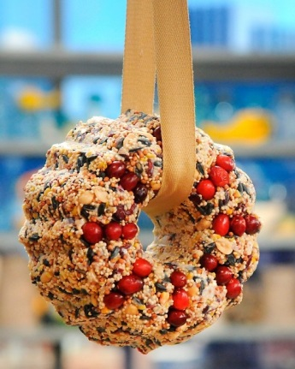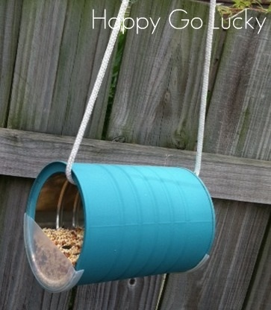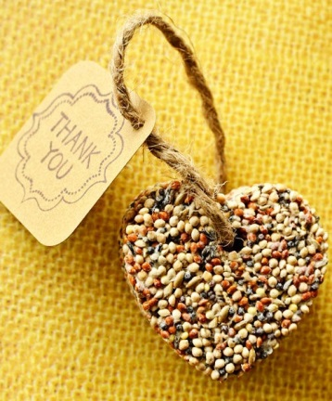

Fruit Feeder Mayo Jar Feeder Muffin Cup Feeder
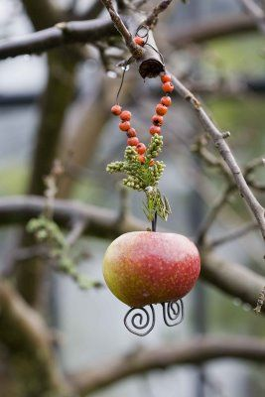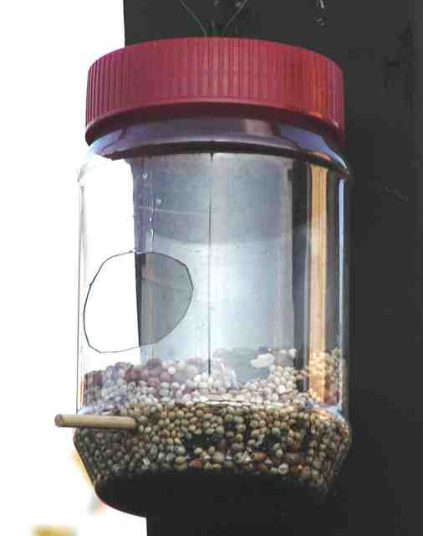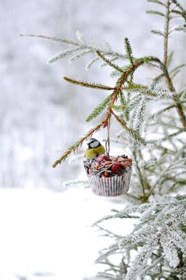

Orange/Grape Feeder Suet Ball Feeder Toilet Paper Feeder
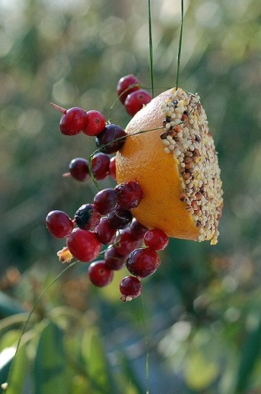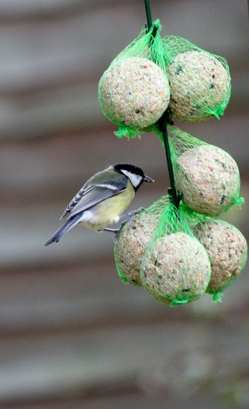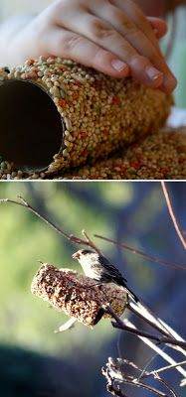

Orange Half Feeder Squirrel & Bird Corn Feeder
