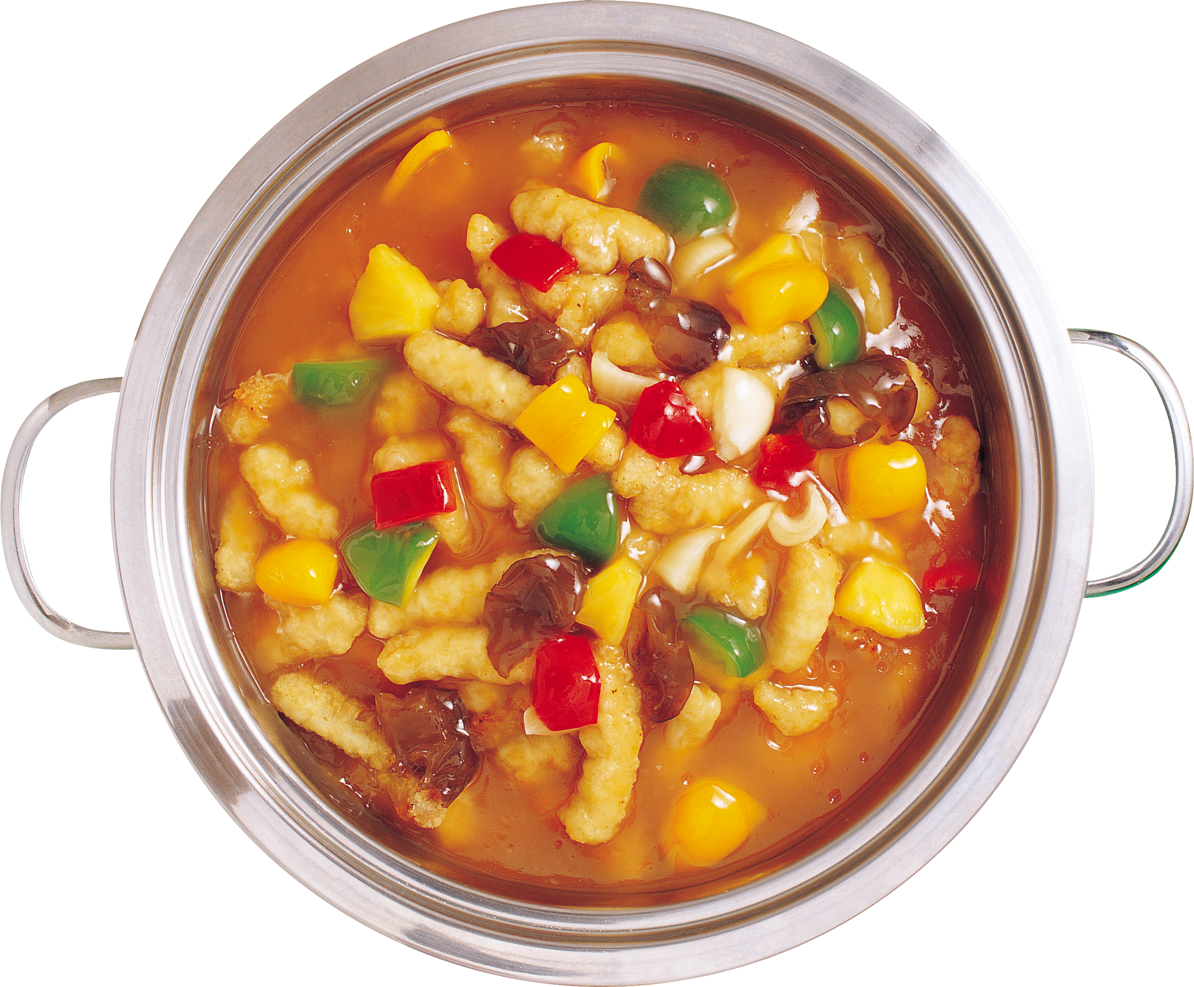

Lenoir County Cooperative Extension Center
1791 Hwy. 11 – 55
Kinston, NC 28504

We are collecting now through March 14. Please drop off your donations here:

Please Donate Any Nonperishable Food Items to Help Feed Local Families in Lenoir County.

Your Help and Participation is Greatly Appreciated!!!!
HELP US BRING A MEAL TO LOCAL FAMILIES

