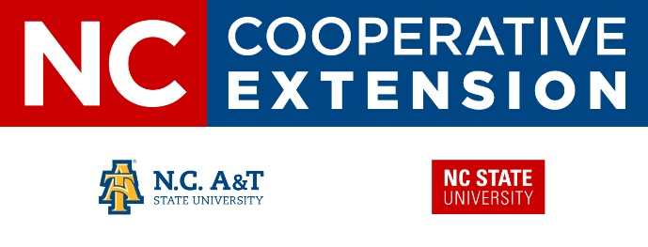

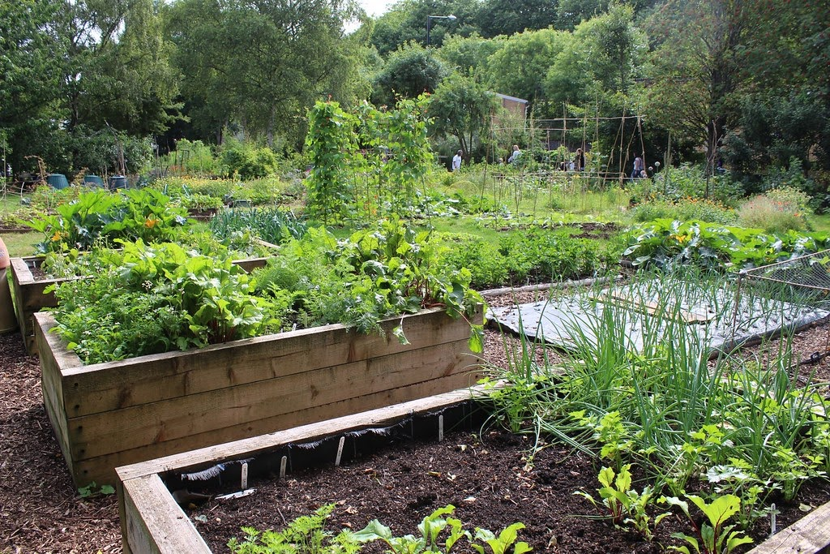

February 10, 2020

1:00pm – 2:00pm

Stokes Wellness Center

3172 NC Hwy 8 South, Unit B

Walnut Cove, NC 27052

Stokes County Extension’s Agriculture & Natural Resources agent, Bryan Hartman,

will be offering an Organic Gardening workshop. This is an intro workshop on the principles of organic gardening.  The topic will cover enhancing soil health and plant nutrition, as well as suppressing weeds following organic principles.

The workshop is free!

Please register at <https://www.eventbrite.com/e/organic-gardening-tickets-90806242917>, calling (336) 593-8179, or email bkhartman@ncat.edu.

**Organic Gardening**

Persons with disabilities and persons with limited English proficiency may request accommodations to participate by contacting Will Strader, Interim County Extension Director at 336.593.8179 (phone) or will_strader@ncsu.edu (email) or 336.593.8790 (fax), or in person at the Stokes County Extension office prior to the event. North Carolina Cooperative Extension is an equal opportunity provider.