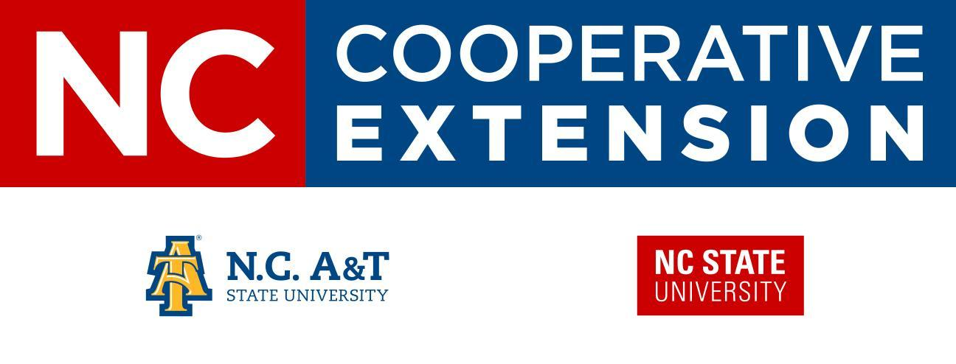
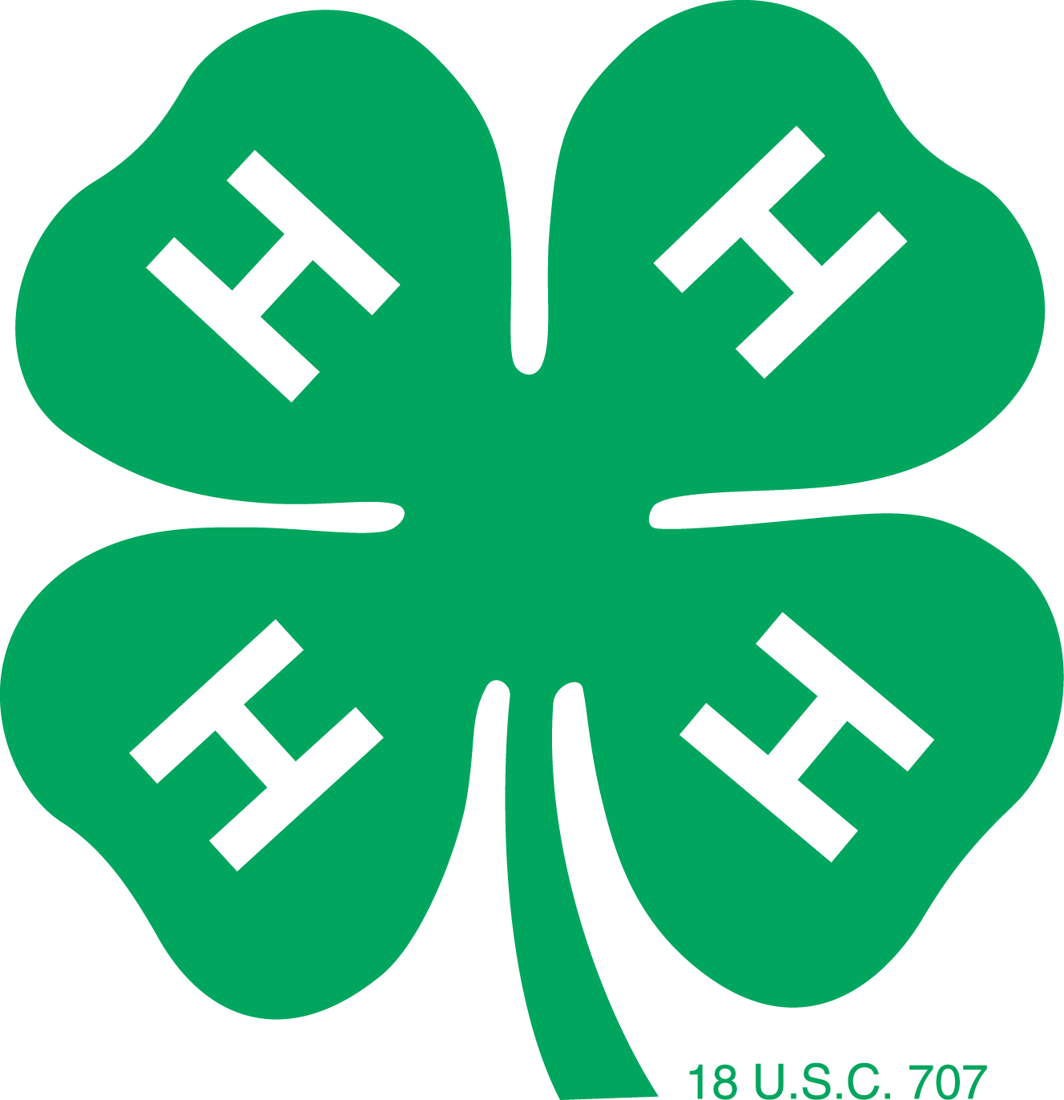
2020 4-H Animal Project
Born & Raised Contract
Eastern Carolina 4-H Livestock Show & Sale

Description:
This paperwork is to serve agents with the knowledge of their 4-H’ers and animal breeders from each county. It is a contract that participants in their respective counties of Edgecombe, Halifax, or Nash complete with the breeders of their animals in the same respective counties. The contract is used to assist with county awards as applicable.

For example: A 4-H’er that participates in the Nash County 4-H program that has an animal that was born and raised by a breeder in the same county (Nash Co.) must have a contract signed and submitted to their 4-H Agent before the deadline listed below. Note: The Born & Raised contract helps agents in awarding the “Best County Animals,” however, turning in the contract does not guarantee you will receive an award.

Return completed contract to your 4-H Agent prior to or no later than December 2, 2019 for Steers and January 27, 2020 for Lambs, Goats, and Hogs.
Failure to return the contract to your 4-H Agent before the deadline could result in being ineligible for the
Born & Raised Award.

I, _____________________________________(Print the name of 4-H participant)
a participant in ____________________ County 4-H Program, have an animal that was born and raised by a breeder in the same county as stated above.
Species: __________________
Show Tag #: __________
Other identification, if applicable (i.e. scrapie tag, description): ________________________

______________________________________________ Printed Name of Breeder
______________________________________________ Signature of Breeder
______________________________________________ Breeder’s County of Residence
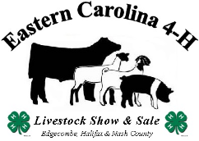
4-H Parent’s Signature: ___________________________________
Date: _______________
Thank You!!!

