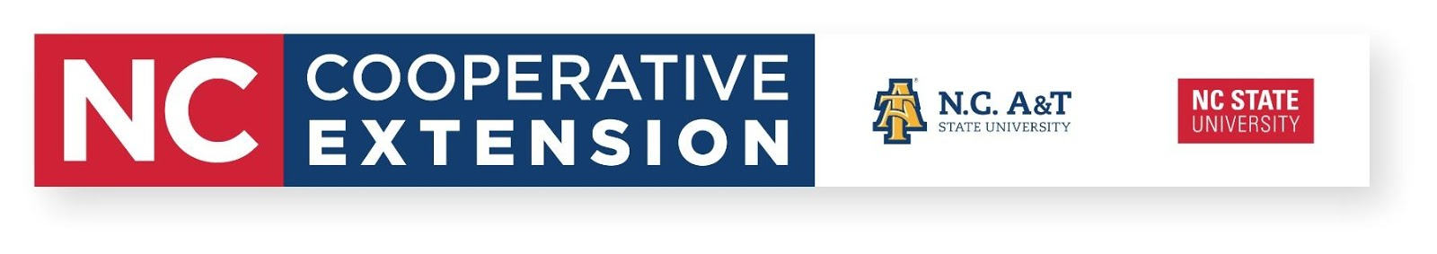
Composting 101 Workshop
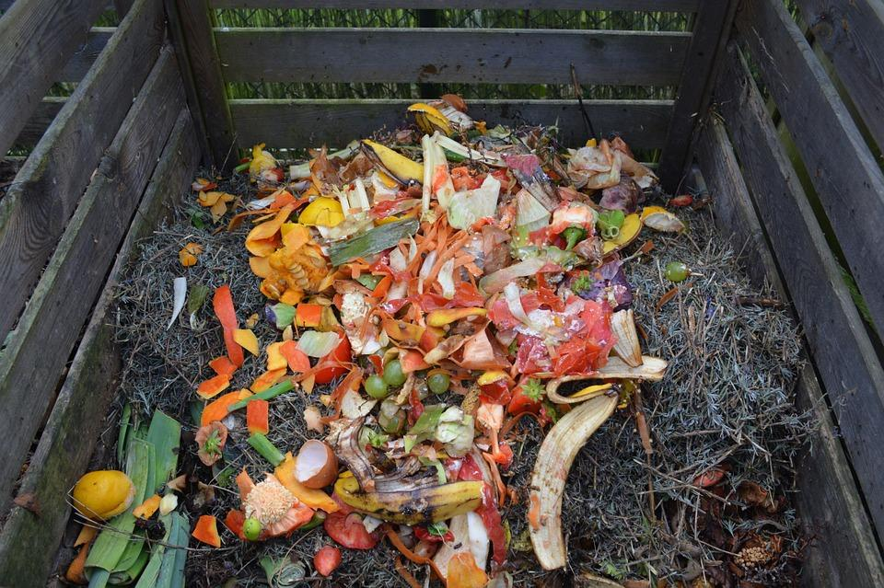
Chance to win pallets for a compost bin
Two different workshops available

July 30, 2019
9:00am - 11:00am

SEEDS Garden
King Senior Center
107 White Road
King, NC 27021
July 31, 2019
10:00am - 12:00pm

Danbury Community Garden
Stokes County Cooperative Extension
700 North Main Street
Danbury, NC 27016

Attendees will receive an overview of starting a compost pile, what to compost, effective management and how to utilize compost. Demonstrations will be given by Bryan Hartman, Stokes County Cooperative Extension Agriculture and Natural Resources Agent.

Register by contacting Bryan Hartman at bkhartma@ncsu.edu or (336) 593-8179.
*Dress accordingly for outdoor demonstrations*

